Victorian Budget 2014|15

Building a Better Victoria

Overview

The Secretary  
Department of Treasury and Finance  
1 Treasury Place  
Melbourne Victoria, 3002  
Australia  
Telephone: +61 3 9651 5111  
Facsimile: +61 3 9651 2062  
Website: budget.vic.gov.au  
Authorised by the Victorian Government  
1 Treasury Place, Melbourne, 3002  
Printed by Impact Digital, Brunswick

This publication makes reference to the  
2014-15 Budget Paper set which includes:  
Budget Paper No. 1 – Treasurer’s Speech  
Budget Paper No. 2 – Strategy and Outlook  
Budget Paper No. 3 – Service Delivery  
Budget Paper No. 4 – State Capital Program   
Budget Paper No. 5 – Statement of Finances  
(incorporating Quarterly Financial Report No. 3)  
© State of Victoria 2014

This work, *2014-15 Budget Overview*, is licensed under a Creative Commons Attribution 3.0 Australia licence. You are free to re-use the work under that licence, on the condition that you credit the State of Victoria (Department of Treasury and Finance) as author and comply with the other licence terms. The licence does not apply to any images, photographs or branding, including the Victorian Coat of Arms, the Victorian Government logo and the Department of Treasury and Finance logo.

Copyright queries may be directed to  
[IPpolicy@dtf.vic.gov.au](mailto:IPpolicy@dtf.vic.gov.au)

ISSN 1440-6969  
Published May 2014  
Printed on recycled paper

Contents

04 Budget at a glance

06 Strengthening Victoria’s finances

08 Building a stronger Victorian economy

10 State-shaping infrastructure to build a better Victoria

12 State-shaping infrastructure to build a better Victoria – Rail

18 State-shaping infrastructure to build a better Victoria – Integrating road and rail

20 State-shaping infrastructure to build a better Victoria – Road

22 Victoria’s infrastructure program

23 Investing in our future – Boosting skills, education and training

25 Strengthening health care and community services

27 Building a better regional Victoria

28 Building a safer Victoria

Budget at a glance

strong economy, strong surpluses, major new job-creating infrastucture building a better victoria

• up to $27 Billion RECORD STATE-SHAPING INFRASTRUCTURE INVESTMENT TO BETTER INTEGRATE VICTORIA’S RAIL AND ROAD NETWORKS, AND SOCIAL INFRASTRUCTURE

– MELBOURNE RAIL LINK  
– THE CRANBOURNE‑PAKENHAM RAIL CORRIDOR PROJECT  
– EAST WEST LINK – WESTERN SECTION  
– NEW SCHOOLS AND UPGRADES

• OPERATING SURPLUS OF $1.3 BILLION IN 2014-2015 GROWING TO $3.3 BILLION IN 2017-2018 FUNDING MAJOR INFRASTRUCTURE PROJECTS

– $1.3 BILLION 2014-2015  
– $3.0 BILLION 2015-2016  
– $3.2 BILLION 2016-2017

– $3.3 BILLION 2017-2018

Jobs and training

• $1.2 billion per year FUNDING FOR VOCATIONAL EDUCATION AND TRAINING THAT HELPS WORKERS ADAPT TO CHANGES IN OUR ECONOMY

• job creating infrastructure

– MELBOURNE RAIL LINK 3 700 JOBS  
– EAST WEST LINK – WESTERN SECTION 3 000 JOBS  
– CITYLINK – TULLA WIDENING 700 JOBS

• debt

– NET DEBT OF 6.3 PERCENT OF GROSS STATE PRODUCT IN 2014-2015 FALLING TO   
4.5 PER CENT IN 2017-18

• $1.4 billion in new health spending over four years

schools

• $2.8 billion initiative and growth over five years

– MORE FRONTLINE SERVICES CONTRIBUTING TO THE COALITION GOVERNMENT’S COMMITMENT OF $5.4 BILLION OF ADDITIONAL INVESTMENT IN SCHOOL EDUCATION OVER 6 YEARS.

• payroll tax rate reduced to 4.85 per cent from july 2014, to benefit 39 000 victorian employers

• melbourne rail link   
including airport rail link

– 30 MORE PEAK-HOUR SERVICES  
– INCREASE NETWORK CAPACITY BY 30 PER CENT  
– 3 NEW STATIONS

INFRASTRUCTURE

• $1.2 BILLION INVESTMENT IN REGIONAL INFRASTRUCTURE, INCLUDING:

– $362 MILLION PRINCES HIGHWAY WEST DUPLICATION PROJECT  
– $180-$220 MILLION MURRAY BASIN RAIL PROJECT

– $73 MILLION LATROBE REGIONAL HOSPITAL REDEVELOPMENT  
– $28 MILLION BARWON HEALTH-NORTH FACILITY  
– $15 MILLION BENDIGO AQUATIC CENTRE  
– $40 MILLION FREE WI-FI ON V/LINE TRAINS AND TO REMOVE MOBILE PHONE BLACKSPOTS

– $86 MILLION NEW INTERSECTION ON THE CALDER HIGHWAY AT RAVENSWOOD   
 NEAR BENDIGO

Strengthening Victoria’s finances

• ACTION TO MAINTAIN VICTORIA’S triple-a CREDIT RATING   
• MANAGING FINANCES TO HELP FUND RECORD infrastructure



Strong budget discipline over four consecutive budgets has allowed the Coalition Government to fund a record infrastructure program of up to $27 billion and deliver high‑quality frontline services.

The Coalition Government is continuing to responsibly manage net debt. Net debt is falling over the next four years as a percentage of gross state product, and net infrastructure spending is forecast to be fully funded by cash from operations from 2015-16.

To maintain Victoria’s triple-A credit rating, the strongest amongst the states, the Coalition Government has acted decisively to bring spending under control while growing frontline services.

Victoria is the only state or territory to forecast surpluses for each of the next four years.

In 2014‑15, the Victorian economy is expected to grow by 2.5 per cent, rising to 2.75 per cent over the forecast period. Employment growth is expected to be near trend of 1.5 per cent, while the unemployment rate is expected to remain stable at 6.25 per cent, before gradually declining to 5.5 per cent over the forecast period.



Building a stronger Victorian economy

• INVESTING IN INFRASTRUCTURE, TRAINING AND EDUCATION TO CREATE JOBS, INCREASE PRODUCTIVITY and GROW THE ECONOMY

STRONG and DIVERSE GROWTH INDUSTRIES

– FOOD & FIBRE  
– INTERNATIONAL EDUCATION  
– TOURISM

– FINANCIAL & INSURANCE SERVICES

– FREIGHT & LOGISTICS

SOLID GROWTH IN gross state product

– 2.5 per cent IN 2014-15 up from 2 per cent in 2013-14

The Coalition Government’s record investment on transformational new infrastructure projects and funding for education and training will create new opportunities and jobs, and increase productivity and economic growth.

Victoria has a diverse and flexible economy and is well positioned to take advantage of new and growing sectors to drive economic growth both domestically and internationally, including in:

– food and fibre exports;

– international education;

– tourism;

– financial and insurance services; and

– freight and logistics.

The agricultural industry is critical to regional Victoria, and the Coalition Government’s $35 million *Food and Agriculture into Asia* will support emerging export opportunities created by the increasing demand from the growing consumer class in Asia.

A growing Victoria

Victoria is one of the fastest-growing states with near record population growth at 1.8 per cent annually. This reflects Victoria’s liveability driven by strong economic management and sound investment opportunities for business and industry. Overall, population growth is expected to remain high by historical standards, easing slightly from 1.9 per cent in 2012-13 to 1.8 per cent over the forecast period.

• Highest net interstate migration in 30 years December 2012‑September 2013  
• Net 6903 increase in Victoria’s population

**Net Migration**

|  |  |  |  |
| --- | --- | --- | --- |
| To Victoria from | | From Victoria to | |
| ACT | 719 | WA | 601 |
| NSW | 3818 | NT | 363 |
| TAS | 902 |  |  |
| QLD | 796 |  |  |
| SA | 1632 |  |  |

State-shaping infrastructure to build a better Victoria

• INCREASing TRANSPORT CAPACITY AND RELIABILITY   
• BOOSTING WORLD-CLASS FREIGHT AND LOGISTICS   
• PROVIDING BETTER ACCESS TO SERVICEs

CHANGING THE WAY PEOPLE, GOODS AND SERVICES MOVE AND CONNECT   
THROUGHOUT VICTORIA

• up to $24 billion for new transport infrastructure projects

The Coalition Government is delivering a program of job-creating major infrastructure projects that will transform Victoria.

The Coalition Government’s infrastructure program delivers planned and targeted initiatives that will build a better Victoria by improving liveability, creating new jobs and boosting the productivity of our local industries as they compete globally.

In total, Victoria’s transport infrastructure program of up to $24 billion of new projects will deliver jobs, from office-based engineering and design roles to onsite roadworks and building and construction jobs, plus the small businesses that support them.

State-shaping projects across the rail, road and freight networks will dramatically change the way people, goods and services move right throughout Victoria.

Transforming the way Victoria moves will grow the economy, create jobs, improve efficiency and the scale of freight and logistics, increase productivity and better link people, products and markets.

Asset recycling opportunities

The Coalition Government will enter into a medium-term lease over the operations of the Port of Melbourne to create capacity on the State’s balance sheet. The Commonwealth and Victorian Coalition Governments are working together to deliver significant projects for Victoria.

Victoria stands to benefit from the Commonwealth’s new asset recycling initiative, which aims to encourage and support States to divest existing assets such as ports and reinvest the proceeds in major new economic infrastructure.



State-shaping infrastructure   
to build a better Victoria – Rail

• MEETing GROWING POPULATION transport needs   
• EASing CONGESTION   
• IMPROVing TRAVEL TIMES   
• INCREASing reliability   
• connecting people to jobs

MELBOURNE RAIL LINK

INCLUDING AIRPORT RAIL LINK  
– $8.5-$11 billion  
– 3 700 jobs at the peak of construction

25 minutes: travel time between the cbd and Melbourne Airport

EXTRA CAPACITY

– 30 MORE peak-hour SERVICES

– increase network capacity by 30 per cent

– 3 new stations

NEW STATIONs

• melbourne airport

• DOMAIN (underground)

• FISHERMANS BEND/MONTAGUE (underground)



Rail Network

Melbourne Rail Link

The Melbourne Rail Link will transform our rail network and create 3 700 jobs at its peak of construction. A new rail tunnel from South Yarra to Southern Cross Station will deliver 30 additional peak-hour services across the network. With the addition of new high-capacity trains, it will also increase capacity within the City Loop to upgrade services on other rail lines.

Construction of a tunnel from South Yarra to Southern Cross Station will significantly increase transport capacity and reliability for Melbourne’s growth areas, better connecting people to jobs.

The Coalition Government will also commence construction on the Airport Rail Link. The Airport Rail Link will introduce a new electrified service running along dedicated tracks from a new station at Melbourne Airport to Albion in Melbourne’s west, where it will join the existing rail network and run through to Southern Cross Station. The Airport Rail Link will cement Melbourne’s status as a global city by providing a fast, frequent and reliable train service every 10 minutes during the day.

The Melbourne Rail Link will deliver improvements to public transport services to support the continued growth of Melbourne’s inner north and its expansion as a key economic cluster. This will include enhancing and re-aligning the tram network and improving bus services to the precinct.

Detailed planning and project development is under way with early works commencing in mid-2016 and construction in mid-2017.

The Coalition Government’s record investment of up to $11 billion is delivering an integrated and modern rail network.

cranbourne‑pakenham rail corridor project

• EASing CONGESTION AND IMPROVING SAFETY OF THE TRANSPORT NETWORK   
• 1 IN 10 MELBURNIANS TO BENEFIT FROM IMPROVED SERVICES   
• gippsland v/line services to benefit from improved reliability

– 30 per cent boost to services  
– $2-$2.5 billion

Cranbourne-Pakenham Rail Corridor project

The $2–$2.5 billion Cranbourne-Pakenham Rail Corridor project will significantly improve rail services for one in every 10 Melburnians. This project will:

– boost services by 30 per cent on Melbourne’s busiest suburban line;  
– provide 25 next-generation, high-capacity trains that, combined with additional services, will provide room for an additional 4 500 passengers in the peak hour;  
– deliver two additional services in the peak hour;  
– install high-capacity signalling enabling more trains to run more reliably;   
– remove four congested level crossings at:

> Murrumbeena Road, Murrumbeena;

> Koornang Road, Carnegie;

> Clayton Road, Clayton; and

> Centre Road, Clayton.

– plan for the removal of an additional five level crossings at:

> Corrigan, Heatherton and Chandler roads, Noble Park;

> Grange Road, Carnegie; and

> Poath Road, Murrumbeena.

– rebuild stations at Clayton, Carnegie and Murrumbeena; and

– build a new depot.

V/Line Gippsland commuters will also benefit from a more reliable journey through the metropolitan area.

REMOVing FOUR MORE LEVEL CROSSINGS

• $685 MILLION OVER FOUR YEARS, BRINGING TOTAL INVESTMENT IN THE 2014-15  
BUDGET TO MORE THAN $1 BILLION

Removing level crossings

The Coalition Government has now allocated planning and/or construction funding for   
40 level crossing removals and grade separations – the largest such program on record.

The program has already removed level crossings at:

– Mitcham Road, Mitcham;

– Rooks Road, Mitcham;

– Springvale Road, Springvale; and

– Anderson Road South, Sunshine as part of the Regional Rail Link project, with the Anderson Road North level crossing removal close to completion.

Planning and early works were funded in the *2013-14 Budget* for the removal of level crossings at Mountain Highway and Scoresby Road, Bayswater.

The *2014-15 Budget* invests $685 million to remove four level crossings, supporting around 1 000 jobs during the peak of construction. These level crossings are at:

– Main Road, St Albans (as part of the Regional Rail Link project);

– Blackburn Road, Blackburn;

– North Road, Ormond; and

– Burke Road, Glen Iris.

The Coalition Government has now funded removal of eight of the 10 level crossings identified as priorities in its Metro Level Crossing Blitz election commitment. The *2014-15 Budget* provides an additional $21 million to plan for the next seven priority level crossing removal projects.

murray basin rail project

• $180-$220 million upgrade, BENEFITS TO REGIONAL industry

• 300 jobs at peak of construction

Murray Basin Rail Project

The Murray Basin Rail Project will commit up to $220 million over four years to undertake major country rail freight upgrades and standardise the key Mildura to Geelong rail link.   
The first stage of the Murray Basin Rail Project will undertake immediate upgrades on the Mildura to Maryborough and Murtoa to Hopetoun rail lines, and finalise the business case for the Mildura to Geelong standardisation. The final cost and alignment of the Mildura to Geelong rail standardisation will be guided by the final business case to be delivered before the end of 2014.

Regional Rail Link

Construction of the Regional Rail Link is currently ahead of schedule. The first service to use this new rail line is expected to start by mid-2015, and the St Albans level crossing removal is due to be completed in 2017. The project created around 3 600 jobs at the peak of construction. Through dedicated regional tracks from West Werribee Junction to Southern Cross Station, this landmark project will remove major bottlenecks in Victoria’s rail network. V/Line commuters from Ballarat, Bendigo and Geelong will see improved travel times and reliability by separating the regional and metro rail network.

City Loop upgrade

The Coalition Government will invest $44 million to upgrade fire and emergency equipment within the City Loop. Upgrades will include water hydrants, emergency lighting, fire detection systems, and improvements to automation for power shutdown, escalators and platform announcements.

more affordable public transport

• free tram travel FOR CBD AND DOCKLANDS MAKING public transport   
MORE AFFORDABLE

commuter SAVINGS ON RAIL TRAVEL  
• saving $5 per day for Zone 1 & 2 travellers

More affordable public transport

The Coalition Government is helping to ease cost of living pressures by:

– providing free tram travel in Melbourne’s CBD and Docklands;  
– enabling bus, train and tram commuters to travel in Zones 1 and 2 for the price of a Zone 1 fare;  
– enabling full-fare commuters who currently buy a Zone 1 and 2 fare to save about $5 per day, equating to savings of around $1 200 each year, and commuters who currently use an annual *myki* pass to save more than $750;  
– allowing commuters who currently travel in Zone 2 only, to benefit from Zone 2 fares remaining at their lower rate; and  
– easing daily traffic congestion in the suburbs.

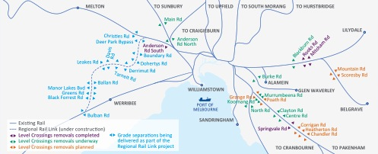

State-shaping infrastructure to build a better Victoria – Integrating road and rail

Melbourne Rail Link

– Construction from mid-2016  
– $8.5–$11 billion  
– 3 700 jobs created during the peak of construction

East West Link – Eastern Section

– Construction from late‑2014  
– $6–$8 billion  
– 3 200 jobs created during the peak of construction

East West Link – Western Section

– Construction from late-2015  
– $8–$10 billion  
– 3 000 jobs created during the peak of construction

Citylink – Tulla widening

– Construction from early-2015  
– up to $850 million  
– 700 jobs created during the peak of construction

Cranbourne-Pakenham Rail Corridor project

– Construction from early-2015  
– $2–$2.5 billion

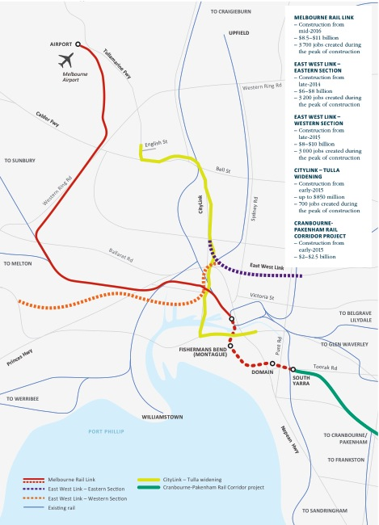

State-shaping infrastructure   
to build a better Victoria – Road

• easing CONGESTION   
• BENEFITing REGIONAL AND URBAN COMMUTERS   
• SECURING the FREIGHT TRANSPORT NETWORK   
• INCREASing PRODUCTIVITY

EAST WEST LINK – western section  
– $8-$10 billion complete western section

– 3000 jobs at the peak of construction

CITYLINK – TULLA WIDENING  
– 700 jobs created during the peak of construction

PRINCES HighWaY WEST DUPLICATION project  
– $362 million TO DUPLICATE 37 KM OF HIGHWAY BETWEEN WINCHELSEA AND COLAC

East West Link – completing the Western Section

The Coalition Government will complete the East West Link to relieve chronic traffic congestion in Melbourne’s inner north and west, unlocking the western suburbs growth corridor.

Commuters from Victoria’s regional centres in Geelong and Ballarat will benefit from a reduced reliance on the West Gate Freeway. The reliability of Victoria’s transport network will be improved by a much-needed alternate route to the current river crossing.

Tendering for the Eastern Section is already under way with works expected to commence in late 2014. The Western Section, delivering the much needed alternate route to the West Gate Bridge, will commence construction in late 2015, creating 3 000 jobs at the peak of construction.

CityLink – Tulla widening

Up to $850 million will be invested in partnership with the private sector to widen the Western Section of Melbourne’s integral CityLink network. This project will create around 700 jobs during the peak of construction. This project will complement the Airport Rail Link with new lanes and improved operations, getting people and goods from the CBD and the Port of Melbourne to the airport faster, as well as supporting Victoria’s growing tourism sector. A minimum of one extra lane will be added to each side of the freeway, as well as an additional lane for traffic heading inbound from the Tullamarine Freeway, just north of English Street, to the Bolte Bridge.

The Princes Highway West duplication project – Winchelsea to Colac

The Princes Highway is the key east-west route in south-western Victoria, and the Coalition Government will provide $362 million to duplicate 37 kilometres of highway between Winchelsea and Colac. This will support around 250 jobs during the peak of construction.

In addition, $11 million has been allocated to deliver three new overtaking lanes on Gippsland’s Princes Highway East between Nowa Nowa and Orbost, and $32 million will be provided to upgrade the Sand Road and Princes Highway intersection.

The Commonwealth Government is contributing $209 million to these projects.

Enhancing Victoria’s roads

The Coalition Government is investing in road infrastructure in metropolitan Melbourne and regional Victoria to improve overall road safety and access, and ease congestion. In 2014-15, the Coalition Government will provide an additional $370 million to maintain, restore and improve other parts of our road network. This includes new funding of $50 million for capital restoration works and an extra $80 million for road maintenance and resealing.

Victoria’s infrastructure program



Investing in our future – Boosting skills, education and training

• reskilling workers to transition into new and growing industry sectors   
• major investment in schools   
• further support for students with disabilities

major commitment IN SCHOOLS FOR the FUTURE  
– $2.8 billion initiatives and growth OVER five YEARS

significant VOCATIONAL EDUCATION AND TRAINING funding  
– $1.2 billion per year

12 new schools  
– more than 70 schools receive upgrades and works

Investing in the skills that lead to jobs

Funding for skills amounts to $1.2 billion per year. The Coalition Government is also investing $30 million in training for automotive workers. Investing in vocational education and training will boost Victoria’s workforce capability and assist workers to transition into new and growing industry sectors.

Victoria is enabling the higher qualifications required by modern industries, and achieving this faster than the rest of Australia. With the Coalition Government’s support, workers seeking to upgrade their skills will have more opportunities to secure jobs in the growth sectors of Victoria’s economy.

Record investment in our schools for the future

The Coalition Government is investing an additional $5.4 billion for schools to deliver high-quality education over six years. In the2014-15 Budget, the Coalition Government will deliver $1.6 billion over five years (including an initial contribution from the Commonwealth) for initiatives and enrolment funding, together with State funding growth of $1.2 billion. The bulk of this funding is provided directly to government and non-government schools, which are best placed to ensure resources are allocated where they are most needed for their school community. Additional funding will be provided in future budgets to deliver on the full six year commitment.

The Coalition Government’s schools package supports students, investing:

– $564 million for schools to raise performance with targeted funding for disadvantaged students;

– $273 million for more resources for students with disabilities;

– $32 million for bus services to transport students with disabilities; and

– $691 million for increased enrolment demand from Victoria’s population growth.

In addition, the Coalition Government will provide $500 million to build and upgrade government school facilities, including:

– 12 new schools, of which three schools will be built in regional Victoria; and

– $271 million for school upgrades and improvements.

The private sector will be invited to deliver components of the school capital program under a public-private partnership arrangement.

Strengthening health care and community services

• QUALITY SERVICES TO MEET DEMANDS OF a GROWING POPULATION   
• SUPPORT FOR GROWING REGIONAL COMMUNITIES

HEALTH SERVICES

$1.4 Billion boost to health over four years

$190 Million TO BOOST elective surgery over four years

mental health and drug services

$156 Million over four years

support for people with a disability

$200 Million over four years

more health professionals

961 more doctors

1748 more nurses

856 more allied health professionals

(between 30 june 2010-2013)

HEALTH system funding

$15 billion 2014-15

To support a growing population and increased demand for services, the Coalition Government has a clear plan to provide quality health care for all Victorians. Improving patient access to health services is fundamental to Victorians’ quality of life.

The *2014-15 Budget* delivers an additional $1.4 billion over four years to support hospitals, including $60 million to boost health service capacity in 2014-15 over the winter peak. This is in addition to the record investment in 2013‑14 of $1.8 billion over four years to Victoria’s hospitals and health system.

The Coalition Government’s investment includes an additional $156 million over four years to better support Victorians with a mental illness or drug and alcohol addiction.

The Coalition Government will spend $73 million on the Latrobe Regional Hospital redevelopment. In addition, $28 million will be provided to develop the new Barwon Health-North Facility, and $14 million for the Boort Hospital redevelopment, which will include a new 32 bed facility. These investments will provide a range of essential services to growing regional communities. In the past four years the Coalition Government has invested billions of dollars in health infrastructure programs that includes:

– the $1 billion Victorian Comprehensive Cancer Centre;

– the $630 million Bendigo Hospital;

– $448 million for the Box Hill Hospital redevelopment;

– $250 million for the Monash Children’s Hospital;

– $55 million for the Peter Doherty Institute;

– $165 million for the redevelopment of the Royal Victorian Eye and Ear Hospital;

– $81 million for the Frankston Hospital in-patient expansion, emergency department and sub-acute beds;

– $98 million for the Geelong Hospital major upgrade and sub-acute beds;

– $14 million for the new Melton Community Health Centre (including $5 million funded through the Growth Areas Infrastructure Contribution);

– $9 million for the Austin Short Stay Unit expansion; and

– $5 million for the expansion of the Healesville Hospital.

The Coalition Government is investing $200 million over four years to support Victorians with a serious disability to make choices about the services that best suit their needs. Investment in disability services in 2014-15 is now $300 million more than when the Coalition came to government.

The Coalition Government has also made a significant contribution to establish the National Disability Insurance Scheme.

Victoria has a leading role in trialling the NDIS in the Barwon area and the national headquarters will be located in Geelong, creating 300 jobs in the region.

The Coalition Government will continue to support a new National Partnership Agreement on Homelessness over the next four years. This Agreement will support vulnerable Victorians who are homeless or at risk of homelessness, including rough sleepers, people with a mental illness, women with children experiencing family violence, and young people who have experienced family breakdown.

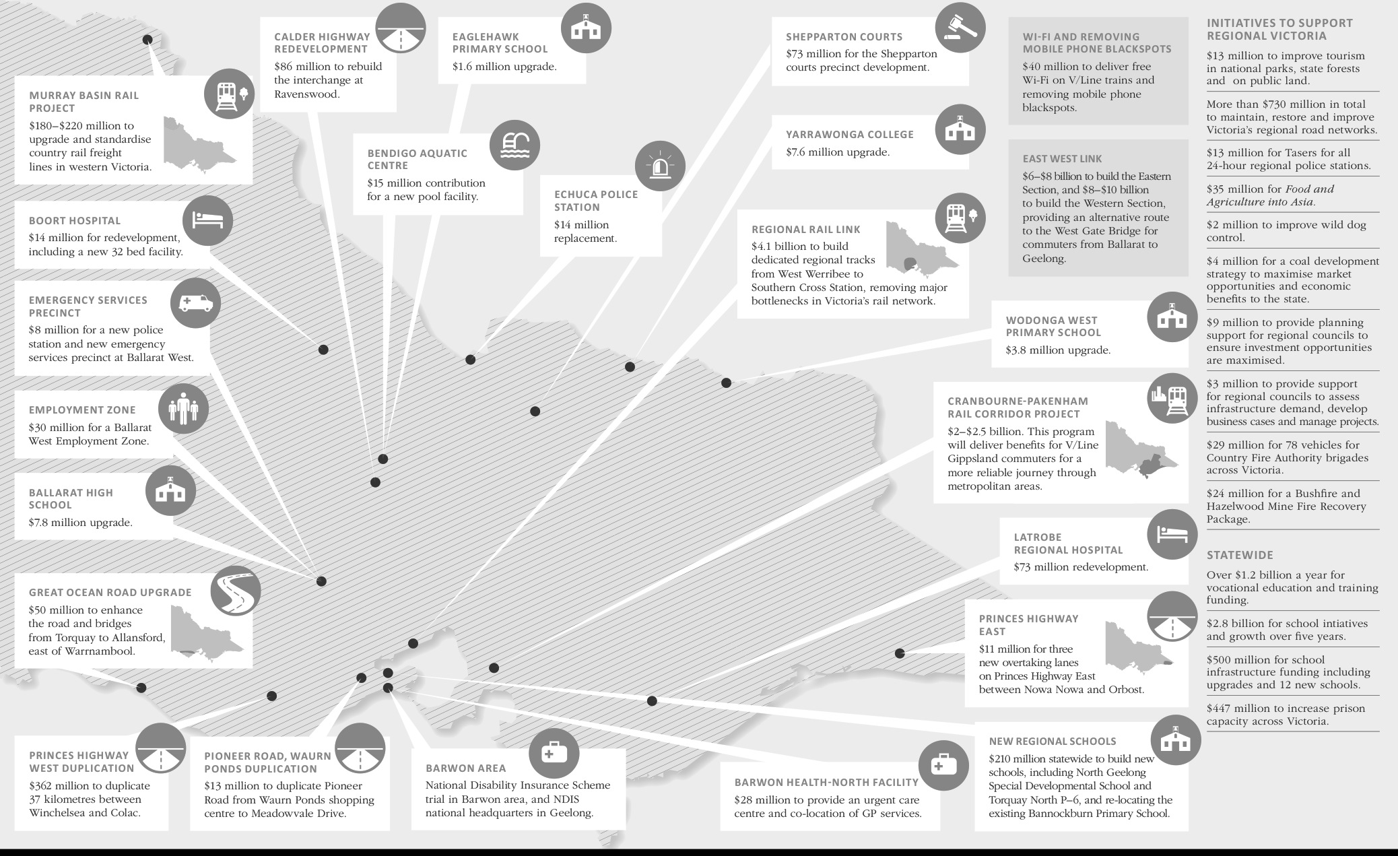Building a better regional Victoria

­­­­­­­

Building a safer Victoria

supporting tougher sentencing and parole laws

$447 Million EXPANDING PRISON CAPACITY

new police stations

$33 Million for new police stations

Country fire authority

$457 Million total funding in 2014-15

2.5 per cent increase from 2013-14

metropolitan fire brigade

$326 million total funding in 2014-15

3.1 per cent increase from 2013-14

country fire authority INVESTMENT

78 new vehicles

Building a safer Victoria remains a key priority for the Coalition Government. The 2014-15 Budget builds on the comprehensive package provided over the past three years to ensure Victorians are safer.

Increasing prison capacity

In 2014‑15, the Coalition Government will invest $447 million to expand Victoria’s prison capacity, supporting important sentencing and parole reforms. The Coalition Government’s commitments will employ an additional 110 ongoing prison jobs across Victoria.

Since the start of 2011, more than 1 200 new beds have been opened   
with more than 2 900 in the pipeline. These include the new 1 000 bed medium-security prison in Ravenhall, which will support around 650 jobs   
at the peak of construction, and a new 40 bed unit at Barwon Prison.

The 2014-15 Budget increases prison capacity by 871 beds, and provides new units, relocatable units and infrastructure upgrades across the prison system, including at Dame Phyllis Frost Centre, Beechworth Correctional Centre and Langi Kal Kal Prison.

Building and upgrading Victoria’s police stations

The Coalition Government is completing the largest recruitment in Victoria Police’s history with 1 700 additional police officers and 940 Protective Services Officers. The 2014-15 Budget delivers $13 million for taser equipment for 24 hour police units in regional Victoria, and $12 million to re-locate the Victoria Police Mounted Branch from South Melbourne to redeveloped stables in Attwood. Building on previous commitments to build and refurbish 11 police stations, $33 million is being invested in:

– a new Echuca Police Station;

– the St Kilda Road Station replacement; and

– a new police station and emergency services precinct at Ballarat West.

This is in addition to the Coalition Government’s previous commitments   
of $56 million to upgrade more than   
100 police stations.

Fire services

Since 2011‑12, the Coalition Government has invested more than $3.1 billion in Victoria’s fire services. In 2014‑15, a $783 million investment in fire services will:

– increase the Country Fire Authority’s budget by 2.5 per cent;

– increase the Metropolitan Fire Brigade’s budget by 3.1 per cent;

– purchase 78 new vehicles for Country Fire Authority brigades across the State; and

– replace all existing respiratory protection equipment to support fire engagement and improve occupational health and safety for firefighters.

If you would like to receive this publication in an accessible format please telephone 9651 0909 or email information@dtf.vic.gov.au.

This document is also available in PDF and WORD at budget.vic.gov.au.

2014-15 Victorian Budget

Budget Overview

budget.vic.gov.au