GETTING IT DONE

Victorian Budget 16/17

OVERVIEW

The Secretary
Department of Treasury and Finance
1 Treasury Place
Melbourne, Victoria, 3002
Australia
Tel: +61 3 9651 5111
Fax: +61 3 9651 2062
Website: budget.vic.gov.au
Authorised by the Victorian Government
1 Treasury Place, Melbourne, 3002
Printed by Impact Digital, Brunswick
Printed on recycled paper
This publication makes reference to the 2016-17 Budget paper set which includes:
Budget Paper No. 1 – Treasurer’s Speech Budget Paper No. 2 – Strategy and Outlook
Budget Paper No. 3 – Service Delivery
Budget Paper No. 4 – State Capital Program
Budget Paper No. 5 – Statement of Finances
(incorporating Quarterly Financial Report No. 3)
© State of Victoria 2016
(Department of Treasury and Finance)
You are free to re-use this work under a Creative Commons Attribution 4.0 licence, provided you credit the State of Victoria (Department of Treasury and Finance)
as author, indicate if changes were made and comply with the other licence terms. The licence does not apply to any branding, including Government logos.
Copyright queries may be directed to IPpolicy@dtf.vic.gov.au.

ISSN 1440-6969 (print)
ISSN 2204-7174 (online)
Published April 2016

Treasurer’s message
The 2016-17 Victorian Budget Getting It Done, builds on the new-found strength of the Victorian economy to deliver the things that matter most to Victorians: hospitals, schools, jobs, transport and our quality of life.
The Budget funds our plans, projects and promises – because getting things done means concrete delivery, not dithering and delay.
It invests in the projects, industries and ideas that will encourage small businesses to grow and encourage big businesses to invest.
It sets aside $572 million to take action on family violence – our number one law and order issue.
It will deliver the most funding for new and upgraded schools ever.
It will cut waiting times for elective surgeries.
It funds the road and rail projects we need to get to work and home on time.
And it recognises regional Victoria as the key to our state’s economic strength.
With this Budget, regional cities can start to rival Melbourne in the race for new jobs, visitors and businesses – and that’s a good thing.
Make no mistake: our economy is strong.
The days of successive annual economic growth of just 1 per cent are over.
Since the Government came to office, more than 112 000 jobs have been created. The unemployment rate is down to 5.7 per cent from its peak of 6.9 per cent in 2014.
These are not mere numbers on a page – these are Victorians who have had a sense of purpose restored.
The Government’s first Budget invested $22 billion in infrastructure, and delivered the biggest education boost in Victoria’s history.
By restoring government’s role in generating jobs and attracting investment, it has given Victoria’s economy a renewed confidence.
Companies who want to invest in Victoria and create new jobs now know they have a government that’s on their side.
That’s just one reason why our state is growing faster than any other.
Growth has risen to 2.5 per cent annually, and we are creating jobs at three times the rate seen under the former Government.
Melbourne is projected to be Australia’s largest city by 2030. Victoria will be the nation’s largest generator of food and fibre exports, a centre of innovation and research, and a drawcard that attracts students and visitors from all over the world.
It’s our job to manage this growth, and make sure no Victorian misses out on the things to which they are entitled: schools, hospitals, jobs, a welcoming community and a decent quality of life.
It will take time and effort, but I’m proud to say that we’re getting it done.

Tim Pallas MP
Treasurer of Victoria

Jobs for Victoria

New and upgraded schools

Boost for elective surgery

Action on family violence

New road and rail projects

More for regional Victoria

More growth means more jobs
Victoria’s economy is growing. Our strength in the service and knowledge sectors means we can make the most of the changes in the Australian economy.
We have a strong economy, with 3 per cent growth forecast for 2016-17. But the benefits of this growth must be shared fairly.
The Victorian Budget 2016-17 makes the right investments in jobs, infrastructure and services so that growth is strong and sustainable for all Victorians. No one will be left out.
That’s why we’ve included up to $12.4 billion capital in this Budget for the projects that Victorians need.
These investments are financially responsible. The Budget produces an operating surplus of $2.9 billion, and surpluses averaging $2.1 billion a year over the forward estimates.
These surpluses will be delivered by ensuring average revenue growth of 3.4 per cent is greater than average expenditure growth of 3.3 per cent.
We will maintain our debt at a sustainable level, consistent with our triple-A credit rating, while still investing in the infrastructure our growing state needs. Net debt is forecast to fall from 5.9 per cent of GSP this year to 4.8 per cent by June 2020.
With population growth of 1.7 per cent last year, Victoria is the fastest growing state in the nation. When growth is this strong, we need to take action to keep up with the demand for services.
Infrastructure investment will average $7.4 billion a year over the next four years, with funding for key projects in urban and regional transport, health and education.
112 600 new jobs have been created since we were elected to office, including 71 100 full-time jobs. The unemployment rate has fallen from 6.9 per cent in 2014 to 5.7 per cent in March 2016, and is projected to be 5.5 per cent by 2018-19.
Two per cent employment growth is forecast for 2015-16, and the initiatives funded in this Budget will grow the job market even more.

Surplus of $2.9 billion in 2016-17
Financially responsible infrastructure investment
Maintaining our triple-A credit rating
Fastest growing state in the nation

Victoria’s finances
The Budget keeps our finances stable, so we can provide the services that we all rely on – like schools and hospitals – and build the road and rail projects that our growing state needs.
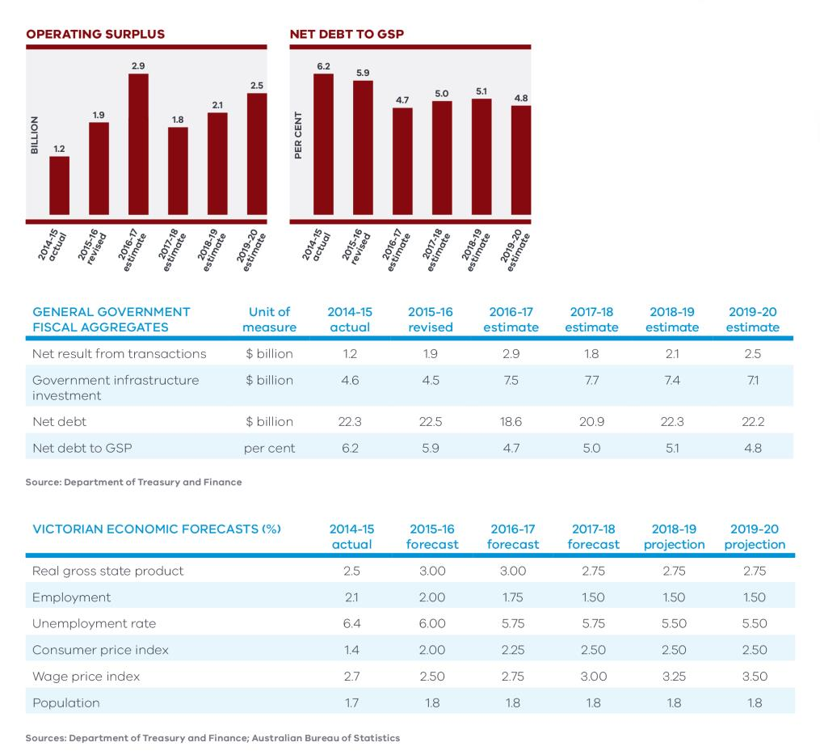

The projects we need
In the Victorian Budget 2016-17, we’re investing an average of $7.4 billion a year for four years to build schools, upgrade hospitals, expand the rail network and cut congestion on the roads that people use every day.
Victoria’s expanding population is straining schools, hospitals, roads and rail. The Government is meeting this demand, and keeping up with the replacement of ageing assets.
Maintaining net debt at around 6 per cent of GSP will keep key financial indicators at prudent levels. If the government increases net debt up to this level from currently estimated and projected levels, additional funding available for transformative infrastructure projects would be to around $16 billion over ten years.
Getting infrastructure investment decisions right is important. We’re getting on with the projects our state needs now, but to advise on our priorities, we've established Infrastructure Victoria as an independent authority to take the politics out of infrastructure projects.

Investing in major projects
Up to $12.4 billion new capital investment
Average of $7.4 billion a year to 2020
Fighting for our fair share from Canberra
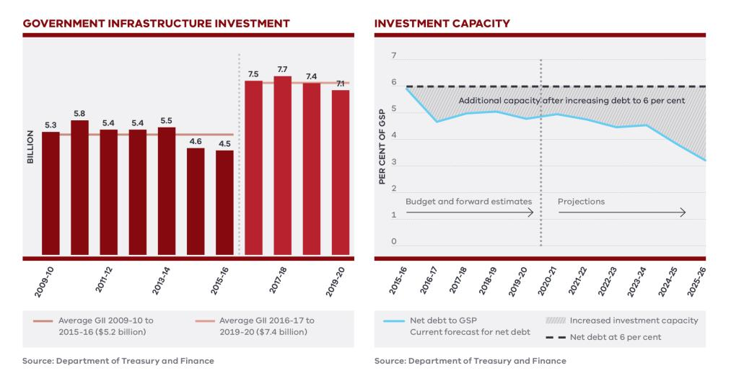

We’re using our assets
Where it is in the community’s interest, capital that’s tied up in existing businesses and assets can be recycled to build new infrastructure.
The 50-year lease of operations at the Port of Melbourne will generate billions of dollars to fund the Government’s Level Crossing Removal Program and other infrastructure projects, including in the regions.

Our fair share
Victorians are being short-changed by the Commonwealth. While our economy and population are growing fast, the Commonwealth Government keeps overlooking our needs.
Victoria is expected to receive only 9 per cent of Commonwealth infrastructure grants on average over five years. This is simply not good enough, given Victoria is home to 25 per cent of the Australian population.
Major projects such as Melbourne’s new Metro Tunnel and the Western Distributor are fully funded and ready to proceed with or without co-investment from the Commonwealth.
The Andrews Labor Government will continue attempts to partner with the Commonwealth to get Victorians their fair share.

New road and rail projects
We are building the Metro Tunnel to free up the space to run more trains in and out of the city. It’s the biggest overhaul to the train network since the construction of the City Loop, and it will leave a legacy for the public transport system.
We're also improving the network by purchasing 65 high capacity trains, five X'Trapolis trains, extending the South Morang line to Mernda to service one of Victoria's fastest growing communities, upgrading the Hurstbridge line, and removing 50 of our most dangerous and congested level crossings to improve safety for everyone.
The Budget includes more than $7 billion to upgrade roads in suburbs and cities across the State, including the duplication of Yan Yean and Thompsons roads, the Drysdale Bypass, streamlining Hoddle Street, the Western Distributor, Monash Freeway upgrade and road safety initiatives.

More schools than ever
The Budget invests $924 million in new and upgraded school buildings, across the Education State.
Under the biggest school building program in Victoria’s recent history, scores of Victorian schools will be renovated, refurbished, maintained and rebuilt. New schools will be constructed and brand-new relocatable classrooms will meet demand at growing schools.

Huge boost for health
Victorians deserve a stronger and reliable health system. The Budget invests $982 million for new buildings, vital health equipment and projects to increase the capacity of our hospitals.
It’s all about saving lives, cutting waiting times on elective surgery lists, and ensuring Victorian hospitals can meet the needs of a growing population.

More for the regions
Regional Victoria is the big winner in this Budget. This Budget will create new jobs, bring new industries to regional cities, boost tourism and build the projects that locals and businesses need.
The 50-year lease of the Port of Melbourne will allow for the creation of the $200 million Agriculture Infrastructure and Jobs Fund. It will boost exports and support Victorian farmers from paddock to port.
The Budget provides $1.3 billion to improve the regional rail network and increase reliability and connectivity. This includes upgrades and frequency improvements to lines servicing Ballarat, Bendigo, Geelong, Gippsland, the North East, Shepparton and Warrnambool.

Creating jobs
Victorian job growth led the nation in 2015 – and with the right investment, it will keep improving. The Government’s plans will help businesses create jobs right across our state.
Major road and rail projects create thousands of jobs, and the $10.4 billion investment to expand the public transport system, fix regional rail, cut congestion and improve safety on suburban and regional roads will do just that.

Making Victoria number one
The Victorian Budget 2016-17 invests $237 million to attract investment in Victoria and bring the best global talent and the biggest international companies to our soil. This includes:
- $116 million for our Investment Attraction and Assistance Program, bringing more jobs to Victoria
- $66 million to expand and support the Victorian Government Business Office network, giving us a voice in the world’s biggest economic markets
- $34 million to promote Victoria to the world
- $12 million to strengthen the Victorian Industry Participation Policy
- $9 million for the Business Events Fund
$50 million is also provided to replenish the Premier’s Jobs and Investment Fund, to help businesses to grow and attract investment to Victoria.

Jobs of the future
The Budget allocates $297 million in sectors where Victoria has a competitive advantage. Strategically targeted programs will help businesses grow and create the jobs of the future.
$111 million will be invested to help Victoria take advantage of some of the fastest growing industries in the world. The Future Industries Fund will be bolstered to fund strategic projects aligned with the Future Industries Sector Strategies, and enhance the competitive advantage for Victoria’s six priority growth sectors:
- Medical technologies and pharmaceuticals
- New energy technology
- Food and fibre
- Transport, defence, and construction technologies
- International education
- Professional services
The Budget provides $33.8 million to deliver the Government's first Creative Industries strategy targeted at generating productivity, income, jobs and export earnings.
$31.9 million will be provided to further strengthen Victoria’s position as the number one destination for international students.

Jobs for Victoria
Investing in priority sectors for the future
Supporting workers in transition
Payroll tax relief

Regional jobs
We are investing $325 million for jobs in the regions, to support a pathway of prosperity for regional Victoria through water, tourism, infrastructure, marketing programs, and cultivating the growth of future industries.
Our goal is regional cities that don’t have to rely on Melbourne for jobs and services. Soon, they will rival Melbourne in the race to attract new jobs, residents and visitors. Our plan includes:
- $123 million for upgrades to irrigation infrastructure, connecting towns in South Gippsland, and protecting Bendigo’s farming industries and the future of the tourist mine
- $101 million for regional tourism infrastructure projects, including funding for a new Penguin Parade Visitor Centre to be built on Phillip Island. The Phillip Island Nature Parks will also contribute $10 million towards the new Visitor Centre
- $38 million for Visit Victoria, to promote our tourism and major events to the nation and the world
- $40 million to help the Latrobe Valley build a strong and secure economy
- $11.1 million to improve mobile coverage in regional Victoria
- $7 million for the Bendigo Arts Precinct, so the regional city can become a creative hub for Victoria
- $4.2 million for the Ballarat Innovation Lab and Digital Space
The Government is also looking out for people who work in industries that are in transition. The Budget provides $73.8 million to give Victorians the skills to succeed, and connect job seekers with employers, so these long-serving specialists and professionals can find decent jobs in new, fast-growing industries. This includes:
- $53 million for the creation of Jobs Victoria to coordinate all Victorian employment programs
- $10.8 million for community revitalisation
- $10 million to expand the Back to Work Scheme for automotive workers

Helping Victorian business
We will make Victoria a more competitive place to do business, cutting red tape, introducing faster and smarter planning processes and reducing the burden of regulation on small business.
The Government will reduce the payroll tax burden on business. The $550 000 payroll tax threshold will be gradually increased to $650 000 by 201920. We’ve listened to business and approximately 36 000 Victorian businesses will pay less tax, allowing them to focus on investment and job creation.
Further, the wages of a displaced apprentice or trainee will be exempt from payroll tax from 1 July 2016, ensuring young workers are given the chance they deserve.
These initiatives together provide tax relief of $312 million over the next four years.

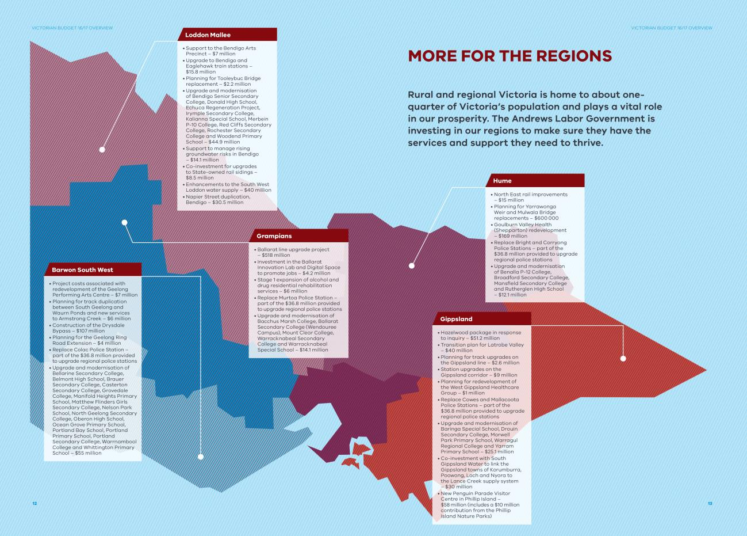

More for the regions

Water
The Victorian Budget 2016-17 provides $468 million to protect Victoria’s water supply and support a healthy environment, a prosperous economy and thriving communities, including:
- $200 million to improve the health of waterways in regional Victoria through an integrated waterway management program that includes large-scale restoration projects
- $79.2 million to enhance water and irrigation infrastructure within the Macalister, Bacchus Marsh, and Werribee irrigation districts, and connect and secure the water supply for the South Loddon Shire
- $59.6 million to modernise irrigation systems and increase efficiency and on-farm water use to ensure the liveability of Victoria’s cities and towns
The Government will soon release its water plan, which will set the direction for water management in Victoria.

Tourism
Tourism is vital to regional Victoria. The Budget continues to invest in Victoria’s growing tourism industry, with a major focus on regional Victoria.
The Regional Tourism Infrastructure Fund will provide $101 million to support regional tourism infrastructure initiatives and boost jobs. A $20 million Regional Events Fund will support a strong calendar of events to attract visitors to the regions.
The Government will invest $38 million in Visit Victoria for major interstate campaigns highlighting regional destinations and continuation of the China brand strategy. This will promote all of Victoria as an attractive tourist destination.

Investing in regional communities
$468 million for waterways and irrigation
Backing the visitor economy
Supporting the Latrobe Valley

Latrobe Valley
The Latrobe Valley is a resource-rich area with abundant forests, rich agricultural land and large brown coal and water resources. To support the growth of future industries, the Victorian Budget 2016-17 provides $40 million for the Latrobe Valley.
The Latrobe Valley community raised concerns about the impact of the Hazelwood mine fire on their health and the health of their loved ones. They were right.
The Budget includes $51.2 million to further assist residents, and restore and rehabilitate the Latrobe Valley community as part of the response to the Hazelwood inquiry. This includes:
- $27.3 million to respond to the health needs of residents of the Latrobe Valley including priority services and preventative health programs, and increased health assessments and early interventions
- $13.8 million to develop an integrated, regional scale rehabilitation strategy and for land use transition of affected mine sites
- $10.2 million for air quality monitoring, and for emergency services agencies to implement recommendations to better prepare for incidents and develop an emergency management plan

Public transport and roads
Our state is growing faster than any other.
The Victorian Budget 2016-17 will transform our public transport system, reduce congestion on our roads and improve safety for everyone.
This Budget invests over $10.4 billion in public transport and road projects across Victoria.
We have already started removing 50 of our most dangerous level crossings, and will fully fund Melbourne’s new Metro Tunnel to get this major transport project done.
We’ll partner with any Commonwealth Government willing to support Australia’s most important infrastructure project, and will keep advocating for Victorians to get their fair share.

$1.3 billion for regional rail services and infrastructure
More services on regional lines
27 new VLocity carriages
V/Line: back on track

Meeting our election commitments:
- Full funding for the Metro Tunnel
- Ten level crossing removals under construction or completed
- Extending the South Morang line to Mernda

A boost for cycling
We’re investing $9.3 million to support cycling, including $4.9 million to continue the Melbourne Bike Share initiative and $1 million for the Westgate Punt.

Melbourne’s public transport network
More trains on our rail network means fewer cars on our roads, and less traffic for those who have to drive. This Budget invests over $1.9 billion to grow our metropolitan public transport system, including:
- $875 million to order an extra 28 high capacity trains to prepare for the Metro Tunnel, and $105 million to purchase an extra five X’Trapolis trains, providing extra room for passengers, and extra services across the metropolitan network
- $588 million to extend the South Morang line to Mernda. This project will ensure that public transport is a real option for residents in one of Victoria’s fastest growing areas
- $140 million for the Hurstbridge line upgrade. This will include duplicating the line between Heidelberg and Rosanna, which will improve reliability and increase peak services for the north-eastern suburbs
- $134 million for fire safety and intruder detection upgrades to the City Loop, making the journey to and from work safer and more reliable for the 130 000 passengers who use the Loop every day
- $50 million to upgrade Frankston Station, providing better access to public transport for locals

Regional rail
The Andrews Labor Government is investing $1.3 billion in rail projects across regional Victoria. This includes:
- $518 million for Ballarat line upgrade project, to duplicate the line from Deer Park West to Melton, build additional platforms, introduce new peak services. This project will provide families in Ballarat, Melton and the growing western suburbs with the reliable services they need to get to work and back home again
- $141 million for regional rail maintenance, and a further $198 million for V/Line to better meet service standards so that our rail infrastructure can deliver reliable services
- Over $186 million for extra services, track and station upgrades on the Ballarat, Bendigo, Geelong, Gippsland, North East, Shepparton and Warrnambool lines
- $280 million for 27 new VLocity carriages, to support extra services

Western Distributor
The Budget provides a government contribution of $1.46 billion over four years towards fully funding the Western Distributor, the much-needed alternative to the West Gate Bridge. The project will create 5 600 jobs during construction and cut travel times from Geelong by 20 minutes.
The project will also add an extra lane to the Monash Freeway between Eastlink and Clyde Road, and provide better access to the West Gate Freeway and Bolte Bridge from Webb Dock, reducing congestion along the M1 corridor.

Suburban roads
To help reduce congestion, the Budget includes:
- $437 million to meet our election commitments to upgrade Thompsons Road, Yan Yean Road, O’Herns Road, Hoddle Street, and Bolton Street in Eltham
- $228 million to duplicate sections of Dohertys Road and Hallam Road and widen Plenty Road, reducing travel times for residents and businesses on these key arterial roads in the outer suburbs
- $10 million to plan the next stage of expanding our outer suburban arterial road network, meeting growing demand and reducing congestion in growth areas across Melbourne. Delivery options will be investigated for bundling of road upgrades and long-term maintenance under an availability style PPP

Regional roads
Regional Victorians need safe, efficient roads. It’s vital for strong regional communities, and with 80 per cent of goods moved by road, it’s essential for the productivity of the whole state. This Budget invests $260 million in road improvements for regional Victoria, including:
- More than $107 million to improve safety and reduce travel times by providing extra overtaking lanes, improved road conditions and plans for future road upgrades
- $107 million to build the Drysdale Bypass, which will reduce congestion on the Bellarine Peninsula
- Over $30 million to duplicate Napier Street in Bendigo between Weeroona Avenue and Hall Street, which will reduce congestion and improve safety in this growing regional centre

Road Safety
The Government is providing $427 million for road safety across Victoria – because one life lost on our roads is too many.

Education State
The Andrews Labor Government is making Victoria the Education State.
We have talked to thousands of Victorian teachers, principals, parents, carers and students who have told us that our schools are good. The system isn’t broken, but more work needs to be done. We must take our schools from good to great, and we must support the kids who need extra help.
We are continuing to make the case to the Commonwealth Government to honour its commitment to fully fund the Gonski Agreement. If the Commonwealth Government doesn’t honour the final two years of this education funding agreement, Victoria’s government schools will be $1.1 billion worse off.
Victoria is doing its part. We’ve reaffirmed our commitment to the Gonski Agreement, and provided the single biggest injection of education funding in the State’s recent history.
Using funding allocated last Budget, we are investing $747 million from the start of the 2016 school year to provide additional support to schools, students, principals and teachers. The Government will make further announcements about additional investment for the 2017 school year.

Making Victoria the Education State
Seeking full funding for Gonski
$924 million for new and upgraded schools
Establishing Tech Schools across Victoria

More funding for classrooms and schools
Students can’t get a first-rate education in a second-rate classroom.
As a result of chronic underinvestment in recent years, our schools are overcrowded and run down. Without additional investment a large and growing number of students will be forced to attend schools that are operating well beyond their enrolment capacity.
The Victorian Budget 2016-17 invests $924 million in new and upgraded schools. This includes:
- $385 million for upgrades to schools in poor condition
- $287 million to construct new schools and buy land, including many in growth areas
- $92 million to establish Tech Schools in the Ballarat, Banyule, Bendigo, Casey, Geelong, Gippsland, Monash, Whittlesea, Wyndham and Yarra Ranges regions
- $63.6 million for relocatable classrooms to alleviate immediate pressure in overcrowded schools
- $50 million to create community hubs in growth areas to enable greater use of school assets outside of school hours
- A further $28 million to remove asbestos in schools
- $18 million for up to 100 secondary schools in disadvantaged areas across Victoria to deliver purpose-built consultation rooms for general practitioner doctors services

Early years
The Education State vision includes giving every child the best start in life, with quality early childhood development, and support to learn, play and grow. The Budget invests $151 million in these services. This includes:
- $133 million for maternal and child health services that provide advice and support on a range of parenting, child and family health, and development and early learning issues
- $10 million to build and plan for new early learning facilities in growth areas
- $4.4 million for small rural kindergartens across the State

Training and skills
Our training system is at the heart of Victorian jobs and economic growth. In a changing economy, we need to do all we can to give workers and students the skills and confidence they need to get a stable job in a growing industry. The Budget invests an extra $49 million to support higher education, training and skills. This includes:
- $20 million for the Back to Work Reconnect program to support young people and early school leavers to undertake foundation training, and provide participants with fee relief and Victorian Training Guarantee exemptions
- $14 million to provide a structured way for industry and employers to examine emerging skills needs across the economy and new industry priorities
The Budget also provides $53 million for the establishment of Jobs Victoria. Jobs Victoria will help people find employment more quickly, so they don’t drop out of the job market.

Record boost to health
The Victorian people deserve a health system they can rely on, and the Andrews Labor Government is investing in it – with a record $2.9 billion to ensure Victorians get the care they need.
This significant boost targets all areas of the health system, including hospital facilities and services, elective surgery, ambulances and mental health.

$2.9 billion for our health system
Boost for elective surgery
First specialist heart hospital
First state to legalise medicinal cannabis

Hospitals
The Victorian Budget 2016-17 provides better hospitals and better services for Victorians, including:
- $169 million to redevelop the Goulburn Valley Health Shepparton campus including new wards and expansion of the emergency department
- $61.3 million for major infrastructure works at the Footscray and Sunshine hospital sites
- $40.8 million for works across the Austin Hospital campus in Heidelberg
- $17.3 million for a new day surgery centre in Broadmeadows, taking pressure off the Northern Hospital
- $10 million for a new Breast Cancer Centre at Maroondah Hospital precinct
Work will begin on Australia’s first specialist stand-alone heart hospital, with $135 million for the Victorian Heart Hospital at Monash University in Clayton.
Demand for emergency departments continues to increase, and additional funding for hospitals will ensure everyone gets the treatment they need.
In total, $1.6 billion has been provided to ensure hospital services can meet the needs of Victorians in our growing state.

Ambulances
We are proud to work with paramedics, not against them, to fix our ambulance system and help save lives.
This work continues in the Budget, which provides $143 million to improve ambulance services, and ensures hard working paramedics have the resources they need.
This includes $116 million to expand the availability of ambulance services and improve response times, and $27.3 million for upgrades to ambulance stations and vehicles.
The Government is improving ambulance response times, with more paramedics, better conditions, more vehicles and better stations.

Elective surgery
Nearly 200 000 Victorians will get the surgery they need sooner from this year with Australia’s largest ever one-off investment to tackle elective surgery waiting lists.
The $335 million boost includes funding over five years for additional elective surgery and an immediate capital works injection.

Mental health
The Government is increasing support for Victorians with a mental illness and their families.
$346 million has been allocated to mental health infrastructure and programs, including supporting young Victorians and responding to vulnerable children, families and trauma.
This includes a $59 million contribution to the redevelopment of Orygen Youth Mental Health facility in Parkville, a major clinical and research facility for younger people across Victoria with serious mental illness.

Medicinal cannabis
Victoria is the first state in Australia to legalise access to medicinal cannabis for those in exceptional circumstances, because families shouldn’t have to make the heart-breaking choice between watching their loved ones suffer and breaking the law.
Hundreds of kids with severe epilepsy will have access to medicinal cannabis as early as next year, with fasttracked funding supporting the roll-out of the Victorian Medicinal Cannabis Access scheme.
The $28.5 million package will support the establishment of the Office of Medicinal Cannabis and an independent Medical Advisory Committee to make sure seriously ill kids can access this life-changing treatment as soon as possible.

Regional health
The Budget invests in rural and regional areas so local families have hospitals and services they can rely on. Goulburn Valley Health will finally receive a long awaited upgrade with $169 million allocated for the Shepparton campus redevelopment.
A $200 million Regional Health Infrastructure Fund will allow hospitals to upgrade and modernise facilities and meet the needs of their local communities.

Action on family violence
Family violence is the number one law and order issue facing the nation.
The ground-breaking Royal Commission into Family Violence described a system in crisis – a system that does not protect victims or punish perpetrators.
It also told us how to fix it.
The Andrews Labor Government will overhaul Victoria’s family violence system from the ground up by implementing all 227 recommendations from the Royal Commission into Family Violence report.
These recommendations will help:
- Prevent family violence
- Improve early intervention to identify and protect those at risk
- Support victims
- Make sure all communities have access to support
- Protect vulnerable children
- Make perpetrators accountable
- Improve the way that government and society work together
The 2016-17 Victorian Budget starts this process with a $572 million statewide funding boost over three years that focuses on the fundamentals like housing and crisis refuges, more counsellors, more prevention programs and more support for children who are victims of family violence.
This is the first step towards a long-term process to fix our broken system and change attitudes towards women. The package supports 65 of the Royal Commission’s most urgent recommendations and includes:
- $152 million to commence a housing blitz to shelter more victims so they don’t have to choose between homelessness or returning to an abusive relationship
- $122 million to keep children safe from harm and give them the best start in life
- $104 million for specialist family violence services such as crisis support, counselling, and services for diverse communities
- $61.6 million in family violence prevention aimed at where Victorians live, work, play and learn
- $25.7 million to work with Aboriginal communities to address family violence
- $23.9 million to commence reforms to the justice system so it protects victims and holds perpetrators to account

Family violence victims are at the heart of these reforms. The Government will work closely with victims and survivors, and the organisations that help them, to deliver a comprehensive 10-year Victorian Family Violence Plan, which will be produced later in the year. The Budget includes:
- $32.5 million to develop a new system for safeguarding and sharing information between services so that victims are kept safe from family violence
- $19 million for a new type of family violence navigator to guide victims through every step of crisis and recovery
- $15.4 million to establish an independent monitor to hold the Government to account, and an implementation unit
- $10.4 million to build the capacity of the family violence workforce and support other workers to identify and respond to family violence
- $5 million to commence work on the 17 safety and support hubs recommended by the Royal Commission

Fixing a system in crisis
Implementing recommendations from the Royal Commission
$572 million for an immediate response
Supporting victims and holding perpetrators accountable

Royal Commission
- 13-month inquiry
- Nearly 1 000 submissions received
- Discussions held with experts and stakeholders
- 25 days of public hearings
- 227 recommendations to fix our broken system

Community safety

Police
The Andrews Labor Government believes the most effective way to address crime is to give police the support and resources they need to do their job. The Victorian Budget 2016-17 boosts the strength and capacity of Victoria Police with an additional $596 million. This includes:
- $540 million to increase public safety and police response, including 406 additional sworn police officers and 52 additional specialist staff, technology upgrades and an expanded forensic capability
- $36.8 million to replace and refurbish a number of police stations in regional and rural areas to improve Victoria Police’s ability to provide safe communities and workplaces
- $19.4 million to continue the Community Crime Prevention Program to provide grants that help communities develop projects to prevent crime at its source
This Budget also provides $63 million to enhance counter-terrorism capabilities, including an additional 40 sworn police officers and 48 additional specialist staff to investigate and respond to an increased terror threat.
To improve police mental health and wellbeing, the Budget also funds a package of initiatives for all Victoria Police employees.

Emergency services
The Government is investing in the men and women of our emergency services, providing them with the skills and resources they need to do their job. The Budget includes $228 million to support emergency services. This includes:
- $80.7 million to audit and repair six existing training facilities and remediate the site of the former Fiskville Training College
- $46.2 million to build new training facilities in the Central Highlands and upgrade Huntly Victorian Emergency Management Training Centre, to increase the State’s training capability
- $37.1 million to continue and expand the emergency medical response program to 35 Country Fire Authority brigades to ensure firefighters are dispatched at the same time as paramedics, which will increase survival chances for critical patients
- $6 million to redevelop Life Saving facilities used by volunteers and the community in Anglesea, Cape Paterson, Edithville and Portsea

Children and families
Victorians need a government that stands with them, delivering services and support to protect our most vulnerable.
The Government’s Roadmap for Reform: strong families, safe children includes once-in-a-generation changes designed to ensure all Victorian families are as safe as possible and that vulnerable children are fully supported. The Roadmap for Reform focuses on prevention, early intervention, and creating services that are co-ordinated and work together to meet the needs of vulnerable families and children.
The Budget includes $168 million for children and family services. This includes initiatives announced as part of the family violence package. This investment includes:
- $86.4 million to respond to urgent Royal Commission recommendations to help meet demand for family services, establish a new in-home early childhood support service, support foster carers, improve maternal and child health services for Aboriginal families, and boost the child protection workforce
- $35.9 million to transform residential care into a treatment model that focuses on early intervention to help children recover from abuse, neglect and family violence
- $34.2 million to increase the number of foster and kinship carers
- $11.7 million to upgrade residential care facilities across the state

Ice
Ice is ruining lives, and the Government is taking action.
The Budget invests a further $57.6 million in the next stage of the Ice Action Plan. This includes:
- $32 million to expand the Drug Court of Victoria to the Melbourne CBD
- $10 million to improve selected mental health, alcohol and other drug facilities
- $6 million to develop an 18 to 20 bed drug and alcohol rehabilitation facility in the Grampians region servicing the Ballarat community
- $5.5 million for further training and support to better equip frontline workers

Justice for all
Our justice system contributes to a safer community by ensuring that serious crimes are punished and victims are supported to move on with their lives.
The Budget provides $414 million to strengthen the management of dangerous criminals and to put in place measures that get less serious and younger offenders back on track. This includes:
- $235 million for community corrections to improve supervision of offenders. Programs will strengthen rehabilitation through targeted specialist services to reduce crime
- $84 million to strengthen the management of high risk offenders, including a new secure detention facility and a range of new treatment programs and interventions

406 additional police
$228 million for emergency services
Protecting vulnerable children
Fighting the ice epidemic

A better society
Victoria is number one in arts, culture, sports and major events.
Our state is also home to millions of families, a thriving multicultural population, and the world’s most liveable city.

A better environment and a better quality of life
The arts and culture capital of the nation
The sporting capital of the world
Equality is not negotiable

Environment and climate change
Protecting and maintaining our natural environment will improve everyone’s quality of life. The 2016-17 Victorian Budget provides support to protect and preserve our unique environment and biodiversity, including:
- $74 million to strengthen Forest Fire Management’s capability with better resources and an upgraded digital network to improve safety and interoperability
- $29.4 million to improve biodiversity and direct involvement by the community to help protect threatened species
- $20 million for important works to refurbish our parks. This will make parks more accessible and enjoyable for people of all ages

Creative industries
The Victorian arts, culture, screen, music and design sectors are getting bigger. We’re renowned worldwide for our creative industries and we need to support them, because they support our economy and our way of life.
To ensure Victoria continues to be the nation’s creative capital, the Budget provides an additional $50 million to support the work of the Arts Centre, State Library of Victoria and the Melbourne Recital Centre.
The Government will also invest $33.8 million into a Creative Industries strategy to help creative industries grow in a changing economy.
Geelong’s Performing Arts Centre redevelopment is underway, and the Budget provides an additional $7 million to expand and improve amenity for the community.

Sport
Sport is a part of life in Victoria. We’re the sporting capital of the world and we need to do all we can to keep it that way.
The Budget provides $46.4 million for community sports and events. This will develop sports facilities and encourage everyone in the community to get active.

Disability
People living with disability deserve choice and control over their support services. The Government will invest $132 million in disability-related initiatives, getting Victoria ready for the National Disability Insurance Scheme. We are committed to the success of the scheme for people with disabilities and their families.

Multiculturalism
The Andrews Labor Government is proud of Victoria’s cultural diversity, and wants to ensure all Victorians, including those who have recently joined us, can proudly call Victoria home.
The Budget provides an additional $18 million to fund a range of programs to support the settlement of humanitarian arrivals across Victoria. The programs will strengthen support for newly arrived refugees and asylum seekers and build the collective capacity of the multicultural, settlement and state government sectors to respond to Victoria’s existing and future humanitarian population.

Aboriginal affairs
The Government is working hard to close the gap between Aboriginal and non-Aboriginal Victorians and build the foundations for self-determination. The Budget provides $23.4 million to work with Aboriginal Victorians, including:
- $8 million to create a unique tourist destination in the south-west of Victoria and capitalise on the proposed World Heritage listing of the Budj Bim Cultural Landscape
- $6.6 million to work with non-government organisations to support Aboriginal businesses strengthen skills and experience
- $3.8 million to work with the Aboriginal community on the development of a self-determination agenda
- $3 million in grants for repairs and upgrades to community infrastructure to help contribute to building wealth and jobs

Equality
Every person has a right to be who they are. Under the Andrews Labor Government, equality is not negotiable. The Budget provides $21.5 million to support the Victorian lesbian, gay, bisexual, transgender and intersex (LGBTI) community, including:
- $15 million to contribute to a Pride Centre for Victorian LGBTI community organisations, associations and groups
- $4 million to establish a grants program to strengthen LGBTI community organisations
- $2.5 million to deliver an education and training program to combat homophobia across Victoria

