A modernised infrastructure procurement framework

for Victoria
This modernised framework makes it easier for industry to partner with government to achieve long-term infrastructure outcomes that benefit all Victorians.

Government and industry working in partnership
Victoria continues to be a leader in major infrastructure procurement, with an impressive track record of large, complex and successfully delivered infrastructure projects.
Some of the biggest and most complex projects in Australia are being delivered by Victorian departments and agencies, working in partnership with industry.
Government Infrastructure Investment has grown significantly, reflecting the Government’s commitment to a strong and sustainable infrastructure program.

A modernised, simplified framework
This framework represents a whole of government approach to procuring infrastructure that is simpler and more consistent. Its evolution responds to the challenges and demands of an unprecedented investment
pipeline and current market conditions. The framework incorporates lessons learned from agencies and their industry partners.
The Government will use the framework to deliver successful infrastructure investments that support vital public services, promote economic growth and boost Victoria’s productivity.
There are several key innovations in the new framework, including more tailored and flexible risk allocations in contracts, increased focus on collaboration with industry and improving efficiencies in infrastructure delivery.
The framework supports the preparation of business case and procurement
requirements.
The framework introduces three broad categories of procurement. These categories support eight separate procurement models.

Figure 1: Whole of government infrastructure procurement framework
Project Lifecycle
1 Business Case
2 Procurement
3 Delivery
Ministerial Directions and Instructions for Public Construction
Procurement – Investment Lifecycle Guideline
Procurement Requirements
Whole of Life
Lump Sum
Cost Reimbursable
Standard Form Contracts and Guidance
Partnerships Victoria
Community Partnerships Precinct Partnerships Economic Partnerships
Construct Only
Incentivised Target Cost
Design and Construct
Managing Contractor
Bundled
Enhanced Design and Construct
Alliance
Procurement Models
Procurement Categories

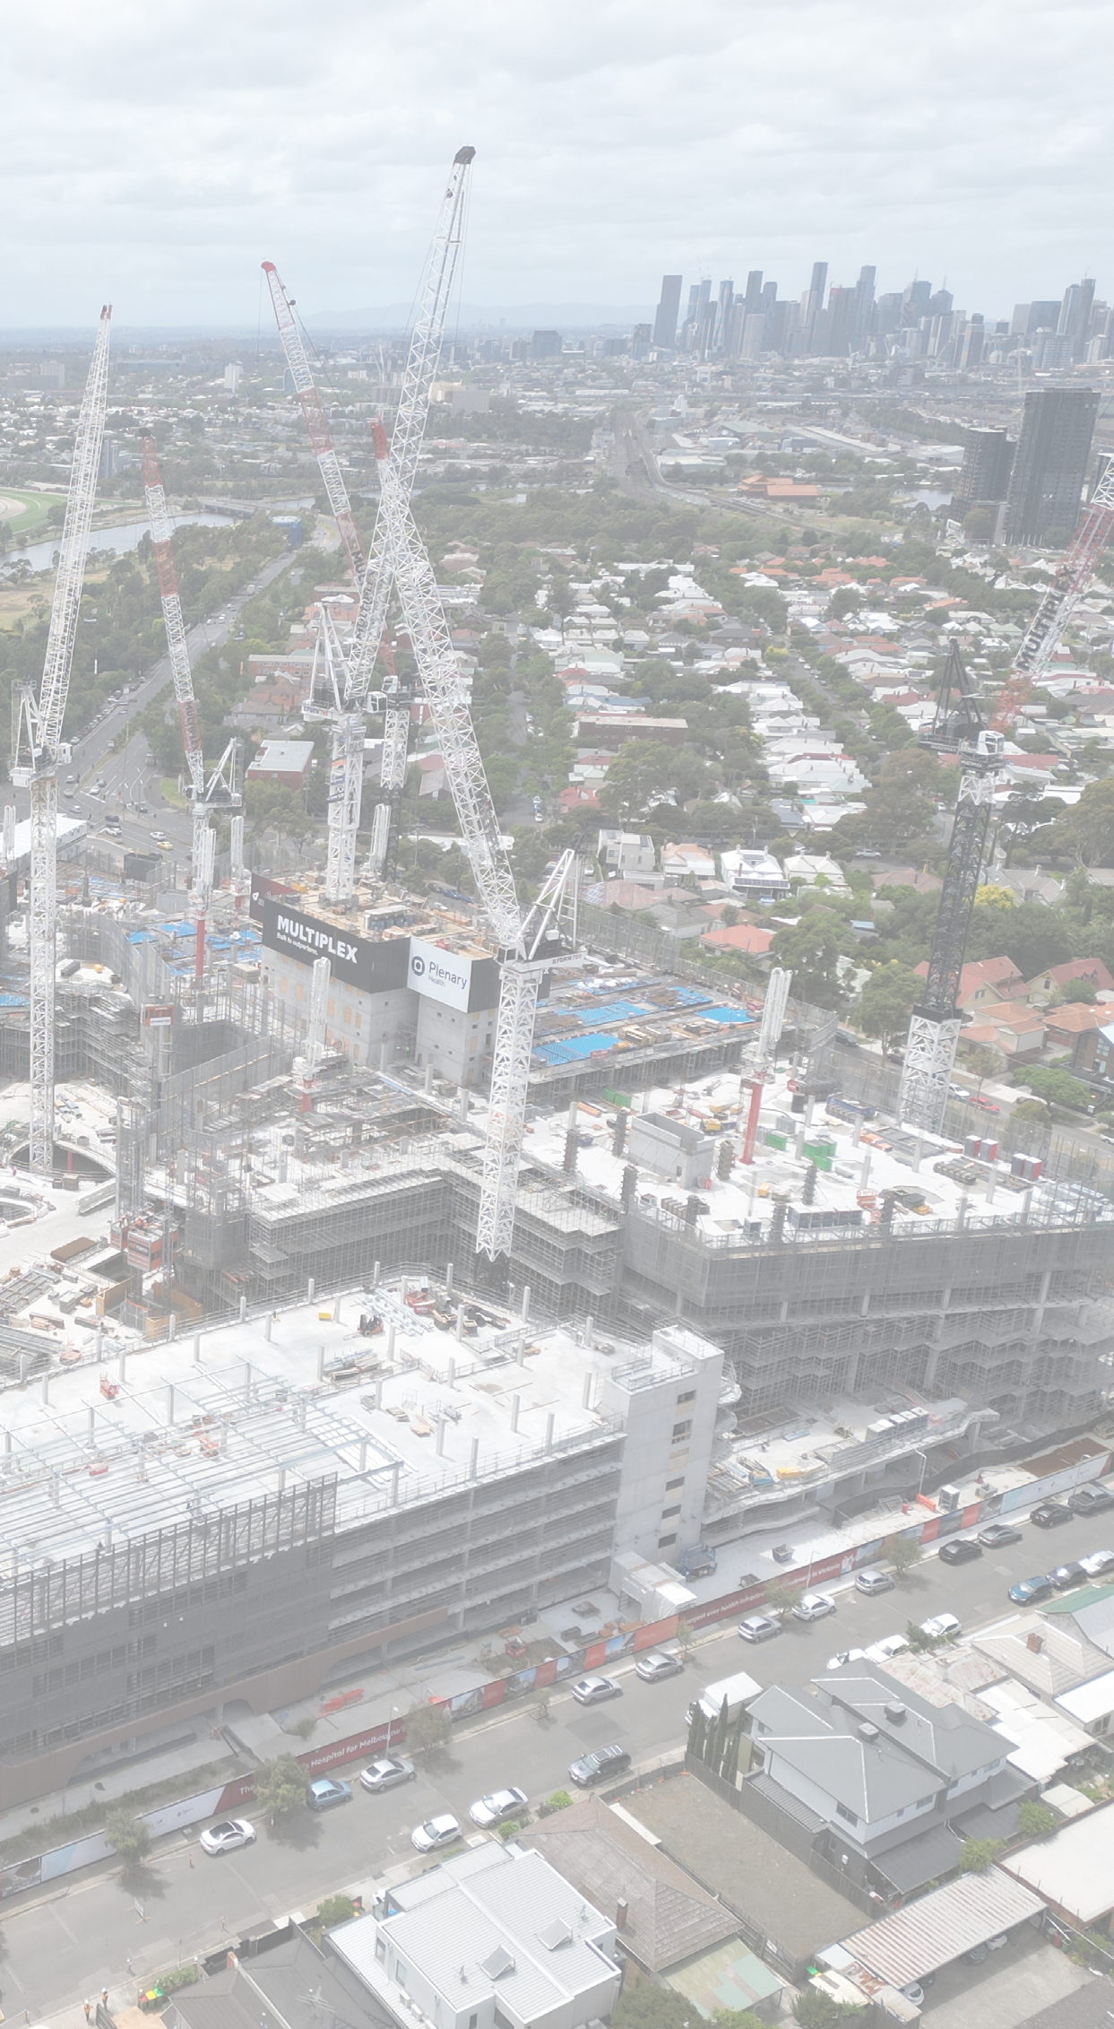

Whole of Life procurement
Models of this type can drive innovation. They improve efficiency and enhance value through a greater focus on long-term service delivery.
In the framework, the Whole of Life procurement models have two streams:
- The Partnerships Victoria model includes precinct, community and economic partnerships
- The Bundled model includes whole of life activities procured as a
package without project finance.
Partnerships Victoria remains key to the suite of infrastructure procurement models available for project delivery. The Partnerships Victoria model combines recent market innovations with established practices. It captures emerging opportunities to secure benefits for the community and value for the Government.
The Partnerships Victoria model provides significant benefits when used for appropriate projects. For example, precinct partnerships have
enabled the Government to regenerate aging public housing sites with the support of private investment. Finding a way to enhance this procurement model has created a tangible uplift in social and affordable housing.

Community partnerships

Economic partnerships
suit economic infrastructure projects, including transport and utilities. They leverage potential revenue and user payments to help fund these critical assets.

Precinct partnerships
suit housing or other precinct developments. They use state investment to attract complementary private investment, delivering broader precinct development and public benefits.
suit projects that provide essential social infrastructure, including hospitals, schools and justice facilities. The private consortium delivers and manages the infrastructure, allowing practitioners to
focus on providing the key services for the community.

Cost Reimbursable procurement
The Cost Reimbursable procurement
category includes three models:
- Incentivised Target Cost (ITC)
- Managing Contractor
- Alliance.
Previously referred to as ‘collaborative’ procurement, these models provide flexibility in managing uncertain project circumstances, including design and risks.
Cost reimbursable models recognise certain risks cannot be effectively allocated to the private sector using a fixed price.

Lump Sum procurement
The Lump Sum procurement category includes three models:
- Construct Only
- Design and Construct (D&C)
- Enhanced Design and Construct (EDC).
These Lump Sum procurement models are fixed price contracts. They suit projects where agencies can clearly articulate the scope and where
there are relatively few project uncertainties.
The new EDC model provides a modernised approach to lump sum contracting where previously this type
of procurement would have been deemed unsuitable. Targeted risk sharing elements can respond to specific risks and challenges, such as contamination.

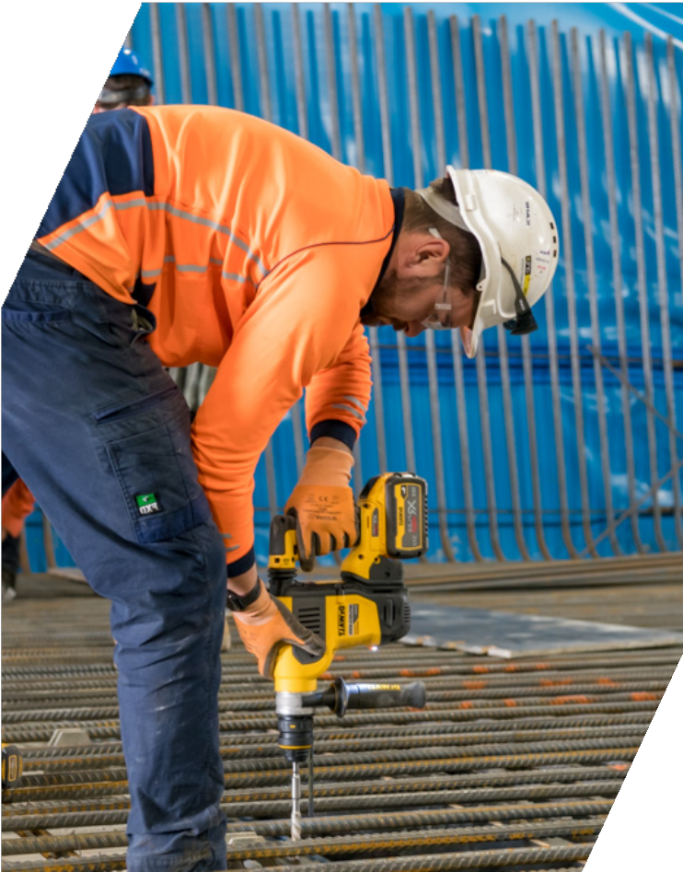

New policies and guidance notes to support the framework
The updated Procurement – Investment Lifecycle High Value High Risk (HVHR) Guideline outlines the process and relevant context for infrastructure procurement.
It provides guidance on how to select the optimal procurement method and packaging approach when preparing a business case. It also provides an overview of how to conduct effective procurement, from tender development to contract negotiation and award.

The three new categories of procurement (Whole of Life, Lump Sum and Cost Reimbursable) are also enabled with:
- a procurement requirements document that outlines the mandatory government approval requirements and best practice expectations for high value, high risk projects
- a standard form contract and accompanying
guidance for each procurement model.
DTF has released a suite of documents to support the new framework. These are available at the links below:
- Procurement – Investment Lifecycle High Value High Risk (HVHR) Guideline
- Cost Reimbursable Procurement Requirements
- ITC standard deed and supporting guidance
- EDC standard deed and supporting guidance
- a suite of harmonised project documents for
Partnerships Victoria projects.
Separately, DTF is developing a suite of standard form contracts for small to medium scale projects delivered through lump sum models. DTF will continue to develop documents across the set of procurement models.
For more information about the infrastructure procurement framework visit Procurement – Investment Lifecycle High Value High Risk Guidelines or contact the Department of Treasury and Finance by email at: infrastructure.delivery@dtf.vic.gov.au.

The Secretary
Department of Treasury and Finance
1 Treasury Place
Melbourne Victoria 3002
Australia
Telephone: +61 3 9651 5111 dtf.vic.gov.au

Authorised by the Victorian Government 1 Treasury Place, Melbourne, 3002
© State of Victoria 2023
You are free to re-use this work under a Creative Commons Attribution 4.0 licence, provided you credit the State of Victoria (Department of Treasury and Finance) as author, indicate if changes were made and comply with the other licence terms. The licence does not apply to any branding, including Government logos. Copyright queries may be directed to IPpolicy@dtf.vic.gov.au
ISBN 978-1-925551-96-9 (pdf/online/MS word) Published September 2023
If you would like to receive this publication in an accessible format, please email information@dtf.vic.gov.au. This document is also available in Word and PDF format at dtf.vic.gov.au

