Gateway Review Process
Gate 3 – Readiness for market workbook

The Secretary
Department of Treasury and Finance
1 Treasury Place
Melbourne Victoria 3002
Australia
Telephone: +61 3 9651 5111
dtf.vic.gov.au

Authorised by the Victorian Government
1 Treasury Place, Melbourne, 3002

© State of Victoria 2019
Copyright queries may be directed to IPpolicy@dtf.vic.gov.au

ISBN 978-1-925551-39-6
Published October 2019

If you would like to receive this publication in an accessible format please email information@dtf.vic.gov.au

This document is also available in Word and PDF format at dtf.vic.gov.au

Contents
The Gateway Review Process 1
About this workbook 1
Readiness for market 1
Project Development and Due Diligence 2
Gateway Review 3: Readiness for market 5
Project documents 6
1. Assessment of procurement approach 7
2. Business case and stakeholders 10
3. Project Development and Due Diligence 11
4. Risk management 13
5. Review of current phase 14
6. Readiness for next phase: tender decision 14
Appendix A: Best practice sources 16

The Gateway Review Process
The Gateway Review Process examines programs and projects at key decision points. It aims to provide timely advice to the Senior Responsible Owner (SRO) as the person or people responsible for overseeing the delivery of the project and transitioning it into operation. A review provides the SRO with an independent view on the current progress of the program or project and assurance that it can proceed successfully to the next stage.
Given the aim is to help the SRO at key decision points, each review is short and focused on the work that is complete at the time. For the best result, a review is carried out shortly before a decision is made to allow sufficient time for any recommendations to be implemented.

About this workbook
This workbook supports Gateway Review 3: Readiness for Market. This review investigates assumptions in the business case and procurement strategy proposed for the project. The procurement documentation will include details of the sourcing options, proposed procurement route and supporting information. The review also checks implementation plans are in place.
This workbook describes the main products and provides appraisal questions and sources of further information, including best practices for review teams. It offers key questions to explore and potential evidence to look for. Because each policy, program or project is unique and circumstances change, the workbook should be used as a guide to the range of appropriate questions and evidence, and not as a full checklist of mandatory items.

Readiness for market
Following Gateway Review 2: Business Case, the decision-making body will have determined the project is feasible and there is a robust business case. This next phase defines the procurement approach; focusing on establishing a clear definition of the project and a plan for its implementation. Any outstanding assumptions from the business case for the project should now be verified.
The review assesses the level of understanding of the supplier market and the approach for achieving the project’s objectives. If appropriate, the review will assess whether the project is ready to invite proposals or tenders from the market. This review assures the project board the selected procurement approach is appropriate for the proposed business change, whether it involves the acquisition of goods or services, effects organisational change, policy implementation or a rollout of services to the public or another development.
Note that where a project alliancing arrangement is in place, procurement regulations may still apply, along with market benchmarking, value-for-money assessments and potential contract changes. The Gateway Review 3 appraisal must still be undertaken. The project team and review team must be satisfied that due consideration has been given to all the factors, including choices about proposed commercial arrangements with the existing supplier that offer value-for-money.
A project will normally go through a single Gateway Review 3 to validate the proposed procurement approach before any commitments are made to prospective suppliers or procurement partners regarding the acquisition process. However, large procurement projects taking many months may need to go through more than one Gateway Review 3.

Project Development and Due Diligence
One important element to consider when assessing procurement documentation is whether an appropriate level of Project Development and Due Dilligence (PDDD) has occured.
The successful execution and performance of a project depends on the quality of its Project Development and Due Diligence (PDDD). PDDD refers to the specific technical and planning analysis that may be conducted for a project at each stage of the GRP. It helps identify key risks and issues including technical, contextual and environmental matters and enables the risks to be better estimated. The level of PDDD analysis may be scaled according to the risk profile and value of the proposal in accordance with the PDDD Guidelines.
The review team should assess the extent and adequacy of due diligence conducted by evaluating documents and evidence that describe to what extent PDDD activities have been completed and to what extent their findings have been translated into identifiable or quantifiable project risks. For this element of the assessment, the review team should not be concerned with the PDDD findings as much as whether it has been conducted and quantified into risks. Where relevant, measures to address gaps in the extent of due diligence conducted could be detailed in the Recommendation Action Plan.
This workbook includes some areas for reviewers to probe to establish the level of PDDD analysis that has been undertaken and evaluate its appropriateness.
NB: The terms ‘supplier’, ‘bid’, ‘tender’, ‘contract’ etc. in the following sections should be interpreted in the context of the nature of the procurement solution and the likely commercial relationship between the client organisation and the procurement partner organisation.

Figure 1: Overview of the Gateway Review Process
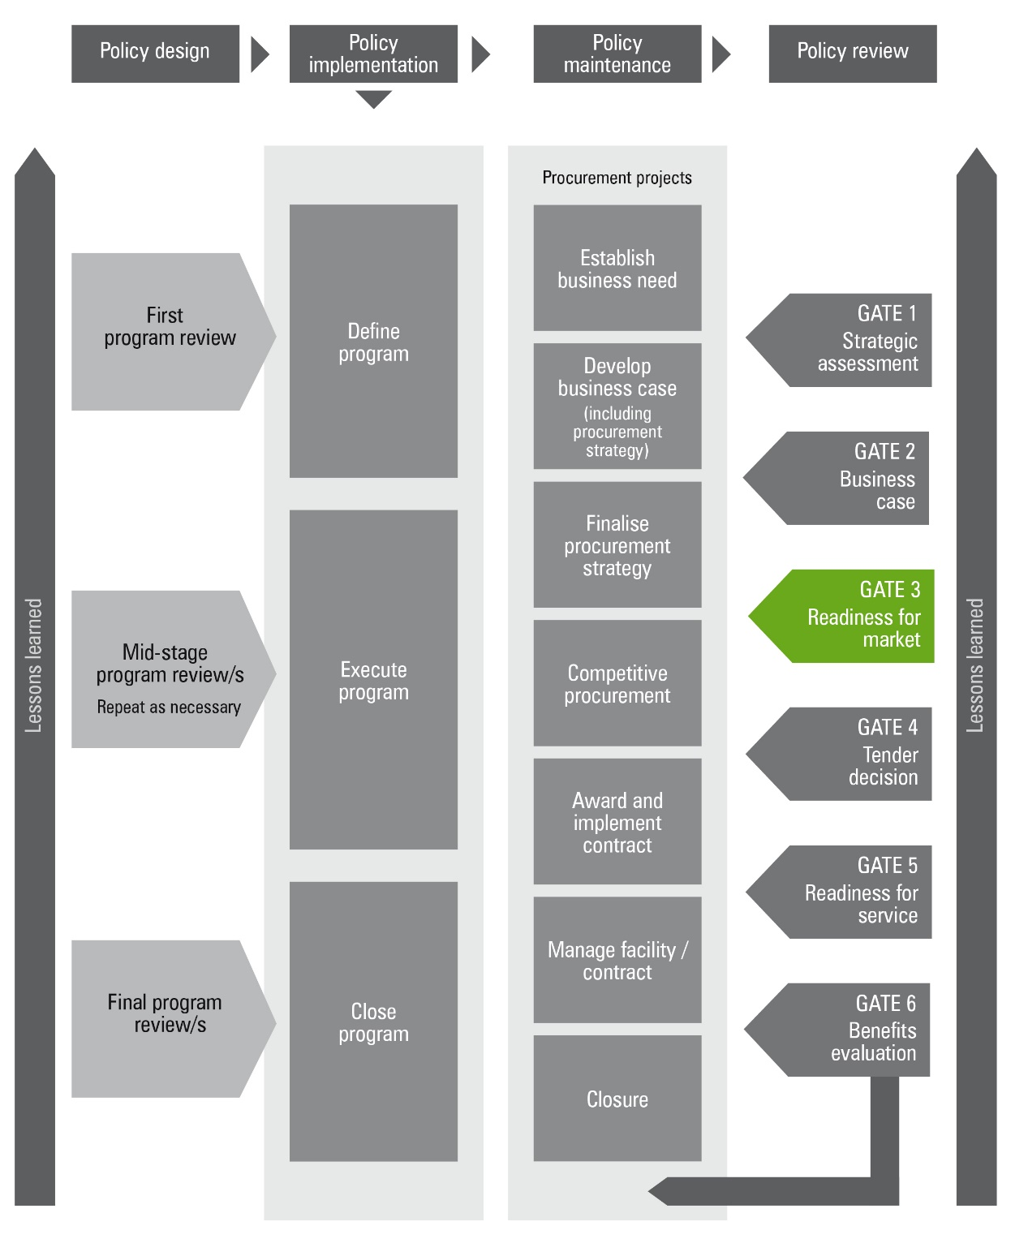
** This Figure assumes a two-stage budget process. If Government elects for a one stage budget process, then Gate 1 and 2 reviews are usually combined into one review.
Figure 2: Applying the Gateway Review Process to different project delivery methods
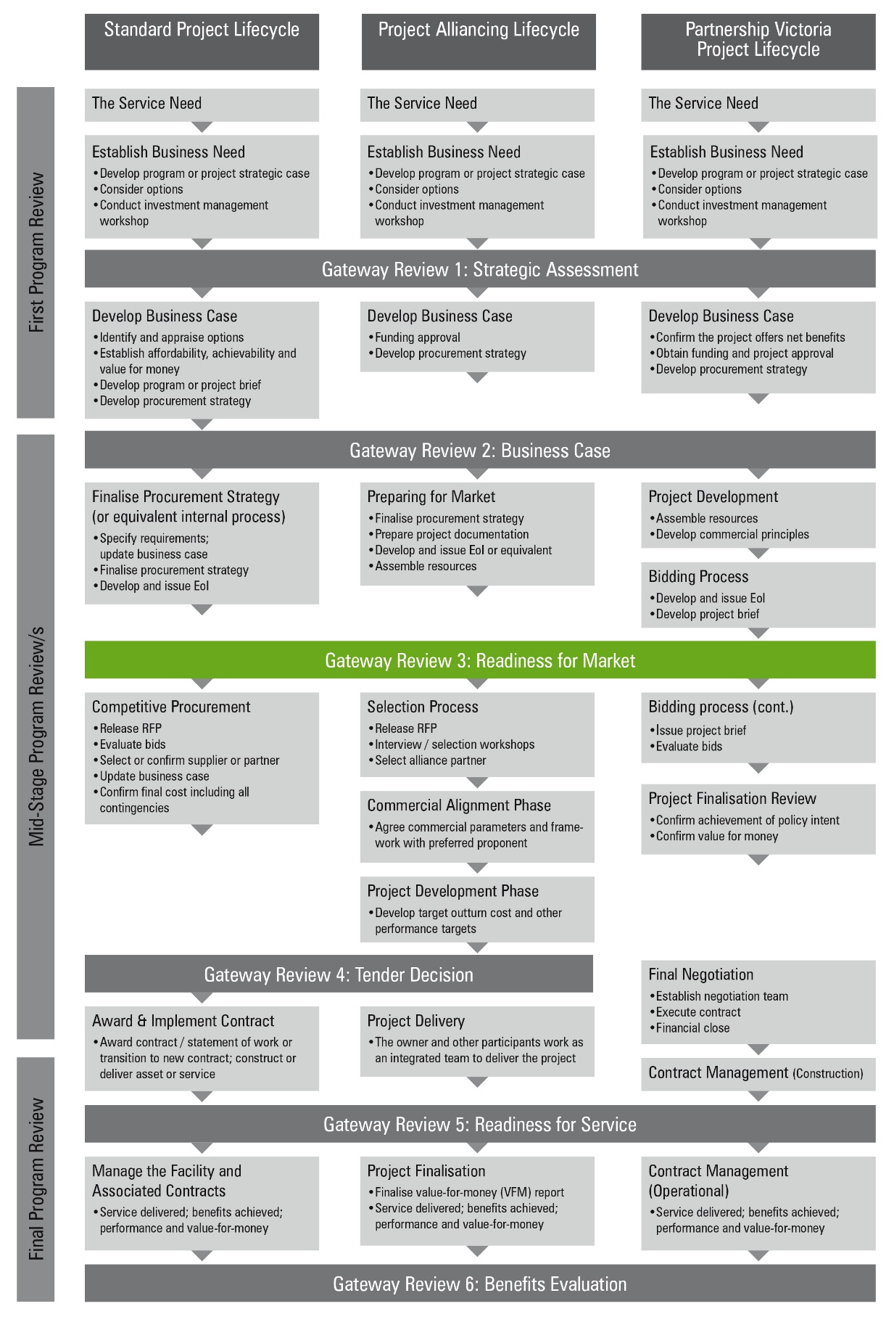

Gateway Review 3: Readiness for market
The purpose of the review is to:
- confirm the business case, and change control register, when the project is fully defined;
- confirm the objectives and desired outputs of the project remain aligned with the program to which it contributes;
- ensure the procurement approach is robust, appropriate and has obtained the necessary sign-off;
- ensure the project’s plan is appropriately detailed and realistic including the contract management strategy;
- ensure the project controls and organisation are defined, financial controls are in place and resources are available;
- confirm funding availability for the whole project;
- confirm the development and delivery approach and mechanisms remain appropriate and manageable;
- check the supplier market capability and track record for existing supplier’s capability and performance, is fully understood;
- confirm the procurement or acquisition approach will underpin good client-supplier relationships;
- confirm appropriate project performance measures and tools are being used;
- establish the level of PDDD analysis that has been undertaken and evaluate its appropriateness;
- confirm there are plans for risk management, business and technical issue management and these plans will be shared with suppliers and/or procurement partners;
- confirm quality procedures have been applied consistently since the previous review;
- confirm internal organisational resources and capabilities will be available, as required, for future phases of the project;
- confirm the stakeholders support the project and are committed to its success;
- for a procurement project, confirm there is an appropriate procurement plan in place to ensure compliance with legal requirements and all applicable Victorian Government Purchasing Board rules; while meeting the project’s objectives and keeping procurement timescales to a minimum;
- for IT-enabled projects, confirm compliance with IT and information security requirements and standards; and
- for construction projects, confirm compliance with health and safety, and sustainability requirements.

Project documents
The investigation areas and examples of evidence should be available before the review starts. The required information is likely to be found in the documents suggested below, but may be located in other program or project documents, or elsewhere in the organisation’s documentation system:
- a business case, change control register and initial plan for realising benefits;
- the project’s costs to-date set against budget and based on approval against business case;
- a financial impact report, which provides a snapshot of the financial performance of projects, including spend to date, cost to complete, and contingency and risk draw-down.
- a plan for managing the business change;
- specification of expected outputs and outcomes;
- the procurement and/or acquisition approach and documented justification for the approach;
- tender documentation including specifications, a draft contract based on a suitable standard contract model, conditions of tender and format of tender response;
- the evaluation strategy and model to be used for evaluating proposals;
- the proposed implementation strategy for the new service and/or works contract;
- project development and due diligence analysis;
- an updated risk register, issue log and risk management plans including an assessment of the financial implications for risk transfer;
- current and planned business and/or technical policies, strategies and constraints such as health and safety standards or information assurance requirements such as security schedules;
- an outline of project plans to completion and detailed plans for the next phase;
- the results of any business, commercial or technical benchmarking;
- updated market intelligence and supplier assessment for procurement projects;
- an updated communications strategy and plan;
- project quality documentation; and
- a strategy for measuring project performance, including health and safety in construction projects.

    - Assessment of procurement approach
Areas to probe | Potential evidence
1.1 Have options for the proposed procurement been evaluated, including sources of supply? | - an examination and assessment of options including the use of internal resources;  - all appropriate sourcing options have been examined such as the use of internal resources, single or multiple suppliers, opportunities for collaboration, shared services, use of existing frameworks, etc.  - for construction projects, evidence integrated procurement routes, including Partnerships Victoria (PV), project alliancing and design and construct have been fully evaluated; and  - for IT-enabled projects, the decision to contract for an output or for constituent building blocks or activities is sound;  - where PV is the proposed option, confirmation it is appropriate;  - commercial intelligence on market capability supports the comparison with similar projects and analysis; and  - reasons for selecting sourcing options are documented and justified.
1.2 Does the client clearly understand the business objectives and are the suppliers likely to understand them? | - a detailed output and/or outcome-based definition of requirements;  - specification to include key success factors to show how achievement of outputs and/or outcomes will be assessed; and  - appropriate quality criteria applied to information for the delivery organisation, either internal or external.
1.3 Are the project’s outputs and/or outcomes accurately reflected in the requirement specification? | - depending on the nature of the procurement, stakeholders have reviewed and endorsed an appropriate form of requirement specification; and  - an appropriate mechanism to articulate the requirement to potential suppliers.
1.4 Will the project be attractive to the market? | - detailed market soundings, including an examination of recent similar procurements by others or a commentary on the market’s capacity and the nature of the project’s likely suppliers;  - initial assessment of likely suppliers;  - an assessment of the market’s capacity to deliver;  - an assessment of the competitive interest in the requirement;  - an assessment of the market’s capacity to deliver;  - an assessment of the competitive interest in the requirement;  - if appropriate, an assurance the organisation has adequate expertise and capacity to undertake internal procurement of the requirement; and  - analysis of potential variations or innovations.
1.5 Has the proposed procurement procedure been evaluated? | - An open, restricted, negotiated or competitive dialogue procedure has been identified;  - reasons for following this procedure are understood, related risks have been identified and evaluated such as the impact on timescales and bid costs for suppliers and decisions are justified and documented;  - if appropriate, an electronic reverse auction has been considered and the risks and benefits evaluated; and  - legal advice has been sought on any procurement approach.
1.6 Is the selected procurement approach defined and endorsed? | - Procurement strategy is appropriate and based on market analysis outcomes;  - the procurement approach has been clearly defined, showing reasons for selection and agreement with stakeholders;  - there is evidence government initiatives have been taken into account;  - there is evidence business continuity and future exit, handover and transition strategies have been considered at a high level;  - the appropriate people have confirmed the development, involvement and endorsement of the procurement approach; and  - the strategy includes, as appropriate:  - a description of the key objectives, constraints such as timescale, the funding mechanism and risk allocation;  - the procurement route or how the approach will be achieved, sourcing options and a contract strategy;  - the procurement procedure e.g. competitive dialogue or negotiated;  - a time plan with a timetable detailing the relevant procurement rules and the time needed for pre-procurement activities, implementation and contingency in the event of unavoidable slippage;  - an assessment of the marketplace and potential suppliers;  - the roles, resources and skills needed to manage the procurement approach; and  - alignment with plans for implementation.
1.7 Have factors that may impact on the procurement strategy been addressed? | - factors influencing the procurement approach have been considered including findings and analysis from due diligence activities; and  - the efficiency and predictability of the procurement process has been considered, with a process in place for addressing the impact of any deviation from the plan and timetable and plans for two-way communication with stakeholders and suppliers.
1.8 Will the procurement approach allow communication and cooperation between all parties and other related programs and projects? | - a communication strategy and support mechanisms are in place;  - the procurement approach to include:  - early involvement of suppliers to ensure the design is fully informed by the delivery process; and  - clearly defined performance criteria and a system for measuring performance.
1.9 Is there adequate knowledge of existing and potential suppliers? Who are the suppliers most likely to succeed? | - knowledge of existing and potential suppliers;  - commercial market intelligence, market sources and potential suppliers;  - public and private sector track records have been considered e.g. the public sector’s ability as a customer to work in this way and the private sector’s record in meeting a similar or equivalent business need; and  - indications of the types of suppliers most likely to succeed.
1.10 Has a contract management strategy been developed? | - The contract management strategy includes consideration of departmental capability to manage the contract;  - the contract management strategy takes account of factors such as the proposed relationship and the management of single or multiple suppliers; and  - evidence of the continuity of key project personnel.
1.11 Has the project team complied with the relevant procurement policies and guidelines in preparing the tender documents? | - tender documents have been reviewed, shown to be complete and contain an accurate description. For construction projects, documents include a requirement for suppliers to provide occupational health and safety information, and specification includes government sustainability commitments;  - implications of the requirement have been thoroughly considered such as ensuring the public take-up new services with contingency plans for phasing out current service provision;  - the scope of tender documents is broad enough to allow for appropriate flexibility, now and in the future; and  - the tender documents are produced in accordance with relevant procurement policies and guidelines and the project team reviews and/or accepts them.
1.12 Do the stakeholders accept the evaluation strategy, including how to demonstrate value-for-money, and is it compliant with relevant procurement policies and guidelines? | - an evaluation plan has been developed that includes evaluation criteria and rationale for evaluation weightings;  - stakeholders have approved the evaluation criteria and model(s);  - the evaluation criteria have been linked to business objectives and given appropriate weighting;  - the financial and non-financial aspects of the evaluation have been separated;  - the evaluation criteria has been included in information to potential tenderers;  - the evaluation includes benchmarking the value-for-money offered by partnering, internal supplier or framework and/or call-off arrangements, where appropriate;  - consideration of contract duration, in relation to value-for-money and whole-of-life costs;  - whether to act on behalf of other public sector organisations in the role of a central purchasing body has been considered; and  - for construction projects, appropriate weight has been given to health and safety, sustainability and design quality.

    - Business case and stakeholders
Areas to probe | Potential evidence
2.1 Does the business case continue to demonstrate a business need and contribute to the organisation’s business strategy? | - ongoing confirmation the project will meet a business need, including confirmation priorities remain unchanged where any external factors might have an effect; and  - confirm the objectives and desired outputs of the project are still aligned with the program to which it contributes.
2.2 Is the preferred way forward still appropriate? | - an assessment based on indicative assumptions about factors such as interdependencies with other programs and projects, reliance on partners to deliver, availability of internal resources, etc, confirms the way forward; and  - mitigation strategies for PDDD findings and analysis that could affect any aspect of the approved business case.
2.3 Is the proposed commercial arrangement likely to achieve whole-of-life value-for-money? | - stakeholders have agreed on the basis for calculating costs or value of requirements and comparison of procurement approaches such as tenders;  - the change control register has been updated on the basis of the full project definition, market assessment and initial benefits plan;  - the procurement approach is reflected in the business case;  - an examination of the sensitivities and financial implications of handling major risks plus an assessment of their effect on the project’s return; and  - projects not designed to achieve a financial return should include comparisons with similar successful projects to assess their potential to achieve value-for-money and to set targets.
2.4 Are the costs within current budgets? Is the project’s whole-of-life funding affordable and do the stakeholders support it? | - reconciliation of projected whole-of-life costs, including costs arising from the PDDD finding, with the available budget;  - stakeholders have reviewed and accepted or approved the project budget; and  - project costs are within the organisation’s forecast spending plans.
2.5 Is the organisation still realistic about its ability to achieve a successful outcome? | - a comparison with similar projects and similar organisations, an assessment of past record in achieving successful change, plans to manage known weaknesses, where applicable, plans for incremental and/or modular approaches and contingency plans are in place; and  - if the project crosses organisational boundaries, there are clear governance arrangements to ensure alignment with the business objectives of all organisations involved.
2.6 Is there a clear definition of the total project scope? | - the updated document shows total project scope including business change, where applicable. See Gateway Review 2: Business Case.
2.7 Are the risks and issues relating to business change understood? Is there an initial plan to address these issues? | - risks and issues relating to business change are logged, with a management plan for each; and  - account taken of relevant impact assessment and appraisal issues such as the environmental impact and sustainability.
2.8 Do stakeholders support the project and is the organisation fully committed? | - documented involvement of, and endorsement by, stakeholders.
2.9 Do stakeholders understand and agree with the project’s benefits? Is there a plan for realising and evaluating the benefits? | - the benefits are clearly stated;  - an initial plan for realising and evaluating procurement benefits, showing costs offset by e.g. improved quality of service and/or savings over the project’s expected life; and  - critical success factors for the project are still valid and agreed with stakeholders.
2.10 Is the procurement strategy consistent with the approved business case? | - consistency of the procurement strategy within the business case.

    - Project Development and Due Diligence
Areas to probe | Potential evidence
3.1 Is there a transaction management plan or equivalent prepared? | - transaction management plan or equivalent.
3.2 Have project specific conditions and modifications (if required) been identified? | - documentation of specific conditions and modifications and how they have been mapped into scope statement.
3.3 Are governance approvals in place to manage the evaluation? | - stakeholder engagement matrix identifying relevant governance bodies and approval pathways.  - approval from relevant governance bodies.
3.4 Are the requirements spelt out clearly and in line with the recommended single option? | - preliminary requirements document updated into final requirements document that also defines any new information and impacts to existing requirements.  - mapping of requirements into single option scope statement.
3.5 Have all system requirements been identified? | - documentation of system requirements and how they have been mapped into single option scope statement.
3.6 Is all the necessary information available to commence the reference design? | - Consideration of all completed design work, business case, risk assessment, specifications and PDDD findings and analysis.
3.7 Has a standard baseline been established? Is there a list of waivers identified? | - High-level schedule with critical path has been developed into further detail based on business case, PDDD findings, operator requirements, planning approvals, etc. and baseline defined.  - list of waivers.
3.8 Have final functional requirements been identified and agreed with key stakeholders? | - details of engagement efforts with key stakeholders to understand functional requirements.  - documentation of functional requirements and how they have been mapped into scope statement.  - key stakeholders agree that scope statement adequately addresses functional requirements.
3.9 Have final operational requirements been identified and agreed with operators? | - details of engagement efforts with operator to understand and agree requirements.  - documentation of operator requirements and how they have been mapped into scope statement and schedule.  - operator agrees that scope statement adequately addresses requirements.  - risk analysis for any operator requirements that are not being considered, including consequences for both operator and the project.
3.10 Have interfaces and interdependencies with the location and other projects been identified? | - project interdependencies are mapped in schedule.  - interface management plan and action register developed.
3.11 Have the client and operator been consulted while reference design progresses? | - details of client and operator engagement during reference design.  - document management system developed for management of comments and revisions.
3.12 Have Building Information Modelling (BIM) requirements been taken into consideration? | - BIM target maturity level defined for the project and BIM strategy defined.  - BIM requirements defined in information management plan.  - BIM system / platform evaluation and determination of key roles undertaken.  - required BIM data sets defined for the project and mapped into contract requirements.
3.13 Does the project fit into the local urban design framework? How and who needs to approve? | - further development of urban requirements including planning and approvals.  - details of engagement with relevant authorities to examine integration of project with urban design framework.
3.14 Have all necessary approvals been obtained prior to contract award? | - stakeholder engagement matrix identifying relevant governance bodies and approval pathways.  - approval from relevant governance bodies.
3.15 Have all processes related to land acquisition been completed? | - land acquisition requirements assessment.  - completed register of required land acquisition.
3.16 How does the project fit into the legislative framework? Has a legal review been obtained on the tender conditions? | - Assessment of legislative requirements and definition of potential risks and constraints that will require special focus or exemption.  - Risk register updated with potential legislative risks.

    - Risk management
Areas to probe | Evidence expected
4.1 Are the major risks and issues identified, understood, financially evaluated and allocated in determining the procurement strategy? | - major issues and risks are logged and are up-to-date including strategic, political, commercial and legislative. In addition:  - interdependencies have been identified with other projects within this program, and with other internal and external programs;  - for construction projects, health and safety risks for the whole-of-life of the project have been identified; and  - for IT-enabled projects, risks relating to IT and information security and take-up have been identified.  - each risk has been assessed financially and included in the business case either as a sensitivity or a separate risk allocation;  - documented assessment of all technical risks, such as ‘buildability’ and risks associated with innovation; and  - have sufficient information gathering PDDD activities been completed?
4.2 Are there risk management plans in place? | - a project risk management strategy is in place, developed in line with best practice;  - stakeholders have approved the clearly identified and allocated responsibilities for managing each risk;  - a risk reporting process is in place for upward referral of risks;  - contingency and/or business continuity plans developed; and  - have mitigation options that make use of PDDD activities been considered?
4.3 Have all the issues raised in previous reviews been satisfactorily resolved? | - the project team regularly reviews the issue and risk logs, and there is evidence of appropriate action.
4.4 Are the external issues being addressed? These include the statutory process, communications, public relations and environmental issues? | - there is a list of external issues and related stakeholders plus plans for contact with each; and  - an external relations plan has been developed and implemented as part of the communications strategy.

    - Review of current phase
Areas to probe | Evidence expected
5.1 Is the project under control? | - the project is on schedule and costs are within budget, as shown in project budget and timetable reports.
5.2 What caused any deviations such as over or under-runs? | - reconciliations set against budget and time plan and in accordance with risk allowances; and  - do additional or new PDDD activities need to be undertaken before going to market?
5.3 What actions are necessary to prevent deviations recurring in other phases? | - analysis and plans are included in project management documentation that is continually reviewed and updated; and  - what lessons were learned from the PDDD activities, which ones were not closed out fully?
5.4 Were there any assumptions made at Gateway Review 2 and earlier reviews that have not been verified? | - a log of outstanding assumptions and plans to verify them; and  - assumptions classed and managed as issues where applicable.

    - Readiness for next phase: tender decision
Areas to probe | Evidence expected
6.1 Is the project plan for the remaining phases realistic? | - clear objectives, deliverables and milestones for the next stage have been defined and signed off by stakeholders; and  - recommendations from the last Gateway Review have been acted upon.
6.2 Are the project’s timelines reasonable and compliant with relevant procurement policies and guidelines? | - timelines are likely to meet business and legislative needs and have been verified with internal stakeholders and suppliers;  - comparisons made with similar projects;  - where appropriate, there is a written record of compliance with relevant procurement policies in relation to all procurement project decisions taken; and  - an analysis of any slippage affecting the project such as procurement and bid costs, with supporting sensitivity analysis.
6.3 What are the arrangements for the next stage of the project? Have its activities been defined and resourced? | - the plan shows roles, responsibilities, training requirements, internal and external resources, skills requirements and any available project management mentoring resources;  - there is involvement from a business, user and technical perspective;  - there is a suitable plan for the selected procurement approach identifying all major review and decision points, including any preliminary reviews; and  - an appropriate standard form of contract has been identified as the baseline for later custom drafting.
6.4 Does the project have the appropriate resources, skills and experience required? | - requisite skills are available in the project team and there is access to external expertise as appropriate;  - project relationships such as team-working and partnering have been considered, with a plan to implement them where appropriate;  - an internal and external commitment to provide the required resources;  - job descriptions for key project staff;  - a skills audit has been undertaken and plans made for addressing any shortfall; and  - contract management staff have been identified to join the procurement team at an early stage to familiarise themselves with the procurement’s intent and processes.
6.5 Has an appropriate level of PDDD analysis been undertaken for the next phase? | - PDDD analysis and findings.

Appendix A: Best practice sources
Source | Information
Investment management standard  See Investment management  www.dtf.vic.gov.au/infrastructure-investment/investment-management-standard | - investment management standards  - investment logic maps  - investment concept briefs  - benefit management plans
Investment lifecycle guidance  See lifecycle guidance  www.dtf.vic.gov.au/infrastructure-investment/investment-lifecycle-and-high-value-high-risk-guidelines  See PDDD guidance  https://www.dtf.vic.gov.au/investment-lifecycle-and-high-value-high-risk-guidelines/stage-1-business-case | - business case development guidelines, including strategic assessment guidance  - procurement strategy guidelines  - project tendering guidelines  - risk management guidelines  - Project Development and Due Diligence guidelines
Procurement advice, policy and guidelines  Victorian Government Purchasing Board  www.procurement.vic.gov.au | - longer term contract management  - contract variations
www.infrastructure.gov.au/infrastructure/ngpd | - National guidelines for Infrastructure Projects
www.dtf.vic.gov.au/infrastructure-investment/public-private-partnerships | - Social Procurement Framework
www.dtf.vic.gov.au/public-construction-policy-and-resources/ministerial-directions-and-instructions-public-construction-procurement | - Ministerial Directions and instructions for Public Construction Procurement
www.dtf.vic.gov.au/infrastructure-investment/market-led-proposals | - Market-led proposals guideline
www.dtf.vic.gov.au/public-construction-policy-and-resources/ministerial-directions-and-instructions-public-construction-procurement | - Local Jobs First resources
PPP projects  For the National PPP policy and guidelines, see:  www.infrastructureaustralia.gov.au  Specific Partnerships Victoria requirements apply, see:  www.dtf.vic.gov.au/infrastructure-investment/public-private-partnerships | - contract management policy and guidance material
Project alliancing  See Project alliancing at www.dtf.vic.gov.au | - Project Alliancing Practitioners Guide
Capital development guidelines  Department of Human Services  providers.dhhs.vic.gov.au/capital-development-guidelines-series-7 | - contract administration  - commissioning of facilities  - managing contract occupational health and safety
Asset lifecycle  Department of Education and Early Childhood Development  www.education.vic.gov.au | - operations and maintenance
Victorian Government asset management series  Department of Treasury and Finance  www.dtf.vic.gov.au/infrastructure-investment/asset-management-accountability-framework | - further information about commissioning assets  - other general information
Gateway Review Process  www.dtf.vic.gov.au/infrastructure-investment/gateway-review-process | - Gateway Guidance material  - Becoming a Gateway reviewer

