Gateway Review Process
Gate 6 – Benefits realisation workbook

The Secretary
Department of Treasury and Finance
1 Treasury Place
Melbourne Victoria 3002
Australia
Telephone: +61 3 9651 5111
dtf.vic.gov.au

Authorised by the Victorian Government
1 Treasury Place, Melbourne, 3002

© State of Victoria 2019
Copyright queries may be directed to IPpolicy@dtf.vic.gov.au

ISBN 978-1-925551-33-4
Published October 2019

If you would like to receive this publication in an accessible format please email information@dtf.vic.gov.au

This document is also available in Word and PDF format at dtf.vic.gov.au

Contents
The Gateway Review Process 1
About this workbook 1
Benefits realisation 1
Reporting Gate 6 Findings 2
Gateway Review 6: Benefits realisation 5
Project documents 5
1. Review of operating phase 7
2. Business case and benefits management 9
3. Plans for ongoing improvements in value-for-money 10
4. Plans for ongoing improvements in performance and innovation 11
5. Review of organisational learning and maturity targets 13
6. Readiness for the Future: Plans for future service provision 14
Appendix A: Best practice sources 16

The Gateway Review Process
The Gateway Review Process examines programs and projects at key decision points. It aims to provide timely advice to the Senior Responsible Owner (SRO) as the person or people responsible for overseeing the delivery of the project and transitioning it into operation. A review provides the SRO with an independent view on the current progress of the program or project and assurance that it can proceed successfully to the next stage.
Given the aim is to help the SRO at key decision points, each review is short and focused on the work that is complete at the time. For the best result, a review is carried out shortly before a decision is made to allow sufficient time for any recommendations to be implemented.

About this workbook
This workbook supports Gateway Review 6: Benefits realisation. This review confirms benefits set out in the business case are being achieved and the operational service or facility is running smoothly. The review may be repeated throughout the life of the service with the first review typically 6-12 months after handover to the new owner and a final review shortly before a service contract ends. However, the review is usually used on a one-off basis, to check a project has delivered its intended outputs and benefits.
This workbook provides appraisal questions and sources of further information, including best practices for review teams. It offers key questions to explore and evidence to look for. Because each policy, program or project is unique and circumstances change, the workbook should be used as a guide to the range of appropriate questions and evidence, and not as a full checklist of mandatory items.
This workbook should be read in conjunction with the Gate 6 technical supplement which provides more detail on the evaluation process that could be expected following the delivery of an infrastructure project to inform a Gate 6 review.

Benefits realisation
Gateway Review 6 is for the operational phase of a project, after the agreed outputs have been delivered. This might be a new facility, an IT asset or a soft output such as training. Unlike earlier phases, the operational phase is likely to be long term and consume a significant proportion of investment costs outlined in the business case.
While Gate 6 reviews are largely retrospective reviews that examine the extent to which a project has or will deliver its intended benefits, review teams also need to examine potential risks on the horizon during the operating phase which may impact on the realisation of the project’s intended benefits.
Benefits may not all be delivered at the same time and the review team will need to be pragmatic about reviewing and assessing information that is available.
Handover from the project’s delivery team and SRO to the operational business owner typically occurs within a year of the operational service commencing. It will be the business owner’s responsibility to ensure expected benefits are delivered and the operational service runs smoothly. It will also be their responsibility to close the current arrangements and report back to senior and/or corporate management.
At Gateway Review 5: Readiness for Service, the project’s SRO decides on the timing of the initial Gateway Review 6 to coincide with key decision points following the post-implementation review. The new owner of the operational service will decide when subsequent reviews are held.
The post implementation review is an internal project assurance for the SRO. It confirms investment in the business case was justified and lessons learnt have been captured. Gateway Review 6 is an external peer review that considers the post implementation review as a major part of the review process.

Reporting Gate 6 Findings
Gateway reports remain confidential to the SRO and DTF HVHR analysts to ensure project owners and their teams can be frank and honest with reviewers without fear of consequence. However, the purpose of Gateway Review 6 is to evaluate the effectiveness of projects when delivered. Therefore, the confidentiality rules that apply to Gateway Reviews 1-5 do not apply to Gateway Review 6, and a high-level summary of findings in the Gateway Review 6 report are presented to Government by DTF.
Figure 1: Overview of the Gateway Review Process
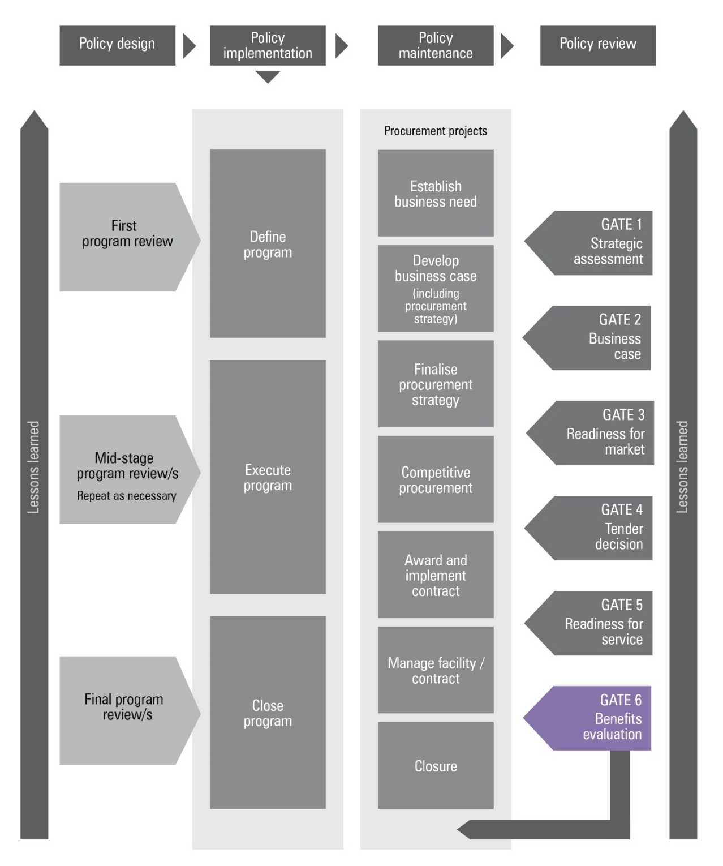
Figure 2: Applying the Gateway Review Process to different project delivery methods
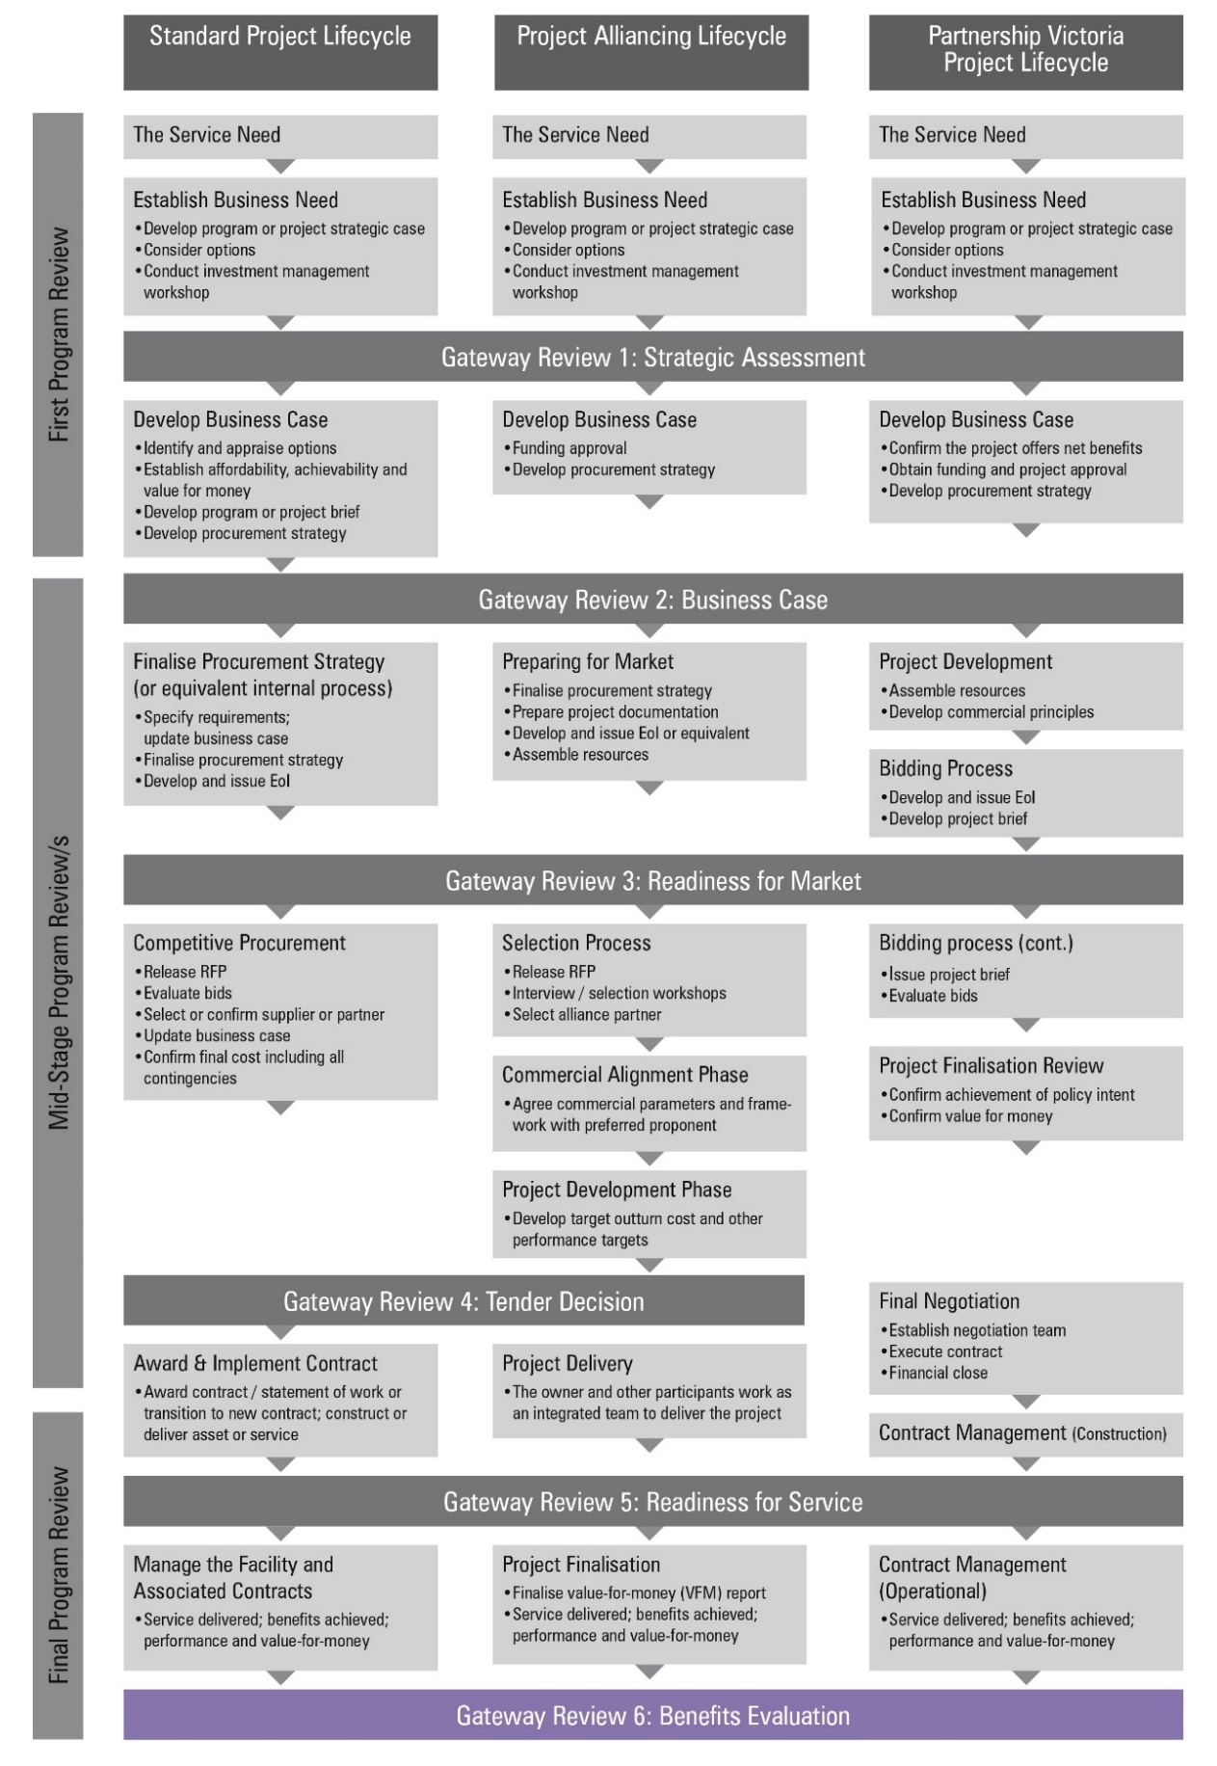

Gateway Review 6: Benefits realisation
Purpose of Gateway Review 6 is to:
- assess whether the business case for the project was realistic at Gateway Review 4; Tender Decision;
- confirm there is still a business need for the investment;
- assess whether the benefits anticipated at this stage are being delivered;
- assess the effectiveness of the ongoing contract and/or facility, and service delivery management processes;
- confirm the client continues to have the necessary resources to manage the facility and any contract successfully;
- confirm continuity of key personnel in facility and/or contract management roles;
- assess the ongoing requirements to meet the business need and if circumstances have changed, ensure the service delivery and any contracts are adapting to the new situation. Changing circumstances could affect: partner management; relationship management; service management; change management; contract management; benefits management; and performance management;
- check any changes do not compromise the original delivery strategy;
- check there are ongoing continuous improvement mechanisms to maximise value-for-money;
- confirm there are plans to manage the facility and any operational contracts to their conclusion, and the validity of exit strategy and arrangements for decomposition;
- assess ‘lessons learnt’ and the methodology for sharing information within government; and
- assess whether there are any potential risks on the horizon during the operating phase which may impact on the realisation of the project’s intended benefits.

Project documents
Investigation areas examples of evidence should be available before the review starts. The required information is likely to be found in the documents suggested below, but may be located in other program or project documents or elsewhere in the organisation’s documentation system:
- an updated business case that reflects actual operating conditions and is against the business case in Gateway Review 5;
- report on the findings from post implementation review or equivalent major post project review;
- an assessment of the benefits delivered to date and expectations for the future (refer to Benefit Management Plan);
- a summary of contract changes since Gateway Review 5;
- plans for contract improvement and service improvement;
- performance reports;
- customer surveys;
- performance measurement systems;
- resources, skills appraisals and personnel plans for future contract management;
- reports on stakeholder issues;
- plans for disposal of any assets at the end of the contract e.g. resources, buildings, staff, intellectual property rights;
- information showing how clients and/or providers manage the relationship and engage with each other;
- investment management standard, benefit management plan and benefits reporting spreadsheet;
- for construction projects, updated health and safety file, and plans for future use of the of the integrated project team; and
- for IT enabled projects, security documents.
    - Review of operating phase
Note: different areas to probe will be relevant for the review team depending on the timing of the review and the extent to which benefits were expected to be materialised and the remaining asset life and future difficulties that could hinder the success of the operating phase.
Focus areas | Evidence expected
1.1 Is the service and/or facility operating to defined parameters? | - operating parameters are updated as needs change and are documented in change control and updated Service Level Agreements (SLAs);  - service delivery measured against those parameters;  - measures to address poor and/or non-performance are proving effective;  - facility safe to operate and maintain;  - information on how the assets are being satisfactorily maintained, including mechanical and electrical systems;  - maintenance plans over the asset’s lifecycle;  - sustainability targets met or exceeded; and  - customer and/or stakeholder satisfaction assessed.
1.2 Is the benchmarking and/or market testing appropriate? | - details of the benchmarking and/or market testing conducted by the parties as agreed; and  - regular value-for-money reviews are conducted in the absence of contractual benchmarking or market testing.
1.3 Has the project documentation, including training material and program, been delivered and kept current? | - new staff trained, and existing staff updated at appropriate intervals;  - no backlog of material to be updated;  - defined responsibilities for updating training material and documentation; and  - health and safety file updated.
1.4 Are the governance and contractual relationships satisfactory? | - regular reviews between supplier and client;  - improvements are documented and changes to the contract are justified;  - documentation showing how agreed actions are dealt with operationally;  - action plan kept up to date as a live plan;  - measurement of service or contract improvements;  - reports on completed work plans for expected work; and  - representation of client and supplier at an appropriate senior level.
1.5 Are there plans for continued contract management? | - future resource plans;  - succession planning for key roles;  - continuity of knowledge when contract team staff change;  - handover and process information recorded clearly;  - facility management and/or contract guide available and in use;  - informal contract agreements documented on a regular basis;  - record of customer input; and  - skills appraisal and plans for addressing shortfalls.
1.6 Are plans for ongoing risk management current? | - updated risk register, risk reporting and management according to best practice;  - updated business continuity and/or contingency plans; and  - consideration of operational health and safety aspects.
1.7 Is change management effective? | - process for evaluating and agreeing proposals for major change;  - documented process for minor changes;  - approval process; and  - reviews identifying possible change.
1.8 Is relationship management effective? | - meetings held between various parties with forward outline timetable;  - communication and meeting structure, both formal and informal, between all parties including stakeholders;  - a structure for running a long-term contract;  - robust contract management processes and good records;  - client views of on-site presence of supplier staff; and  - user groups or equivalent.
1.9 Is training and support adequate? | - the key post holders have appropriate skills and experience; and  - access to expertise or specialist training.

    - Business case and benefits management
Note: different areas to probe will be relevant for the review team depending on the timing of the review and the extent to which benefits were expected to be materialised and the remaining asset life and future difficulties that could hinder the success of the operating phase.
Focus areas | Evidence expected
2.1 Is the business case still valid? | - confirmation the business case still fits with the organisation’s strategic objectives and priorities, is achievable and affordable;  - confirmation of ongoing stakeholder commitment;  - the investment logic remains sound; and  - confirmation the business owner is committed to the business case.
2.2 Have the business benefits been realised as set out in the business case and benefits management plan? Did the organisation achieve more or less than expected? | - findings from post implementation review and/or post project review or equivalent major review show:  - success criteria met;  - project performance criteria and key performance indicators including design quality indicators met or exceeded; and  - whole of life value targets achieved.  - contribution to program or project benefits and strategic outcomes tracked. Does the benefits report show the achievement of the benefits as detailed in the benefits management plan?  - updated benefits capture plans compared with Gateway Reviews 4 and 5;  - assessment of benefits in current operating regime using the benefits measurement basis confirmed in Gateway Review 5; and  - anticipated future benefits.
2.3 Have the needs of the business, end users or stakeholders changed? | - comparison of current business and end user needs with those identified in Gateway Reviews 4 and 5; and  - periodic reviews of business and end user needs and a projection of future changes.
2.4 Have all the governance and stakeholder issues been addressed? These include: the statutory process; communications; external relations; environmental issues, personnel. | - operational communications strategy, updated communications plan and issues log;  - governance structure reciprocated in both client and provider organisation;  - issues addressed at the appropriate level in client and provider organisations;  - staff empowerment to make decisions; and  - stakeholder involvement.
2.5 Are the users satisfied with the operational service? | - details of user groups, outputs and the feedback process;  - Indication of advance preparation for changes in way services are delivered; and  - user-friendly guide to the services provided.
    - Plans for ongoing improvements in value-for-money
Note: different areas to probe will be relevant for the review team depending on the timing of the review and the extent to which benefits were expected to be materialised and the remaining asset life and future difficulties that could hinder the success of the operating phase.
Focus areas | Evidence expected
3.1 What is the scope for improved value-for-money:  - Can more be done for less?  - Could the provider deliver better service quality at the same price?  - Can maintenance costs be driven down? | - analysis of value-for-money to date against future service use scenarios;  - commercial intelligence about the provider’s track record and/or comparison with other providers offering similar services; and  - details of expected and achieved efficiency gains.
3.2 Has the organisation benchmarked its processes by comparing them with other equivalent organisations involved in similar relationships? | - benchmarking of:  - demand management;  - service planning and development;  - service quality;  - investment decisions and/or project justification; and  - benefits management.
3.3 Are commercial mechanisms providing appropriate incentives? | - examples could include:  - payments to the provider dependent on the benefits derived from implementing a particular program of change;  - provider has incentives to deliver and for ensuring individual investments are well planned, achievable and will deliver value;  - clear business justification with identified benefits;  - target incentive mechanisms where work is task based; and  - provider is given incentives to submit estimates for a task, with risks and benefits shared in pre-defined ratios of the provider exceeding or undercutting those original estimates.
3.4 Are inter related projects integrating appropriately? | - governance arrangements operating effectively; and  - related service enhancing or limiting service delivery.

    - Plans for ongoing improvements in performance and innovation
Note: different areas to probe will be relevant for the review team depending on the timing of the review and the extent to which benefits were expected to be materialised and the remaining asset life and future difficulties that could hinder the success of the operating phase.
Focus areas | Evidence expected
4.1 Is the organisation setting realistic targets for continuous improvement each year from this service? Are the targets specific, measurable, agreed, realistic and timely? | - an understanding of and use of techniques such as balanced scorecard, ongoing stakeholder analysis, benchmarking and goal/question/metric approach.
4.2 Are the client and partners working together to actively identify opportunities for improvement through innovation? | - details of innovation achieved using industry surveys, benchmarking, reviews by external consultants and reports from the service provider; and  - whether people at all levels are able to contribute and is this encouraged by using feedback and staff suggestion schemes.
4.3 Is the organisation tracking its progression to improved performance and the flow of results through key milestones and the business planning cycle? | - performance information clearly linked to planned outcomes which enables ready assessment of performance in terms of effectiveness, efficiency and service quality;  - performance information that meets multiple purposes, is consistent and complementary;  - ongoing assessment of appropriateness of performance information;  - responsibilities for performance management are defined and understood by the organisation and supplier;  - direct links between planning and results;  - ongoing monitoring of performance and periodic evaluation; and  - integration with corporate and business planning.
4.4 Does the organisation have performance measures to cover all aspects of the contract? | - performance measures relating to:  - cost and value obtained;  - performance and customer satisfaction surveys;  - delivery improvement and added value;  - delivery capability;  - realised benefits; and  - relationship strength and responsiveness.  - defined roles for measurement responsibilities;  - details on how the information is used and followed up; and  - effect of any contract change or rebalancing of the performance measurement system.
4.5 Do the performance measures offer clear and demonstrable evidence of the success or otherwise of the contract? | - performance measures are meaningful and visible to an organisation’s management group, properly reflect user and stakeholder perceptions and identify the need for supporting or remedial action.
4.6 Are performance measures related to delivery or capability improvement tracked against an existing baseline? | - baseline is established in the business case; and  - performance measures tracked against that baseline.
4.7 Are there performance assessment measures for:  - ongoing service delivery?;  - the desired results of individual programs of change or improvement?;  - the overall results or impact of the project?; and  - benefit tracking and realisation? | - formal SLA approaches and related measures;  - investment appraisal and benefits management techniques are constructed on a case by case basis;  - objectives identified during project scoping and in the preliminary business analysis activity;  - review of the benefits management plan and benefits reporting spreadsheet; and  - for construction projects, user satisfaction is monitored.

    - Review of organisational learning and maturity targets
How to use this section for:
- An initial Gateway Review 6 | - All investigation areas and evidence expected in this section may not be available at this review.
- A Gateway Review 6 at the start of a medium to long term contract for operational service | - To look at the arrangements organisations have to collect and evaluate lessons learnt from the contract and how it will operate. This is important for contracts let on a similar contract basis e.g. PV, term contract, to confirm the relevant organisations learning.
- A mid-stage Gateway Review 6 | - The topics in this section assess whether organisations are collecting learning on an ongoing basis.
- A final Gateway Review 6 | - To look at a review of documented learning during the project’s close down.

Focus areas | Evidence expected
5.1 Does the organisation have an effective process for taking improvements out of the lessons learnt from the project and sharing them across government? | - a mechanism for capturing and recording the initial data;  - internal evaluation of lessons learnt;  - mechanisms and policy for providing information internally and externally;  - a feedback process for organisational project teams;  - participation in knowledge sharing forums;  - help and expertise provided by the corporate centre; and  - details of the provider’s systems and how learning is applied.
5.2 Has there been a review of project management? | - a formal review at project closure; and  - for construction projects, a post project review using key performance indicators.
5.3 Are suppliers encouraged to learn from experience? | - incentives for suppliers to improve project delivery; and  - a commitment to long-term relationships with integrated project teams.

6. Readiness for the Future: Plans for future service provision
Note: different areas to probe will be relevant for the review team depending on the timing of the review and the extent to which benefits were expected to be materialised and the remaining asset life and future difficulties that could hinder the success of the operating phase.
Focus areas | Evidence expected
6.1 Is there an ongoing need for the service? | - Department has planned sufficiently for the contract’s expiry i.e. sufficient time to undertake forward planning, current contract performance assessment, business needs, market analysis and market engagement preparation.  - updated business case linked to current business strategy.
6.2 What is the likely scope of the service in the future? | - options appraisal to include some or all of the following:  - do nothing;  - to retain the scope of the existing contract;  - to split the scope of the existing contract;  - to broaden the scope of the existing contract;  - to completely rethink the requirement for the contract;  - single and/or multiple sources of supply; and  - combining new services with other similar and/or complementary service providers.
6.3 Are there any major issues with the current contract that could affect the approach to re-tendering the service? Factors to consider include:  - range of services – could the provider cope with the range of services offered or were there significant weaknesses?  - flexibility of contract – how adaptable was the relationship to both foreseen and unexpected changes in the nature and level of demand?  - customer’s reaction and adjustment to outsourcing – how well did users adapt to services provided by a third party? Was management confident the provider could be trusted to provide the service? Is the organisation now ready for a greater dependence upon outsourcing?  - exit strategy – will the re-competition be straightforward or is there a danger the customer is now locked in? Have agreements been made to ensure the handover is as smooth as possible? | - updated risk register and issue log;  - reporting of exceptions at regular client and/or provider progress meetings;  - reports from contract and service management functions; and  - exit strategy and details of handover arrangements.
6.4 What is the predicted condition of the asset at the end of the contract period? | - contract information relating to condition of asset at the end of the contract; and  - supplier maintenance plans and clients understanding of these e.g. responsibility for software updates.

Appendix A: Best practice sources
Source | Information
Investment management guidelines  See Investment management  www.dtf.vic.gov.au/infrastructure-investment/investment-management-standard | - investment management standards  - investment logic maps  - investment concept briefs  - benefit management plans
Investment lifecycle guidance  See lifecycle guidance  www.dtf.vic.gov.au/infrastructure-investment/investment-lifecycle-and-high-value-high-risk-guidelines | - business case development guidelines, including strategic assessment guidance  - procurement strategy guidelines  - project tendering guidelines  - risk management guidelines
Procurement advice, policy and guidelines  Victorian Government Purchasing Board  - www.procurement.vic.gov.au | - longer term contract management  - contract variations
- www.infrastructure.gov.au/infrastructure/ngpd | - National guidelines for Infrastructure Projects
- www.dtf.vic.gov.au/infrastructure-investment/public-private-partnerships | - Social Procurement Framework
- www.dtf.vic.gov.au/public-construction-policy-and-resources/ministerial-directions-and-instructions-public-construction-procurement | - Ministerial Directions and instructions for Public Construction Procurement
- www.dtf.vic.gov.au/infrastructure-investment/market-led-proposals | - Market-led proposals guideline
PPP projects  For the National PPP policy and guidelines, see:  - www.infrastructureaustralia.gov.au  Specific Partnerships Victoria requirements apply, see:  - www.partnerships.vic.gov.au | - contract management policy and guidance material
Project alliancing  See Project alliancing at www.dtf.vic.gov.au | - Project Alliancing Practitioners Guide
Information and Communications Technology (ICT) projects  www.enterprisesolutions.vic.gov.au/  www.dtf.vic.gov.au/infrastructure-investment/high-value-high-risk-framework | - Guidance on High Value High Risk projects including ICT projects.  - ICT-related strategy, standards, policies, project dashboard, and  - technical resources for whole of Victorian Government (WoVG).
Asset Management Accountability Framework  Department of Treasury and Finance  www.dtf.vic.gov.au/infrastructure-investment/asset-management-accountability-framework | - further information about government asset management expectations including acquiring new assets  - other general information
Gateway Review Process  www.dtf.vic.gov.au/infrastructure-investment/gateway-review-process | - Gateway Guidance material  - Becoming a Gateway reviewer

