Offsite Construction Guide

Background
Offsite construction (also referred to as modular construction or prefabrication) (OSC) is gaining significant momentum and relevance for public construction in Victoria. It offers a range of potential benefits, including accelerated project timelines, speed to market, cost savings, improved quality control and productivity, and superior OH&S outcomes.

What constitutes Offsite Construction?
OSC is the manufacture of building elements known as components in a workshop or factory that are used in the creation of a built asset at a location that is not the site where the asset will be situated. OSC typically features standardisation, repeatability, automation and scalability.
OSC covers a range of different components and systems, each with varying levels of complexity and degrees of fitting, servicing and finishing. These include volumetric components, structural or panelised elements and prefabricated assemblies.
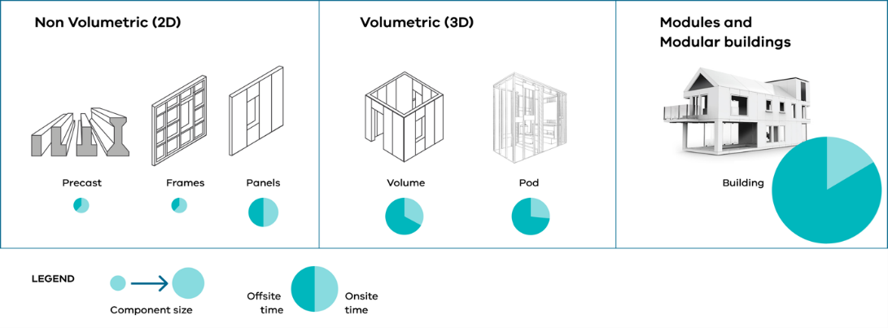

Model Clauses
The suite comprises three sets of model clauses, each designed to accommodate a different delivery scenario:
- Offsite Construction Model Clauses - Supply Model 1 & 2 - Supply Contract
- Offsite Construction Model Clauses - Supply Model 2 - Construction Contract
- Offsite Construction Model Clauses - Subcontracting Model - Construction Contract
Consistent terminology is used across the suite. Relevantly the term "Component" is used to describe the item that will be manufactured off site. A Component may take the form of a piece of construction material (e.g. a structural beam), a non-volumetric preassembly (e.g. mechanical / electrical / plumbing risers or prefinished panels) or volumetric preassemblies (e.g. bathroom pods, either pre-finished or fully finished including services). While in practice there are many ways of incorporating OSC into a project, there are essentially two primary contracting approaches, being the Supply Model and the Subcontracting Model set out below.

Supply Model
Under the Supply Model, there are two primary contracting approaches depending on the scope of work undertaken by the Supplier (Component Manufacturer). They are:
Supply Model 1 - engage a Supplier to:
- supply the Components;
- supply and design the Components;
- supply and install the Components; or
- supply, design and install the Components.
Supply Model 2 - engage:
- a Supplier to supply or design and supply the Components; and
- a Construction Contractor (under any number of different forms of construction contract, for example, a construct only, design and construction or managing contractor contract) to construct the works of which installation of the offsite Components will form a part. The Components are free-issued by the State to the Construction Contractor.
Under either Supply Model 1 or Supply Model 2, the State may also engage a Design Consultant to undertake initial design work or prepare a design brief (meaning the State owns the design), which may then be incorporated in the Supply Contract (whether Supply Only/Supply and Design/Supply and Install/Supply, Design and Install) and, for Supply Model 2, the Construction Contract.
Supply Model 1 Supply Model 2
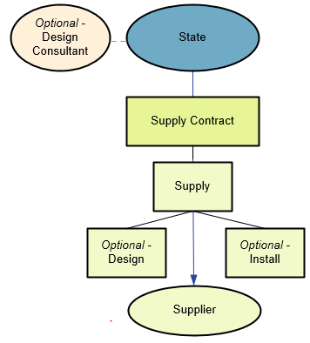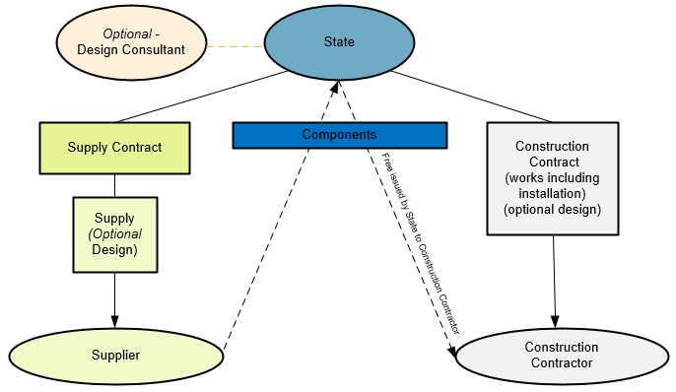

Subcontracting Model
Under the Subcontracting Model, the State engages a Construction Contractor (likewise, under any number of different forms of construction contract) to both manufacture the offsite Components and construct (or design and construct) the works, including installation of the offsite Components. Under this contracting model, the Construction Contractor will be responsible for the manufacture of the Components, meaning the relevant Supplier will be a Subcontractor to the Construction Contractor.
As with the Supply Model, the State may also engage a Design Consultant to undertake initial design work or prepare a design brief (meaning the State owns the design), which may then be incorporated in the Construction Contract.

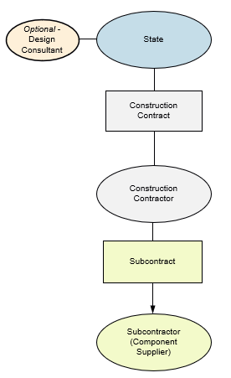

The Subcontracting Model Clauses have been prepared to be included in the Construction Contract between the State and the Construction Contractor.

Which Model Clauses should you use?
The model clauses that are appropriate for use will be informed by:
- the delivery agency's assessment of the key considerations and risks set out below; and
- ultimately, the contracting model selected by the delivery agency for the project (i.e. Supply Model or Subcontracting Model).
Table 1 below sets out some of the key considerations and risks that inform the selection of the appropriate contracting model. The table nominates the model best suited to achieve or optimise the outcome referred to in the Risk / Consideration column.

Table 1 – Key Considerations and Risks
Legend
Preferred | The model that will (or is best placed to) achieve desired outcome and is preferred
C | Not ideal or optimal but somewhat achieves desired outcome and could be considered
X | Will not achieve desired outcome

No | Risk / Consideration |  | Supply Model 1 |  |  | Supply Model 2 | Sub-contractor Model
 |  |  | Supply Only | Supply & Install | Supply Design  & / or Install
 | Single source responsibility for modular manufacture, installation and completion of all Works (including defects). If the State prefers that one party assume liability |  | X | X | C | X | Preferred
 | Interface risk between the Components and the final built asset (this includes design interface risk and installation / integration risk). If the project involves material interface and the State wishes to transfer that risk |  | X | C | C | X | Preferred
 | Lead time requirements. Early procurement of Components may be desired/critical to achieve volume and/or project program. Components may be free issued and installation included in appropriate instances. If early procurement is a priority |  | Preferred | C | C | C | X
 | Sensitivity to/likelihood of other risks such as delivery delay, defects, manufacturing. If the level of risk is relatively: | High | X | X | C | X | Preferred
 |  | Low | C | C | C | C | C
 | Site risks, such as site and ground condition risks. If there are complex or material on-site construction activities: | Yes | X | X | X | Preferred | Preferred
 |  | No | C | C | C | Preferred | Preferred
 | Market capacity to produce required volume of Components. If multiple suppliers required |  | Preferred | X | X | Preferred | C
 | Manufacturing capability to deliver integrated system. If the State prefers that one entity manufacture, install and perform associated construction |  | X | Preferred | Preferred | X | Preferred
 | Price premium to transfer risk. If the State wishes to: | Accept risk and avoid cost premium | Preferred | C | C | C | X
 |  | Transfer risk regardless of cost premium | X | X | C | X | Preferred
 | Design approach preference. If the State wants to be hands-on / control design |  | Preferred | C | C | C | C
 | Component usage – multiple sites. State can realise economies of scale by using one manufacturer (with installation by potentially separate contractors across multiple sites). If State requires Components for multiple sites across separate projects |  | Preferred | C | C | Preferred | X
 | Component usage – storage. State may wish to store Components for future use. If Components are to be procured/stored for future use |  | Preferred | X | X | C | X
 | Component usage – repeat work with installation. If repeat work is envisaged where installation is relatively straightforward |  | C | C | Preferred | X | X
 | Contractor size/quality. Where the budget allocated to the project is significant and the State wants to attract larger contractors for knowhow/superior resources (especially for coordination of Component installation into main works) and is prepared to accept higher margins. State wants to engage a larger contractor |  | X | X | C | C | Preferred

Once the delivery agency has selected the appropriate contracting model, the relevant Model Clauses are as set out in Table 2. In each instance, please refer to the Guidance Notes in the Model Clauses.
Table 2: Relevant Model Clauses
Contracting  Approach | Base Contract / Party | Model Clauses
Supply Model 1 and Supply Model 2 | Supply Contract / Supplier | Model Clauses as relevant for Supply Only/Supply and Design/Supply and Install/Supply, Design and Install (as relevant) are set out in:  - Offsite Construction Model Clauses - Supply Model - Supply Contract
Supply Model 2 | Construction Contract/or | All Model Clauses are set out in:  - Offsite Construction Model Clauses - Supply Model - Construction Contract
Subcontractor Model | Construction Contract/or | All Model Clauses set out in:  - Offsite Construction Model Clauses - Subcontractor Model - Construction Contract
The intention is that all of the Model Clauses will be included in the relevant Base Contract, other than where they are specified to be “Optional”, in which case the “Option” that is not applicable should be deleted. If a Model Clause is otherwise “not applicable”, rather than being deleted, it should be switched off in the “Particulars” or "Annexure Part A" as indicated in the Guidance Notes.

