Incentivised Target Cost Contract Suite
Commercial Principles

The Secretary
Department of Treasury and Finance
1 Treasury Place
Melbourne Victoria 3002
Australia
Telephone: +61 3 9651 5111
dtf.vic.gov.au

Authorised by the Victorian Government
1 Treasury Place, Melbourne, 3002

© State of Victoria 2023
You are free to re-use this work under a Creative Commons Attribution 4.0 licence, provided you credit the State of Victoria (Department of Treasury and Finance) as author, indicate if changes were made and comply with the other licence terms. The licence does not apply to any branding, including Government logos.

Copyright queries may be directed to IPpolicy@dtf.vic.gov.au

ISBN 978-1-925551-92-1
Published September 2023

If you would like to receive this publication in an accessible format, please email information@dtf.vic.gov.au.

This document is also available in Word and PDF formats at dtf.vic.gov.au

Contents
1. Introduction 1
1.1 Purpose 1
1.2 Context 1
2. Overview of the Incentivised Target Cost Contract Suite 3
2.1 Key features 4
2.2 Assumed application 4
2.3 Contractual framework 5
2.3.1 ITC Contract Suite 5
2.3.2 ITC Development Deed 6
2.3.3 Development Phase Activities 7
2.3.4 Shortlisted Respondent selection process 8
2.3.5 ITC Delivery Deed 8
2.4 Design management 9
2.4.1 ITC Development Deed – Development Phase 9
2.4.2 ITC Delivery Deed – Delivery Phase 9
2.5 Collaborative framework 10
2.5.1 Issue resolution 11
2.6 Target Outturn Cost and Actual Outturn Cost 12
2.6.1 Reimbursable Costs 12
2.6.2 Contractor Corporate Overhead and Profit 13
2.6.3 Principal’s Benchmark 13
2.7 Payment regime 14
2.7.1 Payment mechanism 14
2.7.2 Risk or Reward Regime 15
2.7.3 Escalation 18
2.8 Delivery features 18
2.8.1 Adjustment Events 18
2.8.2 Subcontracting 21
2.8.3 Defect rectification 21
2.8.4 Fitness for purpose warranty 22
2.9 Approach to key risk areas 22
2.9.1 Site condition 22
2.9.2 Utilities 23
2.10 Time 23
2.10.1 Late completion 23
2.11 Risk 24
2.11.1 Indemnity 24
2.11.2 Insurance 24
2.11.3 Limits of liability 25
2.12 Security 25
2.12.1 Bonds 25
2.12.2 Parent Company Guarantee 25
Appendix A – Incentivised Target Cost Contract Suite indicative risk allocation and cost assignments 26
Appendix B – Illustrative process of the Development Phase 32
Appendix C – Detailed overview of Issue resolution procedure 33

    - Introduction
      - Purpose
This document is one of a suite of publications that comprise the Department of Treasury and Finance’s (DTF’s) whole-of-government infrastructure procurement framework (Framework).
It sets out the Victorian Government’s key commercial principles underpinning the Incentivised Target Cost (ITC) Contract Suite and the rationale for their inclusion.
The document is for use by Victorian Government delivery agencies to assist in understanding and support strategic decision-making around when to use the ITC Contract Suite for a particular project. The document highlights the key differences between this contract form and traditional design and construction (D&C) deeds.
The ITC Contract Suite is part of the DTF suite of standard form contracts. This contract form is supported by detailed guidance notes and aligns with the principles detailed in the Cost Reimbursable Procurement Requirements available on DTF’s Cost Reimbursable Procurement Category webpage.
This document is not intended to be used to inform procurement model selection.
      - Context
The Incentivised Target Cost Contract Suite fits within the Framework.
The Framework covers three categories of procurement, including whole of life, lump sum and cost reimbursable. Each category contains a set of approved procurement models for use on Victorian Government infrastructure projects.
It consists of the following policy, guidance and standard form contracts:
    - the Ministerial Directions and Instructions for Public Construction Procurement (Ministerial Directions), established under Part 4 of the Project Development and Construction Management Act 1994 (Vic)
    - the Procurement - Investment Lifecycle Guideline, which outlines the three procurement categories and a set of approved procurement models
    - a procurement requirements document for each of the three procurement categories
    - standard form contracts and guidance for a subset of the approved procurement models.
Figure 1 provides an overview of the Framework and indicates where the ITC Contract Suite sits within it.
Figure 1 – Framework
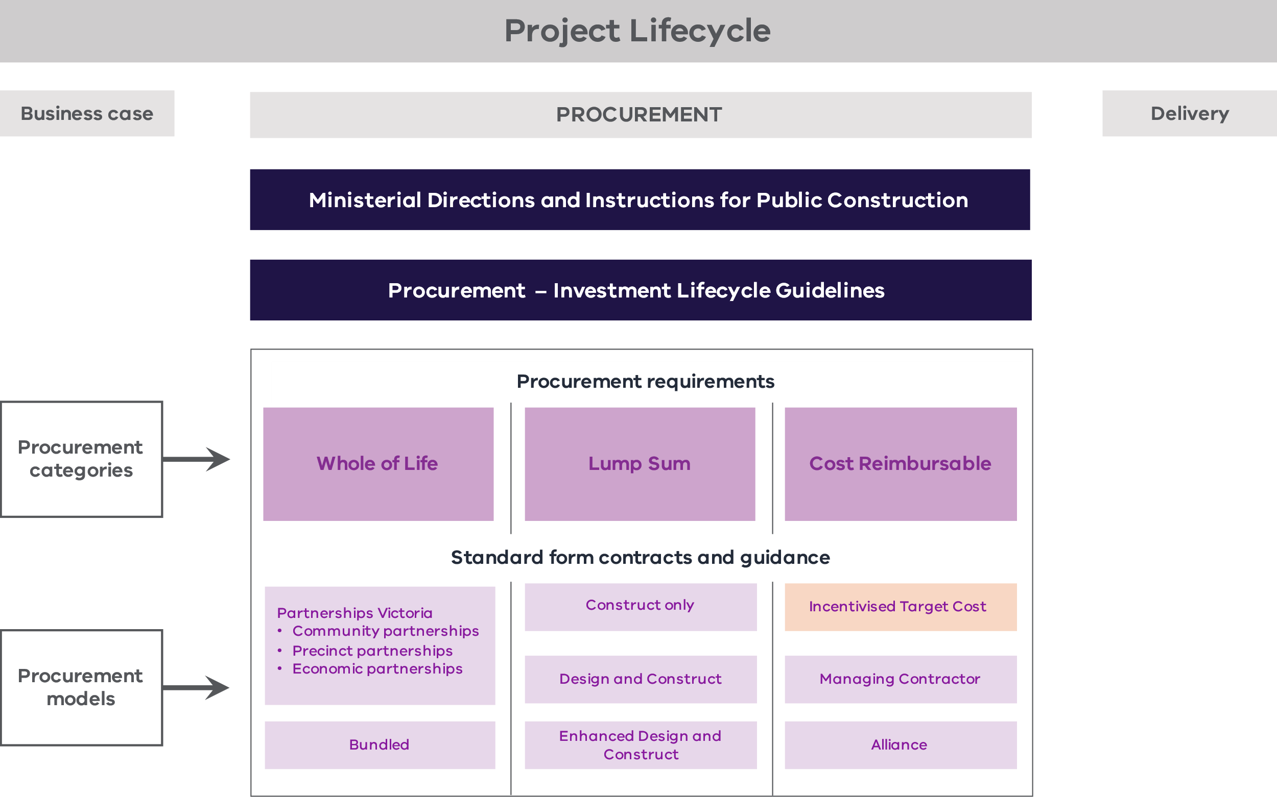
Other Victorian Government legislation, policies and frameworks that are applicable across the project lifecycle include:
    - the Standing Directions 2018 under the Financial Management Act 1994 (Vic)
    - the Investment Lifecycle Guideline series
    - the Asset Management Accountability Framework, Investment Management Standard and Bid Cost Reimbursement Policy for Major Construction Projects
    - the High Value High Risk (HVHR) project assurance framework and associated Gateway Review Process.
National policies, such as the National Alliance Contracting Guidelines and the National Public Private Partnership Policy, may also be applicable.
Where there is a difference in the application of this document from other policies and guidelines, the requirements in this document take precedence.
    - Overview of the Incentivised Target Cost Contract Suite
The ITC Contract Suite has been developed to rebalance roles where traditional risk allocations are not considered appropriate to the project risk profile. DTF recognises that the infrastructure delivery environment is increasingly complex. The ITC delivery model complements existing contract models by providing more optionality for delivery agencies in procurement.
This new delivery model comprises two separate deeds that make up the ITC Contract Suite:
    - the ITC Development Deed; and
    - the ITC Delivery Deed.
As an alternative to the ITC Contract Suite, DTF has also developed an Enhanced D&C Deed. For more details, please refer to the Enhanced D&C Deed – Commercial Principles available on DTF’s Lump Sum Procurement Category webpage.
The purpose of the ITC Contract Suite is to provide a commercially sound contractual framework (consistent with the preferred risk allocation of DTF (as the investor)) where a government agency proposes adopting an ITC procurement approach for a project.
The ITC Contract Suite has been developed based on feedback from the private sector and government stakeholders, along with learnings from other projects and jurisdictions where ITC contracts are regularly used for project delivery.
The ITC Contract Suite builds on standard contract structure and terms previously adopted by Partnerships Victoria to promote greater consistency in contracts used in Victorian infrastructure projects. This base structure is a proven and robust contract form that has been successfully used in some of the state’s biggest and most complex projects.
The ITC Contract Suite will be owned and managed by DTF.
Technical end user guidance is available to support implementation. For more details, please refer to the ITC Contract Suite – Guidance Notes available on DTF’s Cost Reimbursable Procurement Category webpage.
DTF has sought advice from MinterEllison and EY to develop the ITC Contract Suite and Guidance Notes.
      - Key features
The ITC Development Deed is an early contractor involvement agreement under which Shortlisted Respondents are engaged to perform Development Phase Activities. These include design work and Project Proposal development (including a Target Outturn Cost (TOC)). Subject to appropriate probity requirements, the ITC Development Deed also allows for Shortlisted Respondents to undertake early works.
The ITC Delivery Deed is a hybrid procurement model based on a D&C contract, with elements of alliancing in the form of collaborative risk sharing (identification, assessment and allocation) and agreed Relationship Principles. Unlike a conventional D&C contract, the ITC Delivery Deed does not provide conventional fixed-price cost certainty. Instead, it introduces a TOC with delivery proceeding on an Open Book Basis (if the TOC is accepted), with the Contractor reimbursed all agreed costs of performing the works and a percentage for Corporate Overhead and Profit (COP), plus a Gainshare/Painshare Adjustment mechanism to incentivise budget performance. The Contractor’s overall exposure to risk is capped at 50 per cent of the TOC.
The ITC Contract Suite is primarily designed to be used in the context of a competitive TOC development process, although it can also be used for a sole-source TOC development.
      - Assumed application
The ITC Contract Suite can be used for a range of projects. It is well suited to projects where there is scope and design uncertainty, or where there are unknown or unquantifiable risks and complex interfaces. These characteristics may justify the degree of risk the State retains under the ITC model.
Delivery agencies should carefully consider the trade-offs between cost and delivery certainty an ITC contract presents, and whether they are appropriate given the risk profile of the project in question. A fixed-price contracting model is likely to be more appropriate where a project’s risk profile is or can be reasonably well understood and has been efficiently priced by the contractor market previously.
The success of the cost reimbursable contracting process is also contingent on state teams having the necessary capability and capacity to provide robust interrogation of bidder costs. This is required during the procurement process (specifically as part of the interrogation of the TOC through comparisons with the Principal’s Benchmark) and in contract management. A traditional contracting model may provide greater safeguards to support value-for-money (VfM) outcomes where there are constraints on the capability and capacity of the state team.
The ITC Contract Suite is the preferred form of cost reimbursable contract for HVHR projects using the ITC procurement approach.
      - Contractual framework
        - ITC Contract Suite
The ITC Contract Suite has been designed to select the Shortlisted Respondent that is best placed to meet the Principal’s Project requirements. The key steps in the procurement process are shown in Figure 2.
The procurement approach may involve an Expression of Interest (EOI) and a Request for Proposal (RFP) process, or an RFP process only, in accordance with existing DTF infrastructure procurement guidance. There may also be approaches where the RFP process overlaps with the Development Phase.
Figure 2 – Key steps in the ITC Contract Suite procurement process
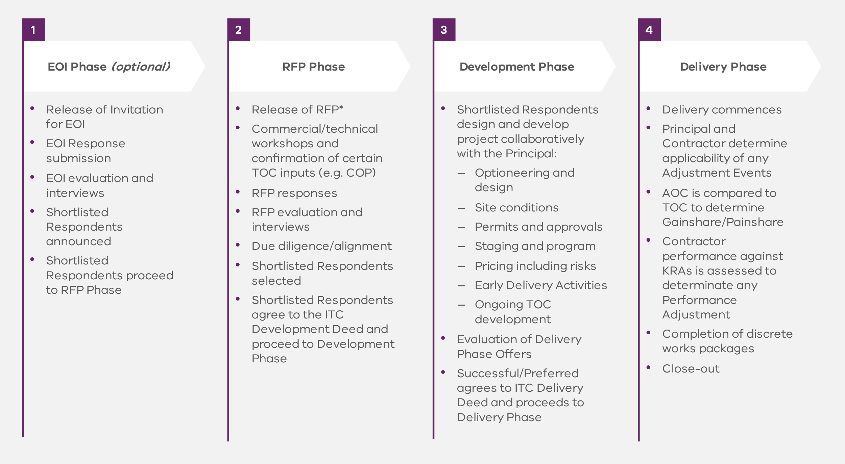
        - ITC Development Deed
The early contractor involvement process that forms part of the ITC Development Deed allows more time for the Shortlisted Respondents to mobilise and understand the project. Early collaboration may provide opportunities to resolve design and other risks. This encourages more thorough risk identification, investigation and mitigation, and provides the opportunity for de-risking, including through front end engineering design. The collaborative integration of the supply chain also ensures that accurate estimates are produced, mitigating the risk of inaccurate construction programs and cost estimates.
Shortlisted Respondents may also participate with the Principal in technical workshops, including risk identification and mitigation. The two parties collaboratively develop the Adjustment Event Guidelines. Early contractor involvement needs to adhere to probity requirements if multiple contractors partake in a competitive TOC development process.
As part of developing the Delivery Phase Offers, the Shortlisted Respondents are required to develop a TOC Estimate on an Open Book Basis.
The success of the ITC contracting process heavily depends on the ability of state teams to ensure the TOC is set accurately. Shortlisted Respondents are inherently incentivised to seek a higher TOC setting to minimise the risk of margin erosion (i.e., Painshare). A robust interrogation of the TOC by the state team is critical, both through analysis against a Principal’s Benchmark and, wherever possible, through competitive tension.
The ITC Contract Suite contemplates a competitive process where the delivery agency simultaneously engages more than one Shortlisted Respondent to prepare Delivery Phase Offers under separate ITC Development Deeds. The Shortlisted Respondents are required to develop a TOC Estimate on an Open Book Basis in their Delivery Phase Offer. The ability to consider Delivery Phase Offers from multiple Shortlisted Respondents ensures that competitive tension is maintained, incentivising Respondents to develop optimal Delivery Phase Offers with respect to pricing, design and program.
A competitive TOC development process should be the default process when circumstances permit. However, delivery agencies may need to consider a non-competitive TOC development approach in exceptional circumstances. Such circumstances may occur where there is a limited number of market participants, where there is significant project scope uncertainty, or where bidder innovation and Intellectual Property are being invested into defining the project scope in parallel or prior to TOC development, so that TOC submissions from different bidders would not provide a suitable comparison. In accordance with the HVHR Framework, Treasurer or government approval is typically required to use this form of contracting with a sole-sourced TOC development approach.
        - Development Phase Activities
The Shortlisted Respondents engaged under an ITC Development Deed are required to perform the Development Phase Services as set out in the Development Phase Services and Deliverables Schedule (DPSDS) (Schedule 4). The Development Phase Services typically involve developing design and associated plans and progressively developing a TOC Estimate. The Shortlisted Respondent’s services may also include assisting with the relevant approvals (when in a sole-sourced TOC development approach).
The Development Phase Services should be tailored on a project-specific basis to ensure that the costs associated with having multiple Contractors undertake the works is proportionate to the benefits associated with maintaining competitive tension during the Development Phase. For example, a high-value, complex procurement may warrant all Shortlisted Respondents performing detailed design work to enable the delivery agency to further evaluate and consider its requirements for the project. Alternatively, a less complex and lower value project may only require a more confined set of Development Phase Services. The expectation is that Development Phase Services are subject to capped COP, with an estimate of reimbursable costs provided as part of the RFP phase. This provides the State with enough information to inform budgeting, while also promoting VfM outcomes for the State.
In addition, Shortlisted Respondents may be directed by the delivery agency to perform Early Delivery Activities, consisting of physical works on the site in accordance with the terms of the ITC Development Deed. Unless otherwise specified, Early Delivery Activities are subject to the terms and conditions of the Agreed ITC Delivery Deed. Probity requirements need to be carefully managed if there are Early Delivery Activities and multiple contractors are participating in a competitive TOC development process. Depending on the size and scale of the works, this could include executing separate contractual arrangements for the Early Delivery Activities or working with a separate contractor not involved in the ITC Development Phase (or both).
If there is a competitive Development Phase, the Principal provides clarifications on technical and design solutions presented by the Shortlisted Respondents. The Principal may go through a more detailed process to review and refine the technical and design solutions presented by a Shortlisted Respondent at the end of the process. This process involves collaboration and interaction with both bidders during the TOC development process. Further project development and due diligence prior to contract award may prove beneficial when undertaking a competitive TOC process.
An illustrative process for single and competitive development phases is outlined in – Incentivised Target Cost Contract Suite indicative risk allocation and cost assignments.
        - Shortlisted Respondent selection process
Following submission of the Delivery Phase Offers, the Principal considers these offers and performs one of the following actions:
    - selects a Shortlisted Respondent as the Successful Respondent, who then enters an ITC Delivery Deed;
    - selects no Successful Respondent but determines that it wishes to negotiate further with a Shortlisted Respondent (i.e., a Preferred Respondent), who must undertake genuine and good faith negotiations and resubmit its Delivery Phase Offer for consideration; or
    - selects no Successful Respondent.
Each Shortlisted Respondent engaged under an ITC Development Deed expressly acknowledges that there is no guarantee it will be selected as a Successful or Preferred Respondent. Further, the delivery agency maintains considerable discretion with respect to the selection process, including the ability to terminate the procurement process at any stage.
        - ITC Delivery Deed
After the Principal has selected a Shortlisted Respondent as the Successful Respondent, that party is engaged as the Contractor under the ITC Delivery Deed to deliver the Project. The Contractor is required to:
    - design and constructs the project in line with the risk profile of the ITC Delivery Deed;
    - be paid the Reimbursable Costs (Schedule 3), Corporate Overhead and Profit (Schedule 4) and any payments due under the Risk or Reward Regime (Schedule 5);
    - competitively and transparently tender proposed subcontracts; and
    - achieve Completion by the relevant date, hand the project over to the Principal and rectify any Defects identified during the Defect Liability Period.
      - Design management
        - ITC Development Deed – Development Phase
During the Development Phase, the Shortlisted Respondent undertakes a review of the initial design concept provided by the Principal and prepares a report setting out its recommendations. The Principal also has an opportunity to review and comment on successive drafts of the Development Phase Deliverables (including the Design Deliverables). The Contractor must develop these in accordance with the PSDR and the Development Phase Plan, which includes the program, design development and management. This process also allows the Shortlisted Respondent to address any comments raised by the Principal prior to submitting its Delivery Phase Offer.
The required design services should be specified in the DPSDS and developed on a project-specific basis to facilitate project teams developing their requirements for the project.
The ITC Development Deed also contains a general novation clause that allows the Principal to direct the Shortlisted Respondent to enter into a Deed of Novation between the Principal, the Shortlisted Respondent and a selected Subcontractor (e.g., the Principal’s design consultant) for a particular part of the Development Phase Services.
The Shortlisted Respondent must use its best endeavours to submit the Delivery Phase Offer (including the Development Phase Deliverables) to the Principal by the date for Delivery Phase Offer.
        - ITC Delivery Deed – Delivery Phase
During the Delivery Phase, the Contractor is required to prepare the Design Documentation and submit it to the Principal Representative and the Principal for review. This is in accordance with the Design Development Process in the Project Scope and Delivery Requirements (PSDR). The content of the PSDR and the Design Development Process should be developed on a project-specific basis by the Contractor. The Design Development Process can be tailored to reflect the required level of Principal involvement in reviewing and commenting on the Design Documentation. For example, the Design Development Process may give the Principal the right to comment or place conditions on the Design Documentation received from the Contractor that the Contractor must address before that documentation can progress to the next stage in the Design Development Process.
The Contractor is also required to appoint a design development coordinator (who will be part of the Project Control Group and may also be part of the Senior Representatives Group (SRG)) to manage the Design Development Process.
      - Collaborative framework
Why include this concept?
The collaborative framework has been introduced to ensure stakeholders work towards what is best for project objectives. This mitigates Contractor concerns that the State can be reluctant to assist in resolving issues, such as planning approvals, when it may be able to readily do so but is concerned about triggering contractual consequences. Instead, there is a mechanism for the Contractor to provide feedback on the State’s performance and collaboration through a regular review of the Key Result Areas (KRAs).
The ITC Delivery Deed contains a collaborative framework to better align the objectives of the Principal and the Contractor so that all decisions are made for the benefit of the Project. This approach aims to reduce or eliminate the adversarial relationship that can emerge between Principals and Contractors under traditional forms of project delivery. The framework encourages parties to manage and resolve any difficulties or conflicts proactively for their mutual benefit. The ITC Delivery Deed facilitates this more cooperative relationship between the project participants by providing clear project objectives and Relationship Principles, and through initiatives such as:
    - the SRG;
    - the Kick-off Workshop;
    - KRAs; and
    - proactive Principal engagement.
The intention is that the Principal’s KRAs will be ‘soft’ KRAs that are not linked to any financial incentive regime. These soft KRAs do not provide the Contractor with any relief if the Principal fails to meet them. The Principal’s KRAs form an important part of the collaborative nature of the ITC Delivery Deed. They seek to achieve proactive Principal engagement throughout delivery of the Project and facilitate achievement of the Project Objectives.
There should not be an increased risk of dispute through the use of the Principal’s KRAs, given it is clear that the Contractor has no claim against the Principal in respect of them, and there is no operative obligation on the Principal to meet the KRAs. Instead, achievement of the Principal’s KRAs is monitored and reviewed by the SRG, so any issues can be addressed at a senior level before they become formal disputes.
The Principal’s KRAs should be considered on a project-specific basis. They are intended to cover (among other things) the following:
    - the Contractor’s rating of the performance of the SRGs in discharging its functions;
    - the Contractor’s rating of the effective participation of the Principal in, and the outcomes of, the Kick-off Workshop;
    - the Contractor’s rating of the Principal’s performance in proactively engaging in the matters referred to in the clause on proactive Principal engagement, including matters relating to the provision of information, facilitative exercise of powers by third parties, stakeholder management, coordination of interfaces and resolution of impediments to the project objectives; and
    - the number of Issues referred to the Issue Resolution Team (IRT), successfully resolved by the IRT or for which a Bespoke Resolution Procedure was agreed.
        - Issue resolution
Why include this concept?
Issues should be raised with those with authority to resolve them quickly and avoid them festering. That is why this deed introduces flexibility to rapidly resolve issues in a bespoke way based on project circumstances before traditional dispute resolution process apply.
The ITC Delivery Deed provides for a time-bound bespoke issue resolution process. This involves a commitment by the parties to early identification and collaborative resolution of issues consistent with the overall collaborative nature of the ITC Delivery Deed and the Relationship Principles. The establishment of an IRT provides the parties with an opportunity to agree to a time-bound bespoke process prior to more formal resolution processes. An overview of the issue resolution process is provided in Figure 3. A detailed outline of the dispute resolution approach is in – Illustrative process of the Development Phase.
Figure 3 – Overview of the issue resolution process
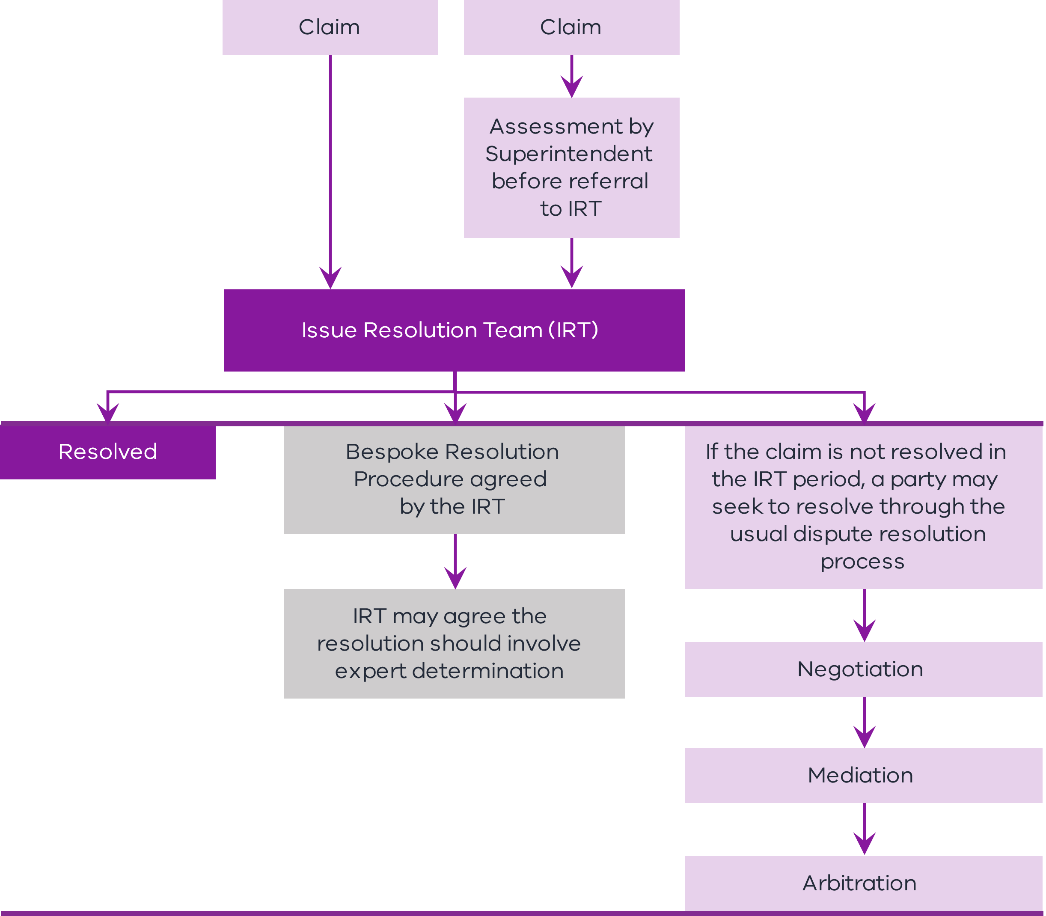
      - Target Outturn Cost and Actual Outturn Cost
The TOC is an estimate of all Reimbursable Costs and COP (and any potential risk provisions) required to perform the Contractor’s Activities. It is progressively developed by the Shortlisted Respondent and submitted as part of the Delivery Phase Offer.
The Actual Outturn Cost (AOC) is the sum of all Reimbursable Costs incurred by the Contractor and any COP payable to the Contractor.
        - Reimbursable Costs
Reimbursable Costs are allowed costs and expenses that are reasonably and actually incurred by the Contractor in performing the Contractor’s Activities. Schedule 3 contains a table specifying a range of standard Reimbursable Costs and Excluded Costs adopted on other projects. The Reimbursable Costs form part of the AOC and should be considered on a project-specific basis.
        - Contractor Corporate Overhead and Profit
As part of the RFP process, Contractors are asked to provide proposed COP that will be paid through the Development Phase and Delivery Phase. The delivery agency should use the proposed COP to assess VfM when determining the Shortlisted Respondents. DTF and the Office of Projects Victoria or a specialist cost estimator (or both) may assist the delivery agency in developing an indicative benchmark COP based on any combination of a project’s size, value or complexity.
Comparison of proposed margins from Shortlisted Respondents and comparison with an appropriate benchmark should support the delivery agency to identify where contingency has been included in the COP.
        - Principal’s Benchmark
Prior to entering into an ITC Development Deed with one or more Shortlisted Respondents, the delivery agency should develop a Principal’s Benchmark. The Principal’s Benchmark is the State’s independent price comparator estimate of the TOC. This is developed independently of the Shortlisted Respondents’ pricing, other than in respect of ensuring the scope, risk and other bases of estimate assumptions are aligned to enable an appropriate price comparison. Best practice is for the Principal’s Benchmark to be developed prior to the procurement process for the ITC Development Deed, noting that the Principal’s Benchmark may be subject to revision as design and construction methodology is refined through the Development Phase. This should be a pre-estimate of the TOC that reflects whether risks are allocated to the Principal or the Contractor under the ITC Delivery Deed.
The delivery agency is accountable for the Principal’s Benchmark and confirming the accuracy of the estimate. The delivery agency needs to consider engaging an external estimator to support the development of a robust Principal’s Benchmark. The Principal’s Benchmark should incorporate the reference design developed as part of the business case and any further development work undertaken by the delivery agency prior to procurement.
The Principal’s Benchmark is used in the VfM assessment of the TOC and the Shortlisted Respondent’s overall Delivery Phase Offer. Elements of the Principal’s Benchmark may also be used as the basis for challenging the Shortlisted Respondent’s price, time and volume assumptions regarding the TOC. A Principal’s Benchmark is expected to be used in both competitive and non-competitive TOC development processes to confirm the appropriateness of the Delivery Phase Offers.
In a non-competitive TOC process, the Shortlisted Respondent has the opportunity to access a larger share of the performance pool in the Delivery Phase if the TOC submitted as part of the Delivery Phase Offer is below the Principal’s Benchmark. This incentive is offered to promote VfM in the absence of competition. Equally, the delivery agency should challenge the TOC if the estimate is significantly below the Principal’s Benchmark to ensure that all key work activities have been covered and the design solution meets stakeholder expectations.
      - Payment regime
        - Payment mechanism
The payment mechanism under the ITC Contract Suite comprises:
Phase | Payment mechanism
Development Phase | - payment of Reimbursable Costs, including Early Delivery Activities (if applicable), directly, reasonably and actually incurred; and  - payment of COP.
Delivery Phase | - payment of Reimbursable Costs, reasonably and actually incurred as per the Reimbursable Cost Schedule;  - payment of COP;  - a Gainshare/Painshare Adjustment to reflect any project Gainshare Amount or Painshare Amount; and  - a performance adjustment to reflect any Performance Reward Amount.

Development Phase payments
The Shortlisted Respondent(s) is paid a Development Phase Services Fee on a cost reimbursement basis during the Development Phase. The Development Phase Services Fee includes:
    - Development Phase Services Reimbursable Costs, including:
      - design costs (based on a Schedule of Rates and assumed rate of effort); and
      - preliminaries and management costs (based on a Schedule of Rates and Reimbursable Cost); and
    - Development Phase Services COP (being the margin percentage bid back in the Shortlisted Respondent’s RFP response multiplied by the Development Phase Services Reimbursable Costs).
The Development Phase Services Fee is paid monthly in arrears based on the value of the Development Phase Services performed on an Open Book Basis. An option may be for project teams to require the Development Phase Services Fee to act as a cap. Consideration may also be given to paying a fixed percentage of the incurred Reimbursable Costs.

Delivery Phase payments
The Contractor is paid:
    - Reimbursable Costs, including:
      - design costs (all costs related to detailed design and investigations);
      - preliminaries costs (mobilisation and demobilisation and Contractor’s management and supervision costs);
      - construction costs (all direct construction-related activities costs); and
      - management costs (management and offsite overhead costs and insurances);
    - COP, which is the margin percentage bid back in the Contractor’s RFP response multiplied by Reimbursable Costs;
    - Gainshare Amounts payable under the Risk or Reward Regime (cost adjustments) based on the relationship between the AOC and TOC;
    - Performance Reward Amounts under the Risk or Reward Regime based on the achievement of agreed KRAs (and supporting Key Performance Indicators (KPIs)); and
    - Adjustment Events resulting in a revision to the TOC, as specified in the Adjustment Event Guidelines.
        - Risk or Reward Regime
Why include this concept?
The Risk or Reward Regime provides cost and performance incentives to drive performance. The Contractor is incentivised to appropriately manage costs and risks to access Gainshare and a performance pool and avoid Painshare. Respondents who have undertaken a competitive TOC development process have automatic access to a higher performance pool, as the competitive tension should result in a reasonable TOC. Respondents who have undertaken a single TOC development process only have access to the higher performance pool if the proposed TOC is within the Principal’s Benchmark. The Risk or Reward Regime has been developed in practitioner workshops and is based on approaches in other ITC contracts used in Victoria and New South Wales.

The Risk or Reward Regime has been designed to promote collaborative relationships between the Principal and the Contractor, and to incentivise the Contractor through payments and performance mechanisms.
The Risk or Reward Regime is separated into two components:
    - a cost adjustment (the Gainshare/Painshare Adjustment in respect of AOC underrun or overrun), which may result in a:
      - Gainshare Amount;
      - Painshare Amount (Primary);
      - Painshare Amount (Secondary); and
    - a performance adjustment (the potential for a Performance Reward Amount in respect of performance against the KPIs).
The Risk or Reward Regime is summarised in Figure 4 below.
Figure 4 – Elements of the performance regime – ITC Delivery Deed
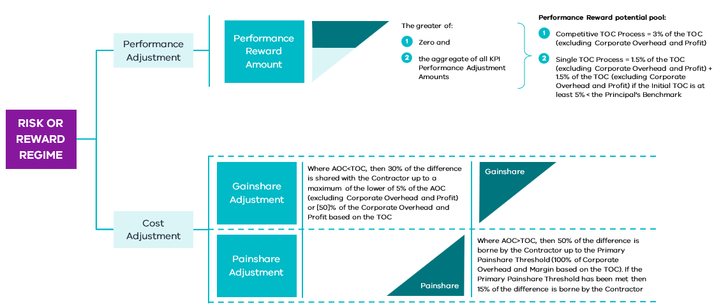

Cost adjustment
The ITC Delivery Deed includes Gainshare Adjustment and Painshare Adjustment mechanisms as part of the cost adjustment to incentivise the Contractor’s performance. If the AOC is less than the TOC, a Gainshare Amount is payable by the Principal to the Contractor. If the AOC is greater than the TOC, a Painshare Amount is payable by the Contractor to the Principal. No cost adjustment is applied where the AOC is equal to the TOC.
In a Gainshare scenario, the Contractor receives a 30 per cent Gainshare ratio, up to a maximum of the Gainshare cap (the lower of 5 per cent of the AOC (excluding COP) or 50 per cent of the COP based on the TOC).
In a Painshare scenario, Painshare represents a 50/50 share of the cost overrun until the COP is exhausted (Painshare Amount (Primary)). Once the COP is exhausted, the State proceeds to reimburse 85 per cent of costs (excluding COP) going forward, with the Contractor accordingly bearing 15 per cent of actual costs until Completion (Painshare Amount (Secondary)). The rationale for this ongoing cost-sharing mechanism is to continue to incentivise all parties to manage cost outcomes in a significant cost overrun scenario. This is similar to approaches adopted on recent ITC projects. The project team may consider opportunities for the Contractor to recoup costs associated with the 15 per cent retention on a project-specific basis.
The ITC Delivery Deed provides for a mechanism to adjust the TOC, KRAs and the Date for Completion through Adjustment Events (discussed below).
Figure 5 – Cost adjustment mechanism
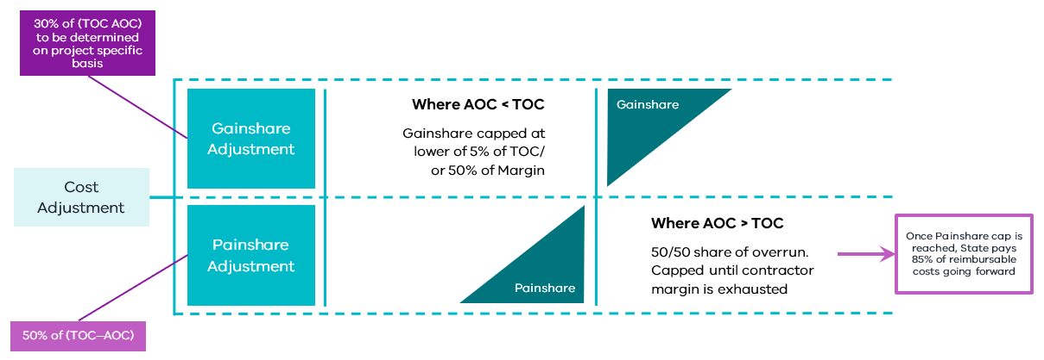

Performance Adjustment
A performance pool is available to the Contractor, with a capped performance adjustment based on the following principles:
    - positive performance is incentivised with payments from the performance pool; and
    - poor performance incurs no additional costs to the Contractor but removes its ability to receive a performance adjustment for the applicable KRA.
The performance pool is established from:
    - the Competitive TOC Process (upfront state funding equivalent to 3 per cent of the TOC); and
    - the Single TOC Process (upfront state funding equivalent to 1.5 per cent of the TOC. An additional 1.5 per cent is available if the TOC is 5 per cent below the Principal’s Benchmark).
At the Date of Practical Completion of the project, a performance adjustment is calculated based on the Contractor’s performance for each KPI against the KRAs. Some examples of KRAs include time, quality and utilities. Projects are required to allocate at least 50 per cent of the performance pool to achievement of a time-based KRA. Other KRAs allocated to the remaining 50 per cent of the performance pool at the project’s discretion may include quality, stakeholder management and sustainability.
A delayed or traditional liquidated damages regime (discussed later) also applies.
Figure 6 – Performance adjustment mechanism
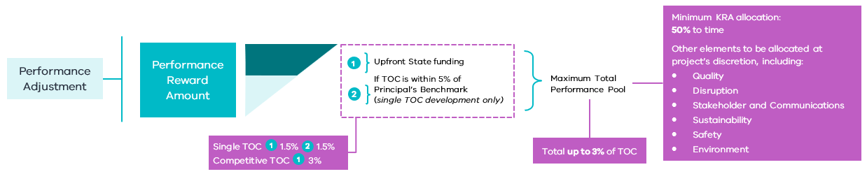

        - Escalation
Escalation risk fluctuates over time. As a base position, transparent escalation assumptions are assumed in the TOC. The State could challenge TOC assumptions as it compares to the Principal’s Benchmark or throughout competitive TOC development when prices are above expectations.
Actual escalation risk (and opportunity) is shared through the Gainshare or Painshare Adjustment mechanism. However, DTF can provide advice on whether a rise and fall regime or alternative mechanism should be applied for specific materials that are subject to price volatility.
      - Delivery features
        - Adjustment Events
Why include this concept?
While most costs are shared through the cost reimbursable model, the ITC Contract Suite allows for adjustments to the TOC, KRAs and the Date for Completion as external events and circumstances that were unforeseen in the TOC development process arise. Adjustment Events are agreed by both parties during the contract negotiation stage. The ITC Contract Suite and Guidance Notes outline the type of unknown events that result in an Adjustment Event, noting that most costs should be addressed by the Gainshare or Painshare Adjustment regime, given that the model allows for extensive due diligence prior to confirming the TOC.
The ITC Delivery Deed provides for a mechanism to adjust the TOC, KRAs and the Date for Completion. The Contractor is entitled to extensions of time, adjustments to the TOC or the KRAs depending on the event as outlined in the Adjustment Event Guidelines.
Project-specific Adjustment Events that impact the TOC and, by extension, the Risk or Reward Regime can be determined on a case-by-case basis in accordance with the Adjustment Event Guidelines.
The following table summarises the events that constitute Adjustment Events. This table is subject to any exclusions contained in the Adjustment Event Guidelines themselves, which are developed on a project-specific basis.
Item | Event | Adjustment Event (Cost) | Adjustment Event (Time) | Adjustment Event (KRA)
 | A breach by the Principal of any Principal Project Document | ü* | ü | ü
 | An act or omission of the Principal when acting in connection with the Project, or any Principal Associate, in each case other than any such act or omission that is:  - a Permitted Act; or  - an Act where an Authority is acting in accordance with its statutory powers | ü* | ü
 | Cessation or suspension of any part of the Contractor’s Activities in connection with a Heritage Claim or Native Title Claim | ü* | ü
 | A material change to the way in which the Contractor’s Activities are carried out in connection with a Heritage Claim or Native Title Claim, unless such change is the subject of a Variation Order (on a project-by-project basis, this may be extended to include Artefacts) | ü* | ü
 | Industrial Action that only occurs at or in the direct vicinity of the Site and is a direct result of an act or omission of the Principal that is not a Permitted Act, undertaken as part of any Interface Works or by an Authority acting in accordance with its statutory powers | ü | ü
 | A direction by the Principal Representative to accelerate where the Contractor incurs more or less cost than would otherwise have been incurred, except to the extent the need for acceleration arises in connection with any Contractor breach of or non-compliance with the Project Documents | ü |  | ü
 | The Reimbursable Costs of a Provisional Sum Item or Provisional Quantity Item exceed the relevant Provisional Sum included in the TOC | ü
 | Suspension of the Contractor’s Activities not caused by a Contractor Act or Omission or Force Majeure Event | ü | ü
 | Due to a material change in the terms of any Insurances (Principal), the Contractor is required to take action to maintain an equivalent level of insurance coverage^ | ü | ü
 | A Change in Mandatory Requirements that results in a Scope Variation | ü | ü** | ü
 | A Scope Variation directed under clause 35.1 of the ITC Delivery Deed | ü | ü | ü
 | On a project-specific basis, a breach of a Direct Interface Deed by a Direct Interface Party^^ | ^^ | ^^ | ^^
 | A Force Majeure Event |  | ü
 | Any act, event or circumstance expressly stated to be an Adjustment Event (Cost) in the ITC Delivery Deed or the Adjustment Event Guidelines | ü
 | Any act, event or circumstance expressly stated to be an Adjustment Event (Time) in the ITC Delivery Deed or the Adjustment Event Guidelines |  | ü
 | Any act, event or circumstance expressly stated to be an Adjustment Event (KRA) in the ITC Delivery Deed or the Adjustment Event Guidelines |  |  | ü
Notes:
* These acts, events or circumstances only constitute an Adjustment Event (Cost) where the Contractor has been granted an extension of time to a Date for Completion in accordance with clause 27.8 of the ITC Delivery Deed, and the adjustment to the TOC only applies to time related costs.
** These acts, events or circumstances only constitute an Adjustment Event (Cost) where they also constitute a Scope Variation under the ITC Delivery Deed.
^ Item 9 in relation to Insurances (Principal) is to be considered on a project-specific basis.
^^ Item 12 in relation to breach of a Direct Interface Deed by a Direct Interface Party is to be considered on a project-specific basis, including whether the entitlement will be time or cost (or both).
        - Subcontracting
The Principal must retain full visibility of contractual arrangements and access to documentation in connection with the Project. They must also have appropriate rights in respect of those arrangements. The ITC Delivery Deed contains a process for managing subcontract tenders that follows a Subcontract Packaging and Procurement Plan developed under the ITC Development Deed. This applies to all Subcontracts except Minor Subcontracts. It ensures that all subcontracting is consistent with the approved procurement strategy and Cost Plan.
Prior to awarding Subcontracts, the Contractor is required to demonstrate to the Principal Representative why a particular Subcontractor should be awarded a Subcontract. This is deemed to be a warranty by the Contractor as to the suitability of that Subcontractor. This should be in accordance with any Subcontractor Packaging and Procurement Plan agreed by the parties. Notwithstanding this, the Principal Representative has ultimate discretion to reject a recommendation by the Contractor on certain grounds. These include:
    - where the Subcontract price exceeds the allowance for the relevant work in the Cost Plan;
    - where the proposed Subcontractor is not an appropriate Subcontractor for the relevant work; or
    - where the Subcontract does not follow the template form approved by the Principal or the Principal Representative.
In these circumstances, the Principal Representative has the right to direct the Contractor to accept another tender or seek alternative proposals.
        - Defect rectification
DTF wants to incentivise Contractors to manage quality throughout delivery of the project, but also wants to encourage pre-emptive rectification of defects. The proposed approach to Defect rectification is as follows:
    - if a Defect is identified prior to Completion and rectified by the Contractor (in the absence of a formal Defect notice from the State), it will be reimbursable;
    - if a Defect is identified prior to Completion and rectified by the Contractor following a formal Defect notice from the State, it will not be reimbursable;
    - if a Defect is rectified after Completion, it is not reimbursable; and
    - at any time, if the State needs to step in and rectify a Defect (as the private sector has failed to do so), it will be at the Contractor’s cost.
DTF considers this a fair risk transfer, consistent with the fundamental principle underlying the ITC Contract Suite.
The ITC Delivery Deed provides for a Defects Liability Period (DLP) of 12 or 24 months commencing on the Date of Practical Completion. Any rectified works are subject to a further 12-month DLP with a cap on the overall DLP of 24 or 36 months after the Date for Practical Completion.
The Contractor is required to provide security for the DLP, and if there are claims outstanding 24 months after the Date of Practical Completion, the DLP Bond is reduced to the higher of 120 per cent of the reasonable costs of completing rectification of the relevant Defects and a monetary threshold, which is released 20 Business Days after the Date for Close-out.
        - Fitness for purpose warranty
The Contractor provides the contractual warranties consistent with traditional forms of contracting as to fitness for purpose and design and is responsible for the overall delivery of the Project.
      - Approach to key risk areas
Information on the approach to risk allocation for key areas and the rationale for this approach is discussed below. – Incentivised Target Cost Contract Suite indicative risk allocation and cost assignments contains a further summary of the risk allocations in the ITC Delivery Deed.
        - Site condition
The Contractor assumes all Site Condition risks other than where expressly stated otherwise in the ITC Delivery Deed. The Contractor warrants that it has been given the opportunity to undertake tests, enquiries and investigations of the Site and its surroundings, including all Site Conditions and the existence or availability of Utility Infrastructure.
The Contractor’s Contamination Remediation obligations are determined on a project-specific basis.
The Contractor must comply with all obligations in respect of any notifiable Contamination under the Environment Protection Act 2017 (Vic).
Site Conditions or Contamination risks (or both) may be agreed Adjustment Events under the ITC Deed.
        - Utilities
The Contractor assumes the risk in relation to:
    - existing Utility Infrastructure and the continuous supply and sufficiency of Utilities in connection with the Contractor’s Activities;
    - the need to relocate, protect or modify such Utility Infrastructure; and
    - any access to the Site or interference with the Contractor’s Activities by or on behalf of a Utility provider.
The Contractor is typically liable for Utility consumption in undertaking the Contractor’s Activities. Certain Utilities risks may be agreed to constitute Adjustment Events under the Adjustment Event Guidelines.
      - Time
        - Late completion
Why include this concept?
Incentivising timely completion is critical for government in the delivery of infrastructure projects. In some forms of cost reimbursable contracting, it is also important to counter any perverse incentives that could arise from the cost reimbursable nature of the model. The ITC Contract Suite provides a positive incentive to achieve timely completion through the bonus pool but maintains a Delayed Liquidated Damages regime, which applies following the exhaustion of the bonus pool, to continue to incentivise the Contractor once its opportunity for reward has been exhausted. The option is also available to adopt a traditional liquidated damages regime. The ITC Contract Suite still allows for Adjustment Events for certain events that are outside of the control of the Contractor.
As outlined above, the ITC Delivery Deed proposes a time KRA to incentivise on-time delivery under the Risk or Reward Regime depending on the Contractor’s performance against pre-agreed milestones. The late Completion regime should be tailored to the characteristics of the project and may include interdependencies with other projects or other critical milestones.
Broadly, this regime involves the following incentives for timely completion:
    - if the Project is completed ahead of schedule or within 5 per cent of schedule (as adjusted by parties), the Contractor is incentivised through access to 50 per cent of the bonus pool, as per the allocation of the time KRA;
    - if the Project is delayed by more than 5 per cent but less than 10 per cent of schedule, the time KRA bonus is proportionately eroded until the delay is greater than 10 per cent of the schedule. At the point the delay is greater than 10 per cent of schedule, the time-based performance pool allocation is nil;
    - if the Project is delayed by more than 10 per cent of schedule, the State levies liquidated damages daily over the following 12 months up to the liquidated damages cap of 10 per cent of TOC or D&C price; and
    - once the liquidated damages cap is exhausted, other contractual measures, such as Default Termination, are available to the State.
The delayed regime is expected to apply to ITC Delivery Phase contracts. However, there may be instances where a traditional liquidated damages regime is more appropriate, and the DTF guidance material provides optionality for this. These may include projects where milestone achievement is critical, or there are multiple complex interfaces to manage.
      - Risk
        - Indemnity
The ITC Delivery Deed sets out several indemnities that the Contractor must provide, including indemnities in relation to:
    - property damage, personal injury or death in connection with any act or omission of the Contractor or any Contractor Associate;
    - breach of any Principal Project Document by the Contractor or a Contractor Associate;
    - the provision and use of Project Information by the Contractor;
    - the disruption, damage, removal and relocation of Utility Infrastructure to the extent caused or contributed to by a Contractor Act or Omission;
    - Contamination caused or contributed to by the Contractor or any Contractor Associate; and
    - any Claim or Liability arising in connection with any breach of representation, warranty or obligation in relation to Intellectual Property Rights (other than in relation to any Principal Intellectual Property).
Delivery agencies may elect to remove the indemnity in respect of Utility Infrastructure on a project-specific basis.
        - Insurance
The ITC Delivery Deed provides for a hybrid approach to insurances, involving the Principal effecting Insurances for the construction works and public liability, and the Contractor effecting Insurances for transportation of plant, equipment and material, insurance of employees, professional indemnity, motor vehicle insurance and constructional plant.
        - Limits of liability
The Contractor’s liability in connection with the ITC Delivery Deed is capped at 50 per cent of the TOC, subject to standard exclusions.
The Contractor is not liable for any Indirect or Consequential Loss, subject to standard exclusions.
      - Security
        - Bonds
The Principal requires the Contractor to provide Performance Bonds in favour of the Principal prior to commencement of the Contractor’s Activities in a form approved by the Principal. The ITC Delivery Deed sets out an approved form that may be used. Provision of the Performance Bonds is a condition precedent to the ITC Delivery Deed.
        - Parent Company Guarantee
The Principal requires the Contractor to provide a Parent Company Guarantee. If the proposed Parent Guarantor is not the ultimate holding company, the Principal needs to be satisfied that the assets of that Parent Guarantor are retained for the duration of the Parent Company Guarantee. This is a matter of evaluation.
If a Parent Company Guarantee is provided for a Significant Subcontractor, the parent of a Significant Subcontractor should be a party to the relevant Significant Subcontractor Direct Deed for the purposes of acknowledging the Principal’s security rights in respect of the Project.

- – Incentivised Target Cost Contract Suite indicative risk allocation and cost assignments
Note: most cost risks are shared through the TOC mechanism other than Adjustment Events (Principal’s risk) or excluded costs (Contractor’s risk).
No. | Type of risk | Description | Risk allocation |  |  | Cost assignment
 |  |  | Principal | Shared | Contractor | Principal | Shared | Contractor
Land acquisition and planning risk
1 | Land acquisition | Risk associated with acquiring land identified at Contract Date as required for the Contractor’s design accepted by the Principal | ü |  |  | ü
2
3 | Extra Land | Any Extra Land required by the Contractor above the land made available by the Principal |  |  | ü |  |  | ü
4 | Planning approvals | Obtaining planning approvals for the Project in relation to land made available by the Principal | ü |  |  | ü
 |  | Changes to planning approvals required following a Principal-initiated Variation or Adjustment Event (Time) | ü |  |  | ü
 |  | Obtaining planning approvals for the Project in relation to any Extra Land required by the Contractor |  |  | ü |  |  | ü
 |  | Changes to planning approvals proposed by the Contractor after Contract Date |  |  | ü |  | ü
5 | Compliance with planning approvals | Obligation to comply with relevant planning approval conditions |  |  | ü |  | ü
Site risks
6 | Contamination the Contractor causes or contributes to on or in the direct vicinity of the Site to the extent remediation is required to:  - comply with any Law;  - ensure there is no unacceptable risk of harm, having regard to the best D&C practices and the use of the Site;  - prevent migration of the Contamination; and  - ensure that the Site is Fit for Purpose |  |  |  | ü |  | ü
7 | Contamination the Contractor encounters, disturbs or interferes with on or in the direct vicinity of the Site to the extent remediation is required to:  - comply with any Law;  - ensure there is no unacceptable risk of harm, having regard to the best D&C practices and the use of the Site;  - prevent migration of the Contamination; and  - ensure that the Site is Fit for Purpose | Costs relating to the management and removal of such Contamination on the Site | ü  (only where caused by the Principal) |  | ü  (other than where caused by the Principal) |  | ü
8 | Contamination required to be remediated to meet the requirements of an Approval | Costs relating to the management and removal of such Contamination on the Site |  |  | ü |  | ü
9 | Contamination that the Principal directs the Contractor to remediate, or that is the subject of a Contamination Notice | Costs relating to the management and removal of such Contamination on the Site | ü |  |  |  | ü
10 | Contamination that has migrated from the Site or the area in the direct vicinity of the Site | Costs relating to the management and removal of such Contamination | ü  (only where caused by the Principal) |  | ü  (other than where caused by the Principal) |  | ü
11 | Native Title Claims | Risk of cost and delay if Native Title Claims are made in respect of the land made available by the Principal | ü |  |  | ü
 |  | Risk of cost and delay if Native Title Claims are made in respect of any additional land required by the Contractor | ü |  |  |  | ü
12 | Aboriginal Heritage and Artefacts | Risk of cost and delay resulting from discovery of Aboriginal Heritage and Artefacts at the Site | ü |  |  | ü
13 | Site Conditions | Risk from general site and environmental conditions (excluding those specifically identified) |  | TBD – adjustment caps/ shared risk under TOC | ü |  | ü
Design and construction risks
14 | Force Majeure | Risk of delay caused by Force Majeure Events that prevent construction milestones being met |  | ü |  |  | ü
15 | Design risk | Risk that the Design Development Process cannot be completed on time or to budget, or that the design does not meet the PSDR |  |  | ü |  | ü
16 | Construction risk | Risk that construction cannot be completed on time (subject to Adjustment Events (Time)) |  |  | ü |  | ü
17 | Construction risk | Risk that construction cannot be completed to budget (subject to Adjustment Events (Cost)) |  |  | ü |  | ü
18 | Defects | Risk that Defects are identified following completion of construction |  |  | ü |  |  | ü
19 | Fitness for purpose | Risk that the Works are not fit for purpose or do not comply with contractual obligations |  |  | ü |  | ü
20 | Principal-initiated Variations | If the Principal elects to make a Variation to the Works | ü |  |  | ü
21 | KRAs | Meeting required standards with respect to KRAs |  | ü |  |  | ü
Industrial relations
22 | Industrial relations risk | Risks of industrial action in respect of the Project |  | ü  (see Adjustment Events Schedule) |  |  | ü
Change in Law or Policy risks
23 | Change in Law or Change in Policy that is not a Change in Mandatory Requirements | Risk of a change in law during the Project |  |  | ü |  | ü
24 | Change in Mandatory Requirements (a subset of certain Changes in Law and Changes in Policy) |  | ü |  |  | ü
Tax
25 | Tax | Tax payable in respect of Contractor’s Activities, including any customs duty, tariffs and primage applicable to imported materials |  |  | ü |  | ü
Pandemic
26 | Pandemic Relief Event | Risk of cost and delay in relation to a Pandemic Relief Event | ü |  |  | ü
27 | Pandemic Construction Site Closure | Additional mitigation costs associated with closure or part-closure of construction Site because of a Pandemic | ü |  |  | ü
- – Illustrative process of the Development Phase
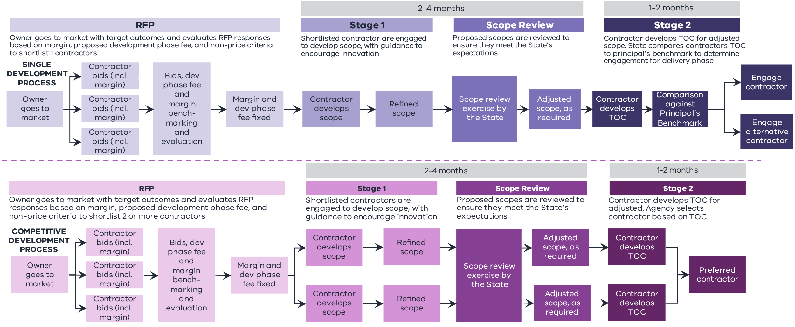
- – Detailed overview of Issue resolution procedure
