Victorian
Government
Climate-related
Risk Disclosure
Statement 2022

Acknowledgement
We acknowledge and respect Victorian Traditional Owners as the original custodians of Victoria’s lands and waters, their unique ability to care for Country and deep spiritual connection to it. We honour Elders past and present whose knowledge and wisdom has ensured the continuation of culture and traditional practices. We are committed to genuinely partner, and meaningfully engage, with Victoria’s Traditional Owners and Aboriginal communities to support the protection of Country, the maintenance of spiritual and cultural practices and their broader aspirations in the 21st century and beyond.

The Secretary
Department of Treasury and Finance
1 Treasury Place
Melbourne Victoria 3002
Australia
Telephone: 03 9651 5111
dtf.vic.gov.au

Authorised by the Victorian Government
1 Treasury Place, Melbourne, 3002

© State of Victoria 2022
You are free to re-use this work under a Creative Commons Attribution 4.0 licence, provided you credit the State of Victoria (Department of Treasury and Finance) as author, indicate if changes were made and comply with the other licence terms. The licence does not apply to any branding, including Government logos.
Copyright queries may be directed to IPpolicy@dtf.vic.gov.au.
Published October 2022.
If you would like to receive this publication in an accessible format, please email information@dtf.vic.gov.au.
This document is available in Word and PDF format at dtf.vic.gov.au.

Foreword
The Victorian Government is a proud leader on climate action.
We have introduced world-leading legislation with the Climate Change Act 2017, which establishes in law our commitment to net zero emissions by 2050 and sets up a clear framework to get there.
Our targets to reduce Victoria’s greenhouse gas emissions by 28 to 33 per cent below 2005 levels by 2025, and 50 per cent by 2030, make us one of the leading jurisdictions globally for emissions reduction.
We are pleased to continue that leadership with the release of the Victorian Government Climate-related Risk Disclosure Statement 2022.
The publication of this disclosure marks the first time in Australia that a government has made a climate-related disclosure in line with the recommendations of the G20 Financial Stability Board’s Taskforce on Climate-related Financial Disclosures. In doing so, it paves the way forward in public sector disclosure of climate-related risk management.
Our action on climate change is more important than ever. The latest Intergovernmental Panel on Climate Change report confirms that the impacts of climate change are widespread, rapid and intensifying.
In Victoria, we are already facing more hot days and harsher fire seasons. We are experiencing fewer but more intense rainfall events, increasing the risk of flash flooding in some places.
This statement outlines how the Government is managing climate-related risks to the state of Victoria, and to the Government’s delivery of services to the community. It also outlines how we are seizing on the opportunities associated with the transition to a net zero, climate-resilient economy.
By releasing this disclosure, we affirm our commitment to providing transparency to the community and investors about how we are managing climate change, in line with global best practice. We are committed to continuously improving our disclosure over time, as we partner with our communities, industries and governments to address climate risk and leverage opportunities.

The process of developing this disclosure is also a useful tool for identifying opportunities to improve how we manage climate change, and ensuring we have robust, effective systems and processes in place to manage related risks and opportunities.
Together, we want to build a cleaner, stronger and fairer Victoria as we work towards our goal of a net zero emissions, climate-resilient state.

Tim Pallas MP The Hon. Lily D’Ambrosio MP
Treasurer Minister for Energy
Minister for Economic Development Minister for Environment and Climate Action
Minister for Industrial Relations Minister for Solar Homes
Minister for Trade

Contents
About this disclosure 1
Overview 2
1. Governance and legislation 4
1.1 Strong and stable system of government 4
1.2 Climate action built into legislation 4
1.3 Fit-for-purpose climate governance 7
2. Strategy 10
2.1 Victoria’s changing climate 10
2.2 Climate-related risks for Victoria 12
2.3 A roadmap for climate action 15
2.4 Ensuring prosperity from climate action 16
3. Risk management 21
3.1 Transitioning to a clean energy economy 21
3.2 Building climate resilience 23
3.3 Embedding continuous improvement in climate risk management 28
4. Working with our partners and communities 33
4.1 Traditional Owner expertise and Aboriginal self-determination 33
4.2 Partnering with Australian and international governments 34
4.3 Supporting Victorian communities 34
5. Metrics and targets 36
5.1 Ambitious interim emissions reduction targets 36
5.3 Strong and achievable energy targets 41
5.5 Targets for government operations 43
6. Next steps for Victoria 44

About this disclosure

The Victorian Government Climate-related Risk Disclosure Statement 2022 (the disclosure) outlines the Government’s actions to understand, manage and monitor climate-related risks and opportunities for Victoria, as well as the government’s own operations.
The disclosure is informed by the recommendations of the G20 Financial Stability Board’s Taskforce on Climate-related Financial Disclosures (TCFD) and is consistent with the broad structure of the International Financial Reporting Standards Foundation’s International Sustainability Standards Board (ISSB) exposure draft on climate-related financial disclosures.
The TCFD recommendations were developed for the private sector, but have been widely adopted, are well understood domestically and internationally, and are generally adaptable to the public sector context (see Figure 1).
The disclosure extends beyond the TCFD recommendations by describing aspects of climate-related risk management that are unique to the public sector context – Section 1 describes how Victoria’s legislative framework, together with governance arrangements, supports the management of climate-related risks; and Section 4 outlines the Government’s work with partners and communities, which is critical to managing climate-related risks for the state.
The disclosure is an initial statement that describes the Government’s existing actions and approach, and establishes a baseline from which to build over time in future disclosures. The Government is committed to ongoing improvements and welcomes feedback from stakeholders on the disclosure to inform future focus areas. To provide feedback please contact us at: information@dtf.vic.gov.au.
Figure 1: Consistency with TCFD recommendations
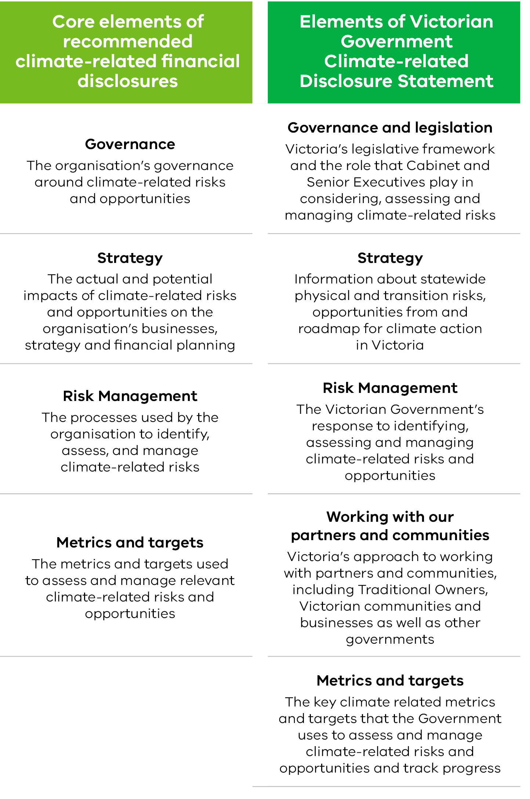

Overview

Climate-related risks include risks associated with the physical impacts of climate change, and risks from the transition to a climate-resilient, net zero emissions economy. This statement describes these risks to Victoria and how the Victorian Government is managing them as a climate action leader.

Governance and legislation
Victoria has a strong and stable system of government and culture of public accountability. Climate legislation creates whole-of-government oversight, shared accountability and devolved responsibilities to build climate resilience and transition to net zero emissions. In addition, the Victorian Secretaries’ Board provides strategic oversight on progress towards Victoria’s climate change objectives.

Strategy
With Victoria’s climate already 1.2 degrees warmer, and with more change to come, the Government released Victoria’s Climate Change Strategy in 2021. The strategy includes interim emission reduction targets and adaptation priorities for the next five years, as well as emissions reduction pledges for all sectors of the economy. The pledges include cost-effective solutions available at scale now, and actions that will build capacity to reduce emissions in the future.
By prioritising effective climate action, the Government is providing assurance to the community and investors that it can continue to deliver for its citizens in the face of climate-related risks. Early leadership enhances opportunities to innovate, create jobs, safeguard public finances and generate investment – ensuring a sustainable, growing economy for Victoria.

Risk management
As the global clean energy transition accelerates, Victoria is playing a leading role with policies and an unprecedented $1.6 billion investment in renewable energy and energy efficiency that give the energy sector confidence to invest in new renewable energy projects, develop supply chains and create local jobs.
The Government is also taking critical steps to build climate resilience, releasing five-year Adaptation Action Plans in 2022 for seven essential statewide systems that are either vulnerable to climate change impacts or essential to ensure Victoria is prepared.
Victoria’s ongoing management of climate risks involves continuous improvement via a legislated five-yearly cycle that incorporates the latest science and builds ambition over time. This cycle is supported by the Victorian Government Risk Management Framework and tools to build climate risk capability across government.

Working with our partners and communities
Minimising the impacts of climate change and taking advantage of the opportunities requires a partnership between all tiers of government, Traditional Owners, institutions, communities and businesses, as well as other jurisdictions. The Government supports community-led action, and draws on expertise and knowledge from across the state and from other jurisdictions, to ensure the benefits of climate action are shared and no one is left behind.

Metrics and targets
Victoria has five-year interim emissions reduction targets and annual greenhouse gas emissions reports required by legislation – establishing a clear pathway to net zero by 2050. Victoria reduced emissions by 29.8 per cent between 2005 and 2020 – comfortably exceeding its 2020 emissions reduction target – and has set a target to reduce emissions by
50 per cent by 2030 on 2005 levels.
The Government has legislated strong but achievable renewable energy targets which require renewable energy to contribute 25 per cent of Victoria’s electricity generation by 2020, 40 per cent by 2025 and 50 per cent by 2030. Victoria comfortably surpassed its 2020 target with renewable energy accounting for more than 30 per cent of total electricity generation by the end of 2021.

Next steps
The Government will continue to strengthen its understanding and management of climate-related risks and opportunities to support Victoria achieve a net zero and climate-resilient future and maximise opportunities that a clean economy offers in a just and sustainable way. The Department of Treasury and Finance will continue work to understand and assess the impact of climate-related risks and opportunities on the Victorian economy and on the financial performance and position of the state. This will include assessment of the impact of a selection of risks over different time scales and under different climate scenarios.

    - Governance and legislation
The Victorian Government is underpinned by strong governance and legislative frameworks, which support the effective management of climate-related risks and realisation of opportunities.

      - Strong and stable system of government

Victoria’s institutional strength
Victoria is one of six states in the Federation of Australia. It has a parliamentary system based on democratic elections and the Westminster system of government. Roles and responsibilities are divided between the Commonwealth and the states in accordance with the Australian Constitution. The rule of law and culture of public accountability support strong, stable and transparent governance. This institutional strength provides the foundation for an effective climate governance environment.

Victorian Government decision making
The Government has a well-established system to support its decision making on the most significant climate-related issues facing the state.
Cabinet is the principal decision-making body for the Government. It comprises all Victorian Government Ministers, with the Premier as the chair, and considers state significant policy and legislation. Well-established arrangements and principles for the operation of Cabinet ensure strong governance.
The Minister for Environment and Climate Action is responsible for the administration of the climate change portfolio and engages colleagues and Cabinet on climate-related issues. All ministers are engaged in the process of managing climate risk as lead and/or supporting ministers for emissions reduction pledges and climate adaptation systems. There is a rigorous process to ensure that all submissions considered by Cabinet are evidence-based, fit-for-purpose and represent a coordinated whole-of-government perspective. An example is the successful development and implementation of Victoria’s Climate Change Strategy.

      - Climate action built into legislation

Climate Change Act 2017
Victoria’s Climate Change Act 2017 (CC Act) establishes in legislation a long-term target of net zero emissions by 2050, making Victoria one of the first jurisdictions in the world to do so. The CC Act includes a framework of five-yearly interim emissions reduction targets, emissions reduction pledges and Adaptation Action Plans informed by the best available science (see Figure 2). Victoria is the only state in Australia that is committed to developing new climate targets and policies every five years, creating a pathway to net zero emissions.
The CC Act prescribes roles and responsibilities for the Premier, the Minister and nominated Ministers for the preparation of each legislative instrument as well as requirements for their public release and/or tabling in Parliament (see Figure 2). This creates a model of shared accountability, transparency and ownership across Government for the achievement of climate change objectives. Nominated Ministers are accountable for reducing emissions and/or managing the impacts of climate change on their portfolio.
The CC Act also includes a general duty to ensure that any decision made by the Government and any policy, program or process developed and implemented by the Government appropriately takes climate change into account where relevant in government decision-making, policies, programs and processes.

Figure 2: Legislative framework, roles and responsibilities under the CC Act

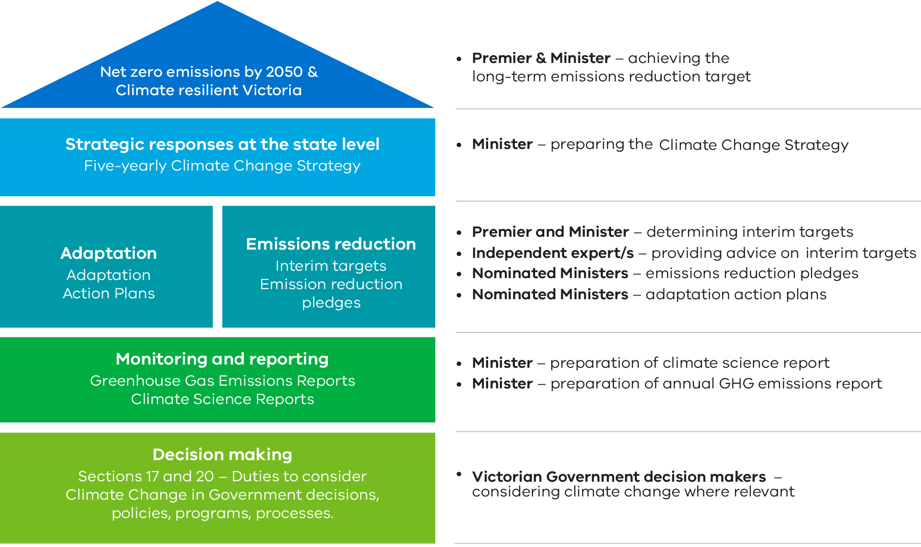

Policy objectives of the Climate Change Act 2017
- Reduce the State’s greenhouse gas emissions consistent with long-term and interim emissions reduction targets
- Build the resilience of the State’s infrastructure, built environment and communities through effective adaptation and disaster preparedness action
- Manage the State’s natural resources, ecosystems and biodiversity to promote their resilience
- Promote and support the State’s regions, industries and communities to adjust to the changes involved in the transition to a net zero greenhouse gas emissions economy, including capturing new opportunities and addressing any impacts arising from the need to reduce greenhouse gas emissions across the economy
- Support vulnerable communities and promote social justice and intergenerational equity.

Financial Management Act 1994
The Standing Directions 2018 issued by the Assistant Treasurer under the Financial Management Act 1994 (FM Act) set the standard for financial management by Victorian Government agencies. Under these standing directions, Victorian Government departments and public bodies need to comply with mandatory risk management and insurance requirements in the Victorian Government Risk Management Framework (VGRMF).
The VGRMF describes the minimum risk management requirements government departments and agencies are required to meet to demonstrate that they are managing risk effectively. This will generally include climate-related risks.
The Financial Reporting Directions, which prescribe financial and non-financial reporting requirements, are also developed under the FM Act.

General obligations to consider climate change
A range of other legislation establishes general obligations on decision makers in the Victorian public sector that extend to consideration of climate change.
- The Public Administration Act 2004 requires boards of public entities to advise responsible Ministers and Secretaries of major risks, consider foreseeable risks of harm to the interests of their entity and exercise care, diligence and skill. Climate-related risks are likely to present foreseeable risks of harm to the interests of Victorian public entities in the vast majority of cases. Guidance for Board members of Victorian Government portfolio entities titled, ‘Directors’ Duties with respect to Climate Risk’, is available on the Victorian Public Sector Commission’s website: Boards.vic.gov.au.
- The General Environmental Duty (GED) under the Environment Protection Act 2017 requires all Victorians, including public sector decision makers, to prevent and minimise harm to people and the environment from pollution or waste (including greenhouse gas emissions). The GED is a positive duty to proactively identify and manage environmental risk. The Environment Protection Authority has developed a draft guideline for managing greenhouse gas emissions to support organisations, including public sector decision makers, to eliminate or reduce greenhouse gas emissions.
- Climate change consideration is also required under a range of other legislation, including for example:
  - Local Government Act 2020
  - Transport Integration Act 2010
  - Flora and Fauna Guarantee Act 1988
  - Marine and Coastal Act 2018
  - Yarra River Protection (Wilip-gin Birrarung murron) Act 2017
  - Circular Economy (Waste Reduction and Recycling) Act 2021
  - Great Ocean Road and Environs Protection Act 2020

      - Fit-for-purpose climate governance

Departments and agencies
Each department and agency is responsible for identifying, assessing and managing all risks to which they are exposed, including climate-related risks. The VGRMF requires that all departments and agencies appoint an audit committee to provide independent assurance that the risk and control environment is operating efficiently and effectively, consistent with the department or agency’s risk management framework.

The Victorian Secretaries’ Board
The Victorian public sector has continued to evolve its governance approach to meet the demands of the Government’s climate change agenda and the evolving risks and opportunities presented by a changing climate. In addition, the Victorian Secretaries’ Board (VSB) provides strategic oversight on progress towards Victoria’s climate change objectives.
The VSB comprises the Secretaries of each department, the Chief Commissioner of Police and the Victorian Public Sector Commissioner (see Figure 3). Its role is to coordinate policy initiatives across the public sector and promote leadership and information exchange.
Figure 3: Victorian Secretaries’ Board membership

State Significant Risk Interdepartmental Committee
The State Significant Risk Interdepartmental Committee (Risk IDC) takes a whole of government perspective on risk, with particular responsibility to advise the Government (through the Assistant Treasurer) on state significant risks and the effectiveness of the VGRMF in helping agencies manage risk effectively, including climate-related risks. It also provides assurance that the most significant risks to the State are known, understood and actively managed.
The Risk IDC supports the identification of major shared and state significant risks, provides advice to departmental secretaries on emerging risks so they can better manage them, and provides advice to the VSB and Cabinet (through the Assistant Treasurer) on options to address any substantial gaps identified.
Climate change already features prominently in several state significant risks due to the scale and complexity of potential impacts. These include the risks of a disorderly energy transition, a major emergency or significant concurrent statewide emergencies due to natural disaster, and the harm experienced by the economy, community, environment and government due to the physical effects of a changing climate.

The Risk IDC is chaired by the Deputy Secretary, Economic Division of the Department of Treasury and Finance, and has senior executive representation from each department and the Victorian Managed Insurance Authority (VMIA).

Emergency management governance
As Victoria’s climate continues to change, effective emergency management will help to keep the community safe. In Victoria the planning for and management of emergencies occurs in a multi-agency framework that supports the capacity to adapt to new or changed circumstances.
A State Emergency Management Plan (SEMP) provides arrangements for an integrated, coordinated and comprehensive approach to emergency management at the state level. The Emergency Management Act 2013 (EM Act) requires the SEMP to set out actions to be taken before, during and after an emergency, and to specify the roles and responsibilities of agencies in relation to emergency management.
Emergency Management Victoria (EMV) was established under the EM Act and is responsible for whole-of-government policy for emergency management in Victoria. EMV also supports the Emergency Management Commissioner who has overall responsibility for leading and coordinating emergency preparedness, response and recovery across the emergency management sector, in conjunction with communities, government, agencies and business.
The Inspector General for Emergency Management (IGEM) provides assurance to the Government and community on emergency management arrangements and fosters continuous improvement.
The State Crisis and Resilience Council (SCRC) was established under the EM Act and is responsible for providing emergency management policy and strategy advice to the Government, and EMV must have regard to decisions made by the SCRC. Its membership consists of the secretaries of all government departments, the Chief Executive Officer of the Municipal Association of Victoria, the Emergency Management Commissioner, the Chief Executive of Emergency Management Victoria and the Chief Commissioner of Victoria Police, and includes the IGEM and Bushfire Recovery Victoria as observers.

Tailored governance

There are specific governance arrangements in place to meet legislative obligations under the CC Act as well as the Government’s climate policy and programs delivered under three climate action workstreams (see Figure 4).
Statutory outputs such as emissions reduction pledges and Adaptation Action Plans are endorsed by Cabinet and supported by executive-level inter-departmental forums. Portfolio-specific arrangements are also in place, for example, the Agriculture portfolio has established the Victorian Agriculture and Climate Change Council to provide independent and strategic advice to the Minister for Agriculture on how the agriculture sector can prepare for and respond to the impacts of climate change.

Figure 4: Climate action workstreams
Reducing emissions | Developing, implementing and monitoring actions to reduce emissions for government and all of Victoria, including the transition to a clean energy economy, through:  - implementing Victoria’s Climate Change Strategy and emissions reduction pledges for the 2021-25 period  - advising government on the 2035 interim emissions reduction target.
Improving climate resilience | Developing, implementing and monitoring actions to build resilience to climate change impacts for government and all of Victoria, through:  - implementing seven Adaptation Action Plans for the 2022-26 period  - managing climate hazards in the marine and coastal environment  - critical infrastructure resilience and management of bushfire risk.
Considering climate change | Developing tools and guidance:  - for government decision-makers to fulfil their duties and effectively manage risks, and  - to support transparency and disclosure of climate risks.

    - Strategy
This section provides information about the physical and transition risks that confront Victoria and opportunities from climate action for the state. It also provides an overview of Victoria’s roadmap for climate action, with resulting social and economic opportunities benefitting communities across the state, now and into the future.
      - Victoria’s changing climate

Physical risks resulting from climate change arise from the interactions between potential climate-related hazards, such as bushfires, flooding, sea-level rise and extreme heat, with the exposure and vulnerability of human and natural systems.
The latest Intergovernmental Panel on Climate Change report confirms that changes in the world’s climate are widespread, rapid and intensifying. Human influence is contributing to many observed changes in extreme events, such as heatwaves and droughts. Some changes, such as sea-level rise, are already irreversible. Even with ambitious targets and actions to reduce emissions, further change is locked in.

Victoria’s future climate will be hotter and drier
Victoria’s climate has warmed by at least 1.2 degrees since national records began in 1910. Victoria’s warmer and drier climate means more hot days and harsher fire seasons. There will be less overall rainfall and snow, but more intense rainfall events, increasing the risk of flash flooding in some locations. An overview of Victoria’s changing climate is set out in Figure 5.

Figure 5: Overview of Victoria’s changing climate
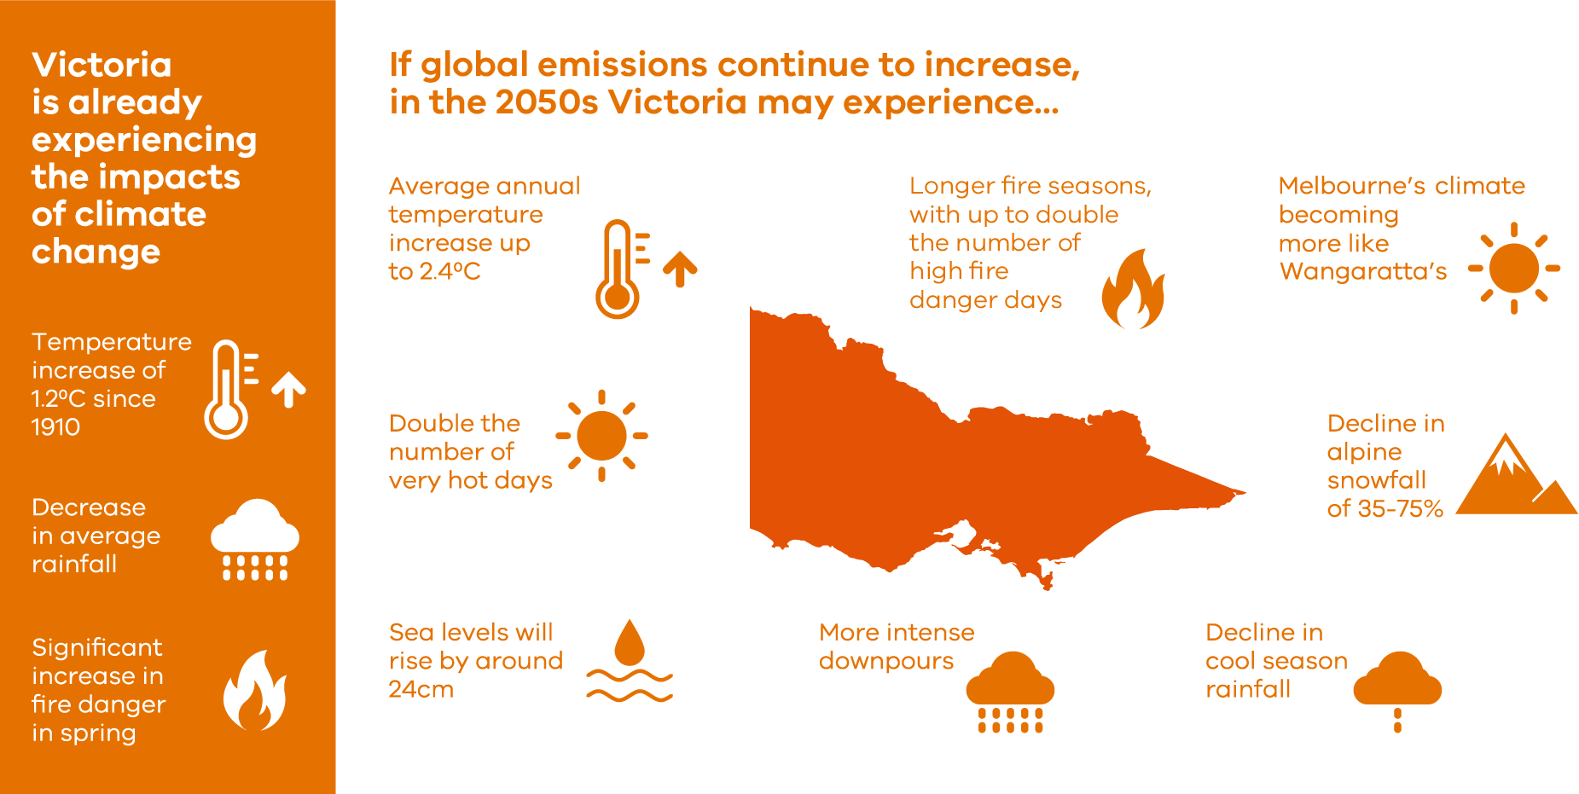
Projections are under high emissions scenario, compared to 1986–2005.
Updated from Victoria’s Climate Science Report 2019.

Using the latest climate science

Victoria’s Climate Science Report 2019 describes how our climate is changing and includes local-scale future climate projections for Victoria, developed with the Commonwealth Scientific and Industrial Research Organisation (CSIRO). The Government is continuing to invest in a climate science program and leverage national research to inform the next report due in 2024.
Climate projections, supporting tools and guidance are informing decisions across the Government and are available online to help local governments, communities and businesses manage climate-related risk. Victoria’s Future Climate Tool can be used by anyone and particularly benefits risk practitioners, environmental/sustainability officers, and program, service, and infrastructure managers.

      - Climate-related risks for Victoria

System-based challenges

As Victoria’s climate continues to warm, the need to recover and build resilience between events will continue to increase. Taking steps now reduces the impacts on the health of people and ecosystems and minimises economic disruption. It also protects Victoria as a destination for investment, employment and tourism. Ambitious adaptation efforts taken today can help to prevent future disruptions and job losses in industries that are central to our state’s economy, such as tourism and primary production.
The Government is working to understand climate change risks, support the most vulnerable people and assets, and prioritise solutions that will help protect essential systems and services. Building Victoria’s Climate Resilience (BVCR) outlines challenges across systems summarised in Figure 6.

Figure 6: Key challenges for seven statewide systems
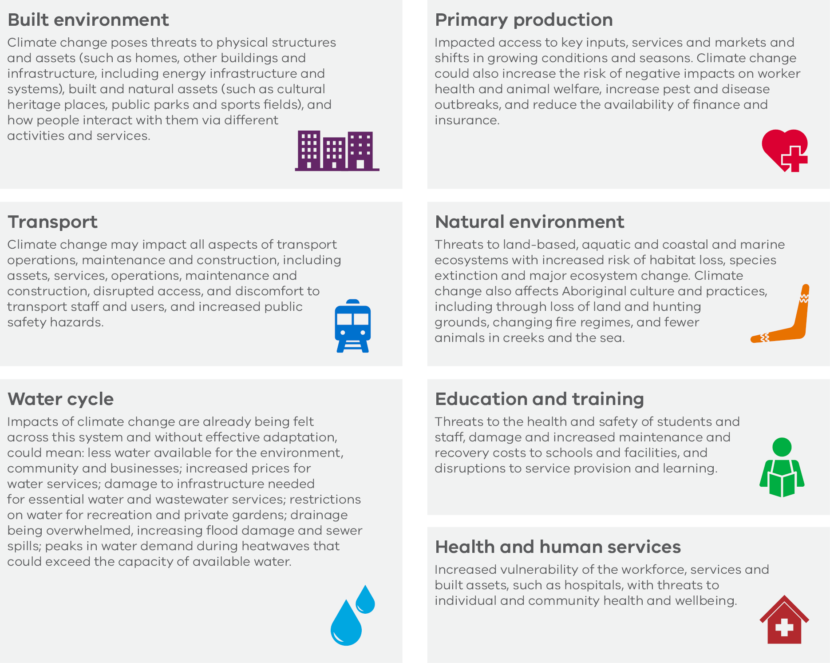
For information about how the Government is driving ambitious adaptation action in response to these challenges refer to Section 3.

Possible impacts on Victoria’s economy

The physical risks associated with climate change may result in significant expense to households, business and government. For example, hazards like heatwaves can reduce workplace productivity, cause deaths and increase emergency department presentations and hospital admissions, and damage infrastructure.
The transition to a net zero emissions economy presents both economic costs and opportunities. Carbon-intensive industries, and regions and workers with high reliance on such industries, will need to navigate alternative economic opportunities. The Government is committed to supporting workers and communities linked to industries in transition to ensure no Victorian is left behind.
Heatwave events already cost Victoria on average $87 million each year. By 2030, they are predicted to cost the Victorian economy $179 million per year. Heatwaves are the leading cause of weather-related deaths in Australia and increase emergency department presentations, hospital admissions, the likelihood of power outages and will increasingly threaten worker safety and productivity in weather-exposed industries.
The transition in the economy’s industry mix may cause periods of volatility in activity and challenges for directly affected businesses and workers, while decarbonisation will also generate economic activity, for example in renewable energy, and boost productivity by lowering costs for businesses and households through energy efficiency initiatives.
In the week beginning 12 January 2020, the rate of Victorians presenting to hospital with asthma and breathing difficulties increased by 125 per cent and 60 per cent respectively, coinciding with periods of significant fire activity or air pollution. This translated to roughly 485 asthma presentations, up from 215 during the same period the previous bushfire season, and 460 presentations for breathing difficulties, up from 280 during the same time the previous season. A similar increase was observed in the week beginning 5 January 2020.
Climate change may also reduce the productive capacity of the economy’s capital stock. For example, the productivity of agricultural land may be negatively affected in certain areas due to drought, sea level rise and other weather events. This aggregate effect on productivity though may be partly offset by investment in new technologies.
The financial sector may also be impacted, particularly through lending exposures to sectors of the economy affected by the downside risks of transition. Insurers may face rising claims for more frequent and more severe weather-related events. Combined, this could constrain credit availability, limit access to financial products, and pose financial stability risks.

Latrobe Valley Authority
The Government established the Latrobe Valley Authority (LVA) in 2016, to oversee its support package for the Latrobe Valley region following the closure of the Hazelwood power station and mine, and to coordinate the longer-term process of transition. The LVA continues to support the longer-term diversification of the region’s economy by building the skills of workers and businesses and investing in identified future growth industries that will create quality, long-term local jobs in strategic growth sectors.
To avoid another unexpected closure, the Government introduced a requirement for Victoria’s coal-fired power stations to provide at least five years notice before closing. The 2028 closure date of the Yallourn power station (announced in March 2021) allows time for workers to plan, reskill and retrain and for government to respond with resources at the right time and in the right place. Over the next year, the LVA will lead the development of a comprehensive Transition Plan to ensure the region is prepared for Energy Australia’s closure of Yallourn in 2028 and other industry transition. The LVA and the Department of Jobs, Precincts and Regions are working together with Energy Australia to commence planning and early intervention for Yallourn’s workforce and supply chain transition.

Possible impacts on government expenditure and fiscal position
Climate-related risks may affect government expenditure and fiscal position because of the Government’s role serving the Victorian community. For example, significant unexpected expenditure to coordinate and deliver emergency response and recovery in response to hazards such as bushfires and extreme weather events could have a negative impact on the State’s operating statement. It could also include spending on infrastructure due to hazards such as heatwaves through higher maintenance and more recurrent repairs, the costs of building infrastructure to higher specifications, and costs relating to service delivery such as from increased emergency department presentations and hospital admissions.
The severity of recent bushfire seasons has had an unprecedented impact on communities across our state. More than 1.5 million hectares were burnt in the 2019–20 bushfires, resulting in $325 million in economic impacts on farms and up to $350 million in lost tourism revenue. These unprecedented bushfires also severely impacted threatened species and their unique habitats, including approximately 78 per cent of the state’s remaining warm temperate rainforest.

      - A roadmap for climate action

Victoria’s first Climate Change Strategy was released in May 2021, providing a roadmap to net zero emissions by 2050 and a climate-resilient state. The strategy details Victoria’s five-point plan to:
- Transition Victoria to a clean energy future that will create jobs, cut costs for households and businesses, and strengthen our energy system
- Invest in innovative technologies, such as zero emissions vehicles and hydrogen, and partner with businesses and communities to set Victoria up for their adoption
- Recognise and safeguard the role of our natural environment in reducing emissions, and ensure our farmers are well placed to embrace new technologies and practices that reduce emissions
- Support Victorian businesses and communities to cut emissions and thrive in a net zero emissions future
- Build Victoria’s climate resilience and strengthen our ability to withstand and recover from extreme weather events.
The Government’s interim targets – to reduce statewide emissions by 28 to 33 per cent below 2005 levels by 2025, and by 50 per cent below 2005 levels by 2030 – set Victoria on a credible pathway to achieving net zero emissions by 2050. These targets are supported by economy wide emission reduction pledges and a whole of government emissions reduction pledge – summarised in Figure 7.

Figure 7: Overview of Victoria’s 2021-25 emission reduction pledges
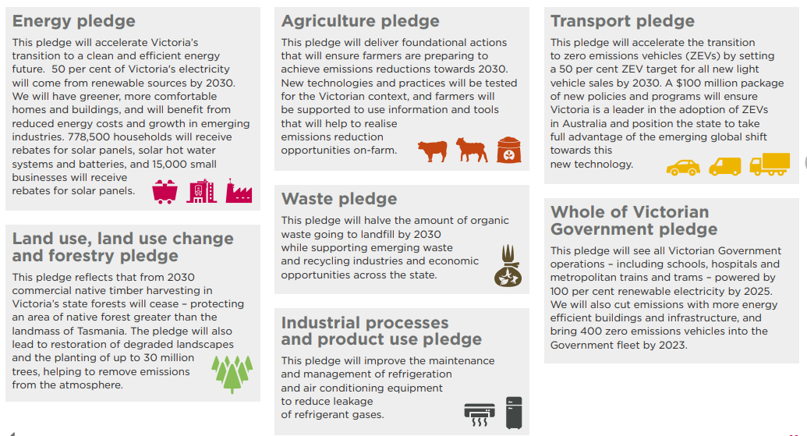

Sector pledge actions are focused on solutions that are cost effective and available at scale now, as well as building our capacity to reduce emissions in the future. The Government also recognises the critical role that Victorian businesses and households have to play in reducing the state’s emissions, and is providing essential support for these efforts.
For more information on these emissions reduction pledges, see Victoria's Climate Change Strategy.
      - Ensuring prosperity from climate action

The transition to a net zero, climate- resilient state could improve resource efficiency, lower energy costs, support innovation and the development of new products, services and markets, and provide resilience and sustainability co-benefits. By moving early to confront the challenges ahead, Victoria is well placed to seize on these opportunities as they emerge.

A changing climate opens market opportunities for Victorian primary producers
Shifts in water availability and temperatures on the land, as well as changing currents, chemistry and temperature in our marine environment could bring about a shift in what crops are grown where and what marine species will be harvested in our oceans. These changes may risk supply chain disruptions and impact on business productivity and profitability. However, they could also provide agriculture market opportunities such as alternative proteins, targeting of new productive fish species in Victoria’s marine waters and new aquaculture businesses.
Victorian farmers in the Wimmera and Southern Mallee region are thinking of ways to stay productive and sustainable while facing the challenges of extreme events and less rainfall. International and domestic markets are boosting opportunities for Australian pulses – such as lentils, fava beans and chickpeas – driven by rising demand for plant-based proteins and growing awareness of health and wellbeing, animal welfare and environmental concerns. In Horsham, recent investments in the manufacture of plant-based protein will provide a potential new high-value avenue for pulses, which are sold as bulk commodities and routinely grown for disease control and soil quality improvement.

Creating new jobs and supporting investment
The Government is investing to ensure Victorians can take advantage of new jobs and emerging opportunities in clean energy, the circular economy and climate resilience. For example, renewable energy employment in Victoria already leads Australia with Victoria accounting for 30 per cent of Australia’s renewable energy jobs. By 2030, estimates suggest 24,400 jobs will be created by achieving Victoria’s 50 per cent renewable energy target alone. Victoria’s actions to reduce emissions and increase climate resilience will create jobs, foster innovation and attract new investment, including but not limited to:
- The Second Victorian Renewable Energy Target Auction (VRET2) was held in 2021-22 with the aim of securing at least 600 megawatts (MW) of new renewable energy capacity in Victoria.
- Victoria’s $797 million Household Energy Savings Package announced in 2020-21 supports investment, employment and innovation in industries that supply solar energy and energy efficiency products and services. The Package also seeks to reduce the cost of household and business power bills and make homes more energy efficient, including by supporting households to make their own investments in renewable energy and energy efficiency. It includes an expansion to the existing Solar Homes program and a stronger Victorian Energy Upgrades program, which supports over 2,000 jobs.
- Victoria’s Greener Government Buildings program has created a $201 million pipeline of energy efficiency and renewable energy projects by reinvesting savings on energy bills. These projects will support jobs for engineers, project managers, electricians, plumbers and mechanical contractors, and suppliers of products and services.
- Victoria’s circular economy policy, Recycling Victoria: a new economy, will create around 3,900 jobs and support the development of clean business practices leading to less waste and new markets for recycled materials.
- Victoria is establishing a thriving offshore wind sector – paving the way for our state to host the first offshore wind energy projects in Australia. Our Victorian Offshore Wind Policy Directions Paper, released in March 2022, sets ambitious targets for first power by 2028, at least 2 GW by 2032, 4 GW by 2035 and 9 GW by 2040. Maximising the huge potential of our local wind resources could sustain up to 6,100 jobs, including 3,100 local jobs during the development and construction phases and an additional 3,000 ongoing jobs during operations.

Investing in skills, training and innovation
The Government is investing in the skills and training required for a clean economy through the $10 million Clean Economy Workforce Skills Initiative. This includes a 16-member Clean Economy Skills and Jobs Taskforce set up to guide the design, development and implementation of a 10-year Clean Economy Workforce Development Strategy. The Strategy will provide a comprehensive picture of the skills and training required for Victoria to take advantage of emerging job opportunities in clean energy, the circular economy and climate resilience. The Strategy is complemented by a $6 million Clean Economy Workforce Capacity Building Fund.
To ensure Victoria is well positioned to make the most of emerging opportunities, the Government is developing roadmaps and investing in research, commercialisation, trials and pilot programs. For example:
- The Government’s $2 billion Breakthrough Victoria Fund is investing in innovation and commercialisation. The clean economy is one of five priority sectors explicitly targeted by its independent fund manager Breakthrough Victoria, and there is substantial overlap with the other priority sectors. This landmark investment will ensure that the new technologies and practices for addressing climate change – like innovative energy and waste solutions – are imagined, validated and commercialised in Victoria.
- The Victorian Government has supported universities, energy companies and other innovative organisations to advance hydrogen technology and to prepare to produce, and use, hydrogen at scale. In March 2022, the Government provided $10 million for a renewable hydrogen highway transport backbone along Victoria’s busiest freight corridor, in addition to grants provided through the Renewable Hydrogen Commercialisation Pathways Fund and Renewable Hydrogen Business Ready Fund. Funding has been provided to most major Victorian universities, for hydrogen skills and products, through the Victorian Higher Education State Investment Fund.
- The Energy Innovation Fund is supporting the commercialisation of innovative, emerging renewable energy technologies in Victoria, required to meet the net zero emissions by 2050 target. The fund aims to bring intellectual property, innovation, local economic development and environmental benefits to the state, local businesses and communities. These will be achieved through supporting activities that progress innovative projects in their commercialisation continuum including feasibility/pre-investment studies, front-end-engineering-design, large-scale pilots and demonstrations.

Investing government funds sustainably
The Victorian Funds Management Corporation (VFMC), is managing climate risk across its portfolio and supporting the transition to net zero. VFMC manages funds of $72.1 billion for 31 Victorian public authorities and related organisations. As the impacts of climate change continue to amplify, investors globally are viewing their portfolios through a climate risk lens, and considering how best to position portfolios to:
- Manage the investment impact of climate risk and economic decarbonisation
- Safeguard their capital from increased risk of exposure to stranded assets.
Considering this, VFMC seeks to protect its clients’ portfolios from the potential investment implications of a decarbonising economy, including:
- increased risk (volatility) and reduced return forecast assumptions for asset classes
- impairment charges arising from assets exposed to transition risks
- increased financing costs for capital raising due to increased climate-related credit risks
- damage and business interruption due to extreme weather events
- impact to investee profit and loss from increased emissions-related costs.
Given climate risk is multi-dimensional and extends across multiple time periods, VFMC adopts a management approach that utilises levers at a company, whole-of-portfolio and systemic market-wide level. VFMC assess top-down portfolio implications, as well as undertaking climate risk and opportunity assessment from a bottom-up perspective through a rigorous pre-investment due diligence and approval process.
In late 2020, VFMC partnered with a global analytics and insights provider to conduct a portfolio-wide climate risk assessment. The information gained from this analysis, along with targeted company engagement and the move to exclude thermal coal miners from the portfolio, will assist VFMC to mitigate growing climate-based market risks.
VFMC is committed to supporting economy-wide decarbonisation and the reduction of real-world greenhouse gas emissions. VFMC has pledged to achieve a net zero emissions investment portfolio by 2050 and is currently developing and implementing a ‘roadmap to net zero’ in line with the COP-26 Just Transition Declaration. In addition to monitoring climate risk, VFMC also supports climate-positive investments which provide strong financial returns and help drive the economy’s transition towards net zero emissions. This applies across all asset classes, from renewable infrastructure to sustainability-linked loans. VFMC is also continuing to pursue investment opportunities that benefit from climate-related structural trends driving the reduction of greenhouse gas emissions. This includes clean power, resource efficiency, sustainable nutrition, biodiversity, clean transport and the rise of the circular economy.

Victoria’s Sustainability Bond
In September 2021, Treasury Corporation of Victoria (TCV) launched the $2.5 billion September 2035 Sustainability Bond under its new Sustainability Bond Framework. Issuance under this Framework supports the state’s initiatives in green, social and sustainability assets and expenditure programs. These programs aim to deliver a low carbon and climate-resilient economy and deliver positive social outcomes for Victorian communities. The Sustainability Bond was issued in alignment with the International Capital Markets Association (ICMA) Sustainability Bond Guidelines and the amount on issue has subsequently grown to over $4 billion as at 30 June 2022.
The bond is backed by an asset/expenditure pool that has a total estimated investment of over $9 billion (see Figure 8 for key projects). The asset/expenditure pool is independently verified by EY each year to ensure it continues to meet the requirements for a Sustainability Bond as set by ICMA.
As a benchmark bond, the 2035 Sustainability Bond is priced is line with other TCV benchmark bonds, but issuance under the sustainability label has allowed TCV to diversify its investor base into fund managers and other financial institutions that have designated ESG mandated funds.
The TCV 2035 Sustainability Bond won the 2021 Kanga News Australian Dollar Rates Bond Deal of the Year.

Figure 8: Key ‘green’ projects financed through Sustainability bond
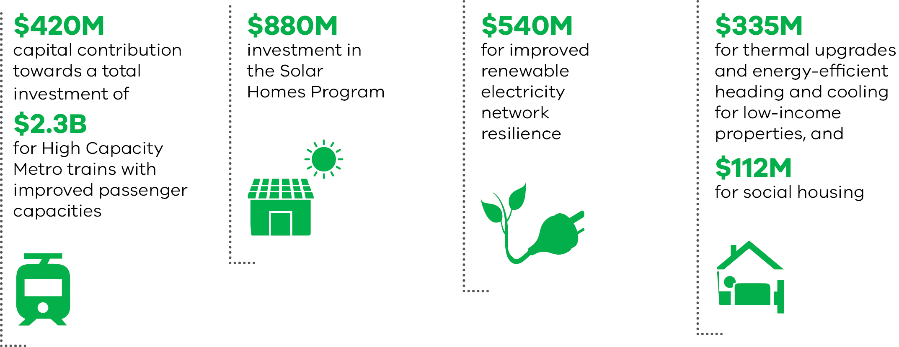

    - Risk management
Building upon the Victorian Government’s understanding of climate risks and opportunities in Victoria, outlined in the Strategy section, specific actions are being taken across the following themes: addressing energy transition risks; building resilience to physical risks from a changing climate; and driving continuous improvement in climate risk management processes.
      - Transitioning to a clean energy economy

Renewable Energy Targets and Renewable Energy Zones
Victoria’s electricity sector accounted for 50 per cent of Victoria’s net greenhouse gas emissions in 2020.The Government has legislated a strong but achievable Renewable Energy Target of 50 per cent by 2030, and has also released an Offshore Wind Policy Directions Paper that outlines an energy target of 9 GW by 2040 for offshore wind in Victoria. The targets provide a clear, long-term signal to the market about the need to transition.
The Government has established a $540 million Renewable Energy Zone (REZ) Fund to invest in REZ infrastructure support and establish a new body, VicGrid, to actively plan and develop Victoria’s REZs and unlock new renewable electricity investment. A new framework is being consulted on for how transmission infrastructure is currently planned and developed, and would introduce a strategic and proactive process to ensure timely co-ordination of investment in transmission, generation and storage infrastructure across Victoria’s REZs.

Gas Substitution Roadmap
On 2 July 2022, the Government released Victoria’s Gas Substitution Roadmap – the Government’s strategic plan to decarbonise the gas sector. The Roadmap outlines actions, including policy and regulatory reform to support sustainable alternatives to fossil gas and pathways for the gas sector to transition to net zero emissions.

Solar Homes
In 2018, the Government launched its 10-year, $1.3 billion Solar Homes Program. The program will provide 778 500 rebates to support Victorian households to install solar photovoltaic (PV) panels, solar or heat pump hot water systems, or solar batteries at their home. As of August 2022, the program has supported 214,000 households and contributed almost 1.3 GW of new solar PV generation capacity.

Improving energy efficiency
The Victorian Energy Upgrades (VEU) program provides subsidies for a range of low and no-cost energy-saving options such as low-flow showerheads and to replace major appliances such as hot water systems and heaters. Since 2009, the program has supported over 2 million households and over 150 000 businesses to upgrade appliances and equipment.
The Government is also improving the energy efficiency of the buildings it owns and leases across the state to improve performance and reduce operating costs and emissions through the Greener Government Buildings program. Savings on energy bills are being reinvested in further upgrades to create a $201 million pipeline of energy efficiency and renewable energy projects across the state.

Victoria’s first all-electric, 100 per cent renewable energy hospital
The Victorian Health Building Authority’s Engineering guidelines for healthcare facilities published in 2020 and revised Guidelines for sustainability in capital works in 2021 embed climate resilience into new health infrastructure and support the transition to all-electric public healthcare buildings.
In May, the Government announced funding for the new Melton Hospital, designed to be Victoria’s first all-electric hospital powered by 100 per cent renewable electricity. The hospital’s design will focus on sustainability initiatives such as maximising on-site solar generation, high-performing façades, efficient plant and equipment, and integration of green spaces within the hospital precinct.

Driving uptake of zero emissions vehicles
Victoria’s transport sector accounted for 25 per cent of Victoria’s net greenhouse gas emissions in 2020 and the transition to zero emissions vehicles (ZEV) presents a significant challenge and opportunity for the electricity grid and renewable sources. Victoria’s Zero Emissions Vehicle Roadmap and Transport Sector Emissions Reduction Pledge have set a strong target of 50 per cent new light vehicle sales to be zero emission vehicles by 2030. The Roadmap and Pledge are supported by a $100 million package of policies and programs, including Australia’s first ZEV subsidy program which provides individual subsidies at the point of sale.
The ZEV Roadmap includes $15 million to transition 400 existing passenger vehicles within the government fleet to ZEVs by June 2023. Introducing ZEVs into the government fleet will help drive the availability and range of new models for purchase in Australia, as well as support the second-hand market. Victoria is also ‘greening’ its bus fleet, investing $20 million in a statewide trial of zero emissions buses and all new public transport buses to be zero emissions from 2025.

Melbourne’s iconic trams are a sustainable way to get around
Melbourne’s trams are already powered by 100 per cent solar electricity – providing clean travel options for city commuters.
Under the Solar Trams Initiative, the Government purchases and surrenders about 82 000 MWh in large-scale generation certificates each year from Bannerton Solar Park near Robinvale and Numurkah Solar Farm near Shepparton, matching the electricity consumption of Melbourne’s entire tram network.
In July 2022, the Government switched on nearly 100 kilowatts of solar panels installed on the roof of the Southbank tram depot, the first of seven solar depots housing solar trams. 200 solar panels will be installed under the Greener Government Buildings program, producing over 550 megawatt hours of power annually to help power depot operations and keep the network running. The new solar panels are expected to cut CO₂ emissions by up to 350 tonnes and save approximately $370 000 on energy costs each year.

      - Building climate resilience

The Government is taking critical steps to adapt to the impacts of climate change and build a climate-resilient state using a comprehensive, evidence-based approach for adaptation that includes adaptation planning for statewide systems and complementary community-led action.
Building Victoria’s Climate Resilience sets out how the Government is driving ambitious adaptation action by:
- using the latest climate science
- building on investment in adaptation and implementation of Adaptation Action Plans for seven statewide systems
- ensuring all communities benefit from the social and economic opportunities of a climate-resilient Victoria, now and into the future.

Adaptation Action Plans
The Government released its first suite of Adaptation Action Plans in February 2022. The plans cover seven essential statewide systems that are either vulnerable to climate change impacts or essential to ensure Victoria is prepared.
Victoria’s Adaptation Action Plans are guiding government action and helping institutions, businesses and individuals take informed action to respond to the risks and opportunities of our changing climate. The plans reflect lessons learned from adaptation efforts to date and have been informed by organisations and experts as well as the public through consultation in mid-2021. Each plan sets out the challenges of climate change for each system, the extensive work already underway and the key priorities for the next five years (see Figure 9).
The actions set out in each plan will help address the current impacts of climate change, reduce the barriers to adapt, and lay the foundation for transformational adaptation so Victoria is prepared for future climate scenarios. Together with Victoria’s six community-led Regional Adaptation Strategies, the plans will help ensure Victoria is ready to respond to the risks and opportunities of a changing climate.

Figure 9: 2022–2026 Adaptation Action Plans for seven statewide systems
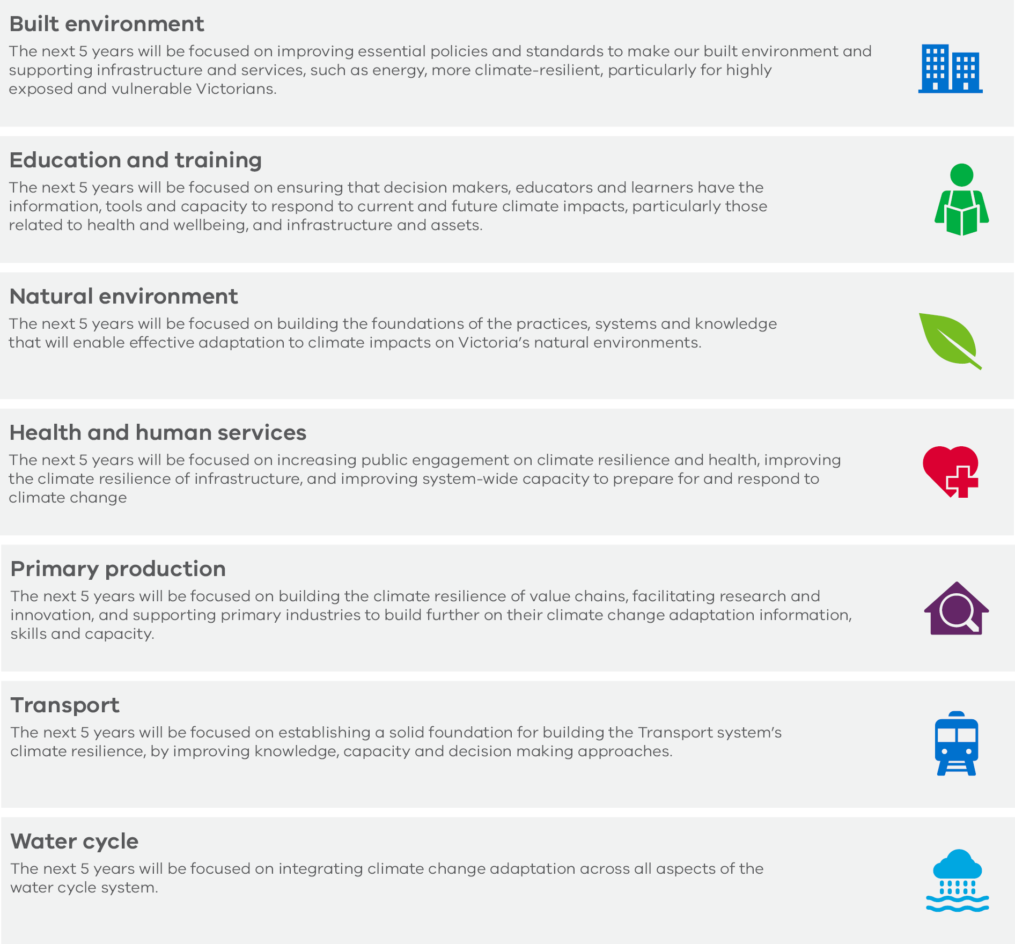

Managing climate hazards in the marine and coastal environment
The Marine and Coastal Policy 2020 (Policy) sets direction and policy for managing and adapting to climate change impacts in coastal and marine areas, including a sea level rise benchmark and adaptation pathways approach that guide decision making.
The Marine and Coastal Strategy 2022 (Strategy) is the first of three five-year action plans to give effect to the Policy, and achieve the vision for a healthy, dynamic and biodiverse marine and coastal environment that is valued in its own right and benefits the Victorian community now and in the future.
Building on the directions in these documents, Victoria’s Resilient Coast – Adapting for 2100+ provides a statewide approach for coastal hazard resilience and adaptation. It includes a framework, guidelines, and support for local government, land managers and their communities to enable place-based, leading practice and long-term coastal hazard adaptation.

Critical infrastructure resilience
Victoria’s Critical Infrastructure Resilience Strategy gives effect to Part 7A of the EM Act, providing the foundation for building resilience and reducing disruptions to essential services. The strategy sets out the vision, principles and strategic priorities for building the resilience of Victoria’s critical infrastructure against all hazards, including climate change hazards. It also acknowledges the important role of infrastructure in delivering services that are essential to maintaining the social and/or economic wellbeing of the state.

Energy resilience
In response to the June and October 2021 major storm events and prolonged power outages, the Government is funding Energy Resilience Design Studies in several affected towns across Victoria.
As more communities are looking to make energy work better for them, the aim of the studies is to investigate energy backup systems for essential services and community hubs, including:
- rooftop solar
- batteries
- larger town-scale energy solutions.
Such options may offer the potential to boost network resilience in high-risk areas and ensure community relief hubs and key infrastructure maintain power during future extreme weather events.

Adapting how bushfire risk is managed
The Government is also committed to reducing the risk of bushfires in a changing climate, including by adapting how bushfire risk is managed. In 2021-22, the Government committed $517 million to forest and fire management to undertake bushfire management more efficiently and effectively in the context of a rapidly changing climate. It is also supporting commitments made in the government’s responses to recent bushfire inquiries.
This includes critical actions delivered under the Reducing Bushfire Risk program and Safer Together, such as an enhanced fuel management program, advanced bushfire risk modelling and upgrades to technology, fire towers and equipment. The radio communications system has been upgraded from analogue to digital, with a $133 million commitment improving reliability, interoperability and efforts to contain fires. To improve coordination and leadership, $21 million was provided to the new Office of Bushfire Risk Management.

Powerline Bushfire Safety Program
Following the Victorian Bushfire Royal Commissions into the Black Saturday Fires, the Government invested $250 million to reduce the likelihood of bushfires being ignited by power infrastructure through the Powerline Bushfire Safety Program (PBSP). Bushfires threaten essential infrastructure, such as energy transmission and distribution lines. These are also a potential ignition source, which can intensify bushfire risk, especially in elevated fire-danger conditions.
The funding was made up of $200 million to underground or insulate 734 kilometres of high-risk bare-wire powerlines under the Powerline Replacement Fund, $40 million to provide 343 residential care facilities with auto-start backup generators under the Local Infrastructure Assistance Funding, and $10 million in Research and Development grants to support the next generation of bushfire safety technology. These investments have contributed to a 44.1 per cent relative reduction in powerline bushfire risk to date, with the likelihood of loss of life or damage to property as a result of powerline ignited bushfires projected to be almost halved by June 2023. A further $1.5 million was invested in 2021-22 to continue the delivery of PBSP, including business case development for future technology-led investment that reduces powerline-related bushfire risk.

Integrating resilience in recovery activities
Capital works delivered as part of recovery activities on public land seek to build resilience to climate change, including new bridges and crossings that are designed to withstand fire and 1-in-100-year floods using concrete and steel components.
By integrating climate sensitive design into bridge and crossing infrastructure built since 2008, including approximately 40 new concrete bridges since 2018, the Government has seen a return on investment in terms of insurability, with infrastructure experiencing substantially reduced damage as a result of extreme events, quicker return to service and reduced cost of reinstatement. For example, an East Gippsland bridge built in 2018 has proved resilient through several events including the 2019-20 bushfires and two floods in July 2020 and April 2022.

Climate action in the water sector
The Government has ambitious targets to reduce emissions from Victoria’s water sector and build a climate-resilient water system. Government action on climate change in Victoria’s water sector has two drivers: the CC Act and the Statement of Obligations (Emission Reduction), a directive issued by the responsible Minister under the Water Industry Act 1994.
Direct action on emissions
The Statement of Obligations (Emission Reduction) establishes greenhouse gas emission reduction commitments for the state’s 18 water utilities. These commitments are some of the most ambitious of any jurisdiction in the world, with Victoria’s water sector set to reduce its emissions by more than 90 per cent by 2030, and to be net zero by 2035. The Statement incentivises direct action on Scope 1 emissions and limits carbon offsetting.
Victoria’s water sector is responsible for a large proportion of all government sector emissions, and most of these emissions are greenhouse gases released directly through wastewater treatment processes. This presents a challenge and an opportunity for the state. Action on direct greenhouse gas emissions enables participation in the circular economy – water corporations can make a compelling business case for investing in waste-to-energy facilities that not only prevent the release of greenhouse gas, but actually turn them into a biogas that can power some operations.
Victoria’s water corporations are limited in relying on purchasing carbon offsets to meet their emission reduction targets. The Statement allows for the purchase of Australian Carbon Credit Units (ACCUs) for difficult to abate emissions, for example from wastewater treatment. Most water corporations are required to source the ACCUs from projects undertaken within Victoria to support other values and benefits for the state.
Building a resilient water system
The Government published the Water Cycle Climate Change Adaptation Action Plan 2022-2026 in 2022. The water sector is one of the seven systems that must develop Adaptation Action Plans every five years, under the CC Act. The framing of ‘systems’ rather than ‘sectors’ acknowledges the complex, cascading and compounding effects of a changing climate. This framing also supports the identification and management of cross-system risks. For example, the impact of a changing climate on the frequency, distribution, and intensity of toxic blue-green algae outbreaks is of concern to the Primary Production Adaptation Action Plan, the Natural Environment Adaptation Action Plan and the Health and Human Services Adaptation Action Plan, as well as the Water Cycle Adaptation Action Plan.
The initiatives of the Water Cycle Adaptation Action Plan range from large-scale, multi-year programs for increasing the diversity of Victoria’s water supply mix, to small-scale or one-off projects. For example, DELWP will develop an iterative communications strategy to inform and influence the behaviour and attitudes of water users and decision-makers in relation to the impacts of a changing climate on the water cycle.
The experience of Victoria’s water sector demonstrates that seemingly niche or small-scale projects such as these can be instrumental in driving action on climate change. An excellent illustration of this is that under the Pilot Water Sector Adaptation Action Plan 2018-2020, DELWP developed the Managing Climate Change Risk Guidance for Board Members and Executives of Water Corporations and Catchment Management Authorities. This guidance was one of the first of its kind in the world, and has shaped the direction of climate action in the Victorian water sector.

      - Embedding continuous improvement in climate risk management
The Government is taking a comprehensive approach to regularly reviewing and improving the approach to climate risk management. This includes the legislated five-yearly climate change policy development cycle, the enterprise risk management framework and tools to build climate risk management capability across government.

Legislated five-yearly cycle
The legislated five-yearly cycle of climate action set out under the CC Act supports continuous improvement in climate risk management (see Figure 10).
The CC Act requires that climate actions, such as the five-yearly climate change strategy, are informed by appropriate evidence and advice. This includes the latest climate change science and knowledge, the advice of the Independent Expert Panel on interim emissions reduction targets, and evidence on the economic and social impacts of Victoria’s emissions reduction targets. In this way the management of climate risks in the Victorian Government is continuously improved as new evidence and advice is developed and considered in decision making.

Figure 10: Legislated five-yearly cycle of climate action
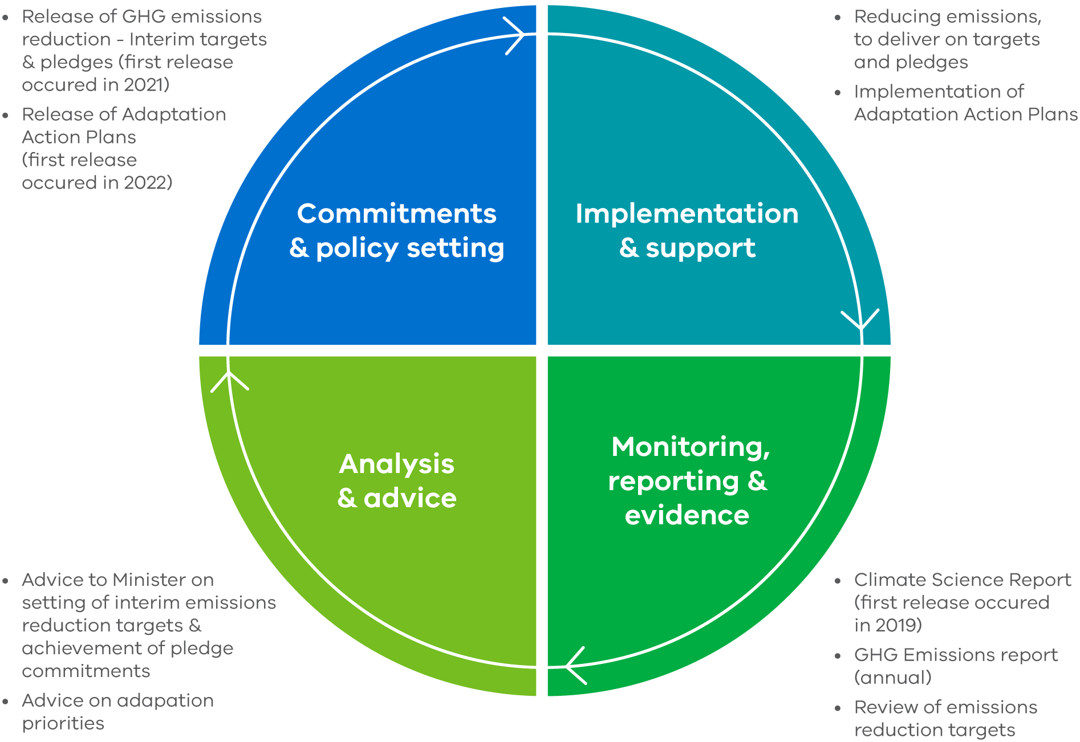

Enterprise risk management

The VGRMF sets out the minimum risk management requirements in the Victorian public sector. It applies to departments and public bodies covered by the FM Act. All other agencies are encouraged to adopt the VGRMF to enhance their risk management practices. All risks, including climate risks, are treated within this framework.
The VGRMF supports continuous improvement in climate risk management because of the way it sets a consistent standard for risk management and requires departments and agencies to regularly review their risk management approach to ensure it is appropriate to the changing risk environment.

Victorian Government Risk Management Framework
Agency risks | Shared risks | State-significant risks
Risks that can be managed entirely within a single agency’s operations and can generally be well understood and effectively managed with straightforward risk management processes. | Risks shared by two or more agencies that require coordinated management by more than one agency. The responsibility for managing a shared risk is shared by all the relevant agencies and will benefit from a coordinated response where one agency takes a lead role. | Risks where the potential consequences or impacts of the risk on the community, the Government and the private sector are so large as to be of state significance. While all state significant risks are shared between agencies, not all shared risks are state significant risks.
- All departments and agencies are required to demonstrate a positive risk culture, define their risk appetite, and consider their material risks in planning and decision-making.  - If no shared risk is identified, the risk is monitored and reviewed at a departmental level.  - When a potential shared risk is identified, it is escalated to a shared risk for coordinated management.  - All departments and agencies are required to review their risk profile and risk appetite at least annually. | - A potential shared risk is assessed to establish the context, causes, and impacts. Impacted agencies collaborate to agree on a lead agency responsible for the shared risk. All relevant agencies are required to participate in the delivery of a coordinated response.  - Work on climate risk to date has improved collaboration across departmental shared risks, and supports greater executive-level engagement when a risk is escalated. | - All departments and agencies are required to contribute to the identification and management of state significant risks.  - If a risk is deemed to be of state significance, it is escalated to the appropriate decision makers to enable a whole-of-government response.  - This could be a department head, the Victorian Secretaries’ Board or Cabinet via the relevant Minister.  - Climate change has been confirmed as a state significant risk and the head of the Department of Environment, Land, Water and Planning (DELWP) has lead responsibility.

Building the capacity to manage climate risk across the Victorian Government

The Government is working to establish and strengthen a positive risk culture across all departments and agencies in relation to climate-related risks and opportunities. The Government is continually building on resources and initiatives to improve the capacity of its people and processes to respond to climate change. Tailored supports and guidance are set out in the table below.

Function | Support
Governance | Directors’ duties with respect to climate risk  The Victorian Public Sector Commission in collaboration with DELWP has issued guidance on Directors’ duties with respect to climate risk, acknowledging the critical role Board members play in overseeing climate-related risks to the delivery of services relied on by the Victorian community. The guidance is complemented by a training module for new and ongoing board directors.  Climate-related risk roundtable for Audit & Risk Committees  A whole-of-government climate roundtable for Audit and Risk Committees was hosted by the VMIA in March 2022. The forum highlighted the important role Audit and Risk Chairs play to influence how climate change risks are identified and managed.
Enterprise Risk Management | Climate Change Risk Management service  The Climate Change Risk Management service provides resources to help government organisations consider and address climate change risks. These resources have been developed for government risk professionals by the VMIA in partnership with DELWP.  Cross-government Climate Risk Community of Practice  The Climate Risk Community of Practice aims to build capability amongst members in climate risk, facilitate interdepartmental collaboration to embed climate change considerations in decision-making, showcase leading practice, and foster innovation across the Victorian Public Sector.
Treasury and Finance | Annual budget process documentation  The annual state budget process includes business case templates that require broader impacts to be considered, beyond the direct benefits and financial costs of the proposal. These impacts extend to climate change impacts.  Investment Lifecycle and High Value High Risk Guidelines: Business Case  Published by DTF, the Investment Lifecycle and High Value High Risk Guidelines set out the issues that agencies should consider when preparing a business case for investment. For projects that are above $10 million in value, and / or classified as high-risk, agencies should consider climate change, including opportunities to reduce Victoria’s emissions and actions that can be taken to adapt to the impacts of climate change and increase the resilience of Victoria’s service delivery capability and supporting assets.
Sustainable Investment Guidelines
Published by DTF, the Sustainable Investment Guidelines supports project teams to incorporate environmental, social and economic sustainability in Victorian Government infrastructure investments. It is consistent with sustainability best practice and government priorities and policies including the Climate Change Strategy, the Recycled First policy, Green Bonds, and aspirations to mitigate project cost escalation by building a more circular economy.
Asset Management | Asset Management Accountability Framework (AMAF)  Published by DTF, the Asset Management Accountability Framework (AMAF) provides a framework for management of risks to government assets, supporting agencies to consider relevant risks (including climate change) in implementing AMAF requirements and recommendations across the asset lifecycle. More specific climate change guidance under the AMAF is currently in development, with the primary objective of building knowledge and capability among government asset managers, enabling them to adequately manage climate change risks and reduce emissions across the Government’s asset base.
Procurement | Social Procurement Framework  The Social Procurement Framework (SPF) establishes requirements that can be applied by government departments and agencies when they procure goods, services and construction. As part of the SPF, the Government promotes sustainable business practices that go beyond compliance requirements to both minimise adverse environmental impacts and deliver positive environmental outcomes through the procurement process.
Reporting | Direction and Guidance for government environmental reporting  The Government has updated ‘Financial Reporting Direction 24: Reporting of environmental data by government entities’ under the FM Act. The update and accompanying resources will ensure more comprehensive and consistent environmental and emissions reporting across the Government, while tailoring to the diversity of Victorian public sector entities and activities.
Climate adaptation planning | Capability building for public sector to undertake climate adaptation planning  The Government invested in capacity building to support the public sector develop seven system-based climate change adaptation action plans and six community-led regional adaptation strategies. Capability building focused on improving knowledge and skills in climate adaptation planning, including through guidance documents; new research; training and workshops; and working groups.

State purchase contract print supplier achieving measurable carbon savings
State Purchase Contracts have been set up to combine demand for commonly used goods and services. This enables government to harness greater economies of scale, increase efficiency of contracting through pre-agreed contract terms and conditions, and centralise supplier due diligence and contract management.
The Government’s print purchasing supplier, Finsbury Green, has developed the Finsbury Green Star Rating System for offset and digital print suppliers.
The Finsbury Green Star Rating System is independently audited and validated by current environmental science sourced from the National Greenhouse Accounts Factor 2017 and the National Carbon Offset Standard V3.
The rating has been reviewed by an independent panel of industry experts and science professionals, and provides an open and transparent environmental rating, as well as highlighting areas where suppliers can improve their environmental practices through a combination of technology and education.
It allows government purchasers to choose a supplier based on price and performance, along with environmental practices fundamental to reducing carbon and achieving measurable carbon emissions savings.

Victorian Managed Insurance Authority supports climate-related risk action
VMIA has the strategic dual role of providing risk management and insurance to Victorian Government departments and authorities. Its Risk Adviser role involves assisting in the establishment of programs for the identification, quantification and management of risks, monitoring risk management and providing risk management advice to the Government and risk management advice and training.
VMIA achieves this for climate change risk by building risk management capability through risk advice, services, training, tools and guidance and on-line risk maturity self-assessment service. VMIA insurance products provide cover for climate-related risks and VMIA considers the impact of changing climate-related events on its insurance portfolios and reinsurance arrangements.
In 2021, VMIA partnered with DELWP to launch a climate change risk management program. This VMIA facilitated workshop helps to explore risks known to the state and approaches adopted to apply risk management frameworks to better manage these risks. Participating in these workshops supports the state’s initiatives to manage the impacts of climate change.
VMIA established a dedicated team in 2019, Statewide Risk Advisory. The goal of this team is to focus on designing and delivering tailored bespoke risk management initiatives, services and advice for whole-of-government risks that are of state significance, including climate change risk. This team’s work supports building capability in the management of shared risks of significance across Victorian Government departments and agencies.

    - Working with our partners and communities
The Victorian Government is actively leveraging expertise, knowledge and experience of its partners and communities in managing climate related risks and opportunities.
      - Traditional Owner expertise and Aboriginal self-determination

The Government is committed to progressing Aboriginal self-determination in climate action – guided by the Victorian Aboriginal Affairs Framework 2018-2023 and the Victorian Government Self-Determination Reform Framework.
Victoria’s Treaty and the Truth processes acknowledge the dispossession and discrimination of the state’s colonial history and contemporary systems. Treaty will further provide a framework for the transfer of power and resources to support self-determining Aboriginal communities to take control of matters that affect their lives, including consideration of Traditional Owner rights on Country.
The Government’s land management approach in the context of climate change is informed by Traditional Owner voices, articulated in the Victorian Traditional Owner Cultural Landscapes Strategy, launched in 2021, and the Victorian Traditional Owner Cultural Fire Strategy. In 2021-22, the Government provided $11 million to Traditional Owner Corporations to implement the Cultural Landscape Strategy on Country and $22.5 million over four years with $6.3 million ongoing, to reinvigorate Traditional Owner-led cultural land and fire management practices.
The Government’s seven system-based adaptation action plans and the six community-led regional adaptation strategies include actions that support Aboriginal self-determination and integrate Traditional Owner expertise into adaptation planning.
The Government is also supporting Aboriginal self-determination in the transition to renewable energy technologies as well as in carbon and land restoration markets:
- The Traditional Owner Renewable Energy Program empowers Traditional Owner Corporations (TOCs) that are Victoria’s Registered Aboriginal Parties to design and implement renewable energy projects and plans. With a total of $1.1 million in grant funding offered, the nine TOCs that applied received $100 000 each to deliver their self-determining interests in renewable energy.
- The BushBank program has worked closely with Traditional Owner Corporations in the development of the BushBank First Peoples grants. Designed to increase the capacity of First Peoples to participate in biodiversity restoration and carbon markets, $14.5 million will be made available over the next 10 years through the grants program.

      - Partnering with Australian and international governments

The Government has been a proud member of the Under2 Coalition since 2016, and a member of its leadership Steering Group since 2018. Through a Memorandum of Understanding, targeted networking and knowledge sharing activities, the partnership demonstrates the effectiveness of sub-national governments in delivering impactful climate action.
Victoria is also a founding member of the Net Zero Future Policy Forum, along with Australia’s seven states and territories and Scotland. An initiative of the Under2 Coalition, the Forum is a voluntary international collaboration designed to address the practical challenges of achieving net zero emissions and leverage the unique policy levers of state and regional governments.
The Government is working closely with Commonwealth and state and territory partners to deliver the National Partnership Agreement on Disaster Risk Reduction, including two grant programs.
- The Risk and Resilience Grants program: replacing the previous Natural Disaster Resilience Grants Scheme available to municipal councils, government departments and agencies, and non-government organisations.
- State and Regional Priority Projects: supporting priority projects at the state and regional level, with an emphasis on risk mitigation activities identified by Regional Emergency Management Planning Committees.

      - Supporting Victorian communities

Inquiry into tackling climate change in Victorian communities
In 2021, the Government released its response to the Inquiry into Tackling Climate Change in Victorian Communities. The Inquiry was conducted by the Legislative Assembly’s Environment and Planning Committee and informed by 162 submissions from individuals, councils, community groups, government departments and agencies and greenhouse alliances. The Government Response recognises that addressing climate change requires sustained collective effort, with Victoria’s Climate Change Strategy establishing mechanisms for united climate action.

Supporting place-based regional adaptation
The Government is supporting Victoria’s diverse regional communities to prepare for and adapt to the impacts of climate change through six place-based, community-owned and -led Regional Adaptation Strategies (RAS). Released in December 2021, the RAS are the flagship initiative of the $9.32 million Supporting Our Regions to Adapt program. Each RAS identifies the unique challenges and opportunities of climate change and guides locally relevant practical adaptation action in Victoria’s six regions – Barwon South West, Gippsland, Grampians, Greater Melbourne, Hume and Loddon Mallee.

Climate Change Adaptation Stories
Climate Change Adaptation Stories is a video series released by the Government in 2022. The videos share outcomes of projects funded by the Community Climate Change Adaptation Grants Program, and feature interviews with community leaders involved in the initiatives. The $1 million program supported the delivery of 17 community-led adaptation projects over the past three years.

Sharing the opportunities of climate change action
Current Government policies ensure that all Victorians can share in the co-benefits of reducing emissions, such as reduced energy costs. Some examples include:
- $112 million for Energy Efficiency in Social Housing Program to support energy efficiency upgrades for 35 000 public, community and Aboriginal housing properties
- $5.3 billion for the Big Housing Build Program delivering over 12 000 social and affordable homes that meet 7-star energy efficiency standards
- The introduction of Minimum Energy Efficiency Standards for all rental properties in Victoria, helping tenants save on their energy bills while also reducing emissions
- 778 500 rebates over 10 years through the Solar Homes Program to support Victorian households to install solar, including dedicated support for rental providers and community housing organisations
- 118 energy audit grants awarded and 55 implementation projects funded in 2021-22 through the Community Climate Change and Energy Action Program
- Seven new Community Power Hubs established in 2021 providing 0.89 megawatts of renewable energy to local community facilities and businesses
- An estimated $4.26 million saved by Victorian Schools on their energy bills through participation in the Resourcesmart Schools Program.

Supporting Victorian communities to recover
The Government is investing in recovery programs and strategies to increase the resilience of communities, the natural environment, built infrastructure and local economies to future, more frequent and severe, weather events.
In 2021-22, more than $200 million was allocated to support communities and businesses to build back better after the destructive storm and flood events of June and October 2021. This investment included $105 million for the complex clean up jointly funded by the Victorian and Commonwealth governments.
Over $760 million in funding has been provided to support Victorian communities to recover from the devastating bushfires that burnt through over 1.5 million hectares of land across Eastern Victoria in the summer of 2019-20. This includes $464.3 million for initiatives jointly funded by the Victorian and Commonwealth governments under the Disaster Recovery Funding Arrangements.

    - Metrics and targets
The Victorian Government has a robust approach to setting, monitoring and reporting on emissions reduction and renewable energy targets that provide a credible pathway to net zero emissions by 2050.
      - Ambitious interim emissions reduction targets

Under the CC Act, the Government must set five-yearly interim emissions reduction targets, each target constituting a greater emissions reduction than the last.

Independent expert advice on interim targets
The CC Act requires the Government to obtain independent expert advice on interim targets and outlines the relevant considerations. The advice is required to include interim target options, indicative trajectories to net zero, and potential emissions reduction opportunities to achieve the targets. In recommending interim target options, the advice must consider: the likely impact of the interim target on the economy and the competitiveness of particular economic sectors of the economy; social and environmental circumstances; any relevant technology; and global climate change commitments.
The CC Act requires the Government to set the next interim emissions reduction target for 2035 by 31 March 2023. Martijn Wilder AM has been appointed as chair of the Independent Expert Panel, with Tennant Reed and Emma Herd as members, and must provide advice to the Minister for Energy and Climate Action by 1 March 2023. The panel sought the views of Victorians between April and June 2022 to inform the advice.

Interim emissions reduction targets to 2030
The Government has set ambitious yet achievable interim targets to cut the state’s emissions, informed by an Independent Expert Panel chaired by the Honourable Greg Combet AM.
28–33 per cent by 2025  below 2005 levels | 50 per cent by 2030  below 2005 levels
Victoria’s 2030 target confirms its position among leading jurisdictions around the world, such as the United States and the European Union.
The expert advice was tabled in Parliament and published online, providing transparency and accountability to the community and investors.

Reporting on interim emissions reduction targets
The Government is required to prepare a report within two years of the end of each interim target period. The first report will be due in 2027. The report must detail the total amount of the state’s greenhouse gas emissions for the five-year period, and whether the interim emissions reduction target has been achieved. It must also contain an assessment of progress towards the 2050 target.
If the interim emissions reduction target has not been achieved, the report must explain why and must contain a statement of any implications from not meeting the target on subsequent interim targets.

Victoria’s progress towards reducing emissions
Victoria’s emissions fell 29.8 per cent between 2005 and 2020, significantly exceeding the 2020 interim target of a
15–20 per cent reduction from 2005. Good progress is also being made towards the 2025 and 2030 interim targets on the road to net zero emissions by 2050.

Figure 11: Victoria’s progress towards interim targets
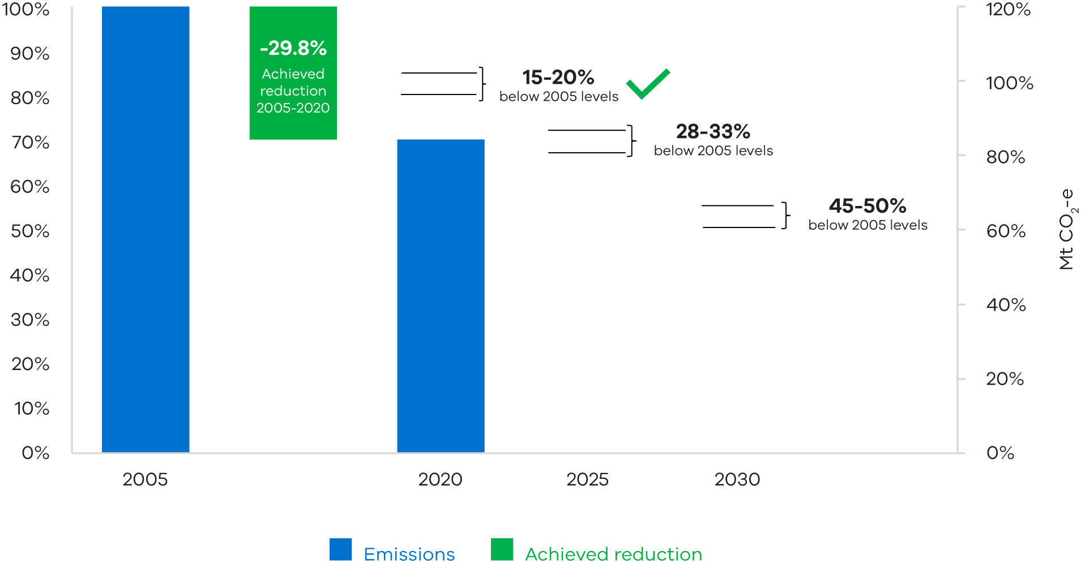
Source: Australian Greenhouse Emissions Information System, Commonwealth Government Department of Climate Change, Energy, the Environment and Water (DCCEEW), 2022
Victoria’s annual emissions reduction reporting provides transparency to the community
The Government publishes a Victorian Greenhouse Gas Emissions Report every year, in accordance with legislative requirements under the CC Act.
Victoria’s annual emissions reports provide important information for the community on Victoria’s emissions reduction performance. They also provide valuable insights to assist the Government in developing climate change policy and enable the effectiveness of policy to be reviewed over time.
The reports outline the best available information about Victoria’s greenhouse gas emissions and set out the percentage reduction in the state’s emissions since the base year, 2005. The reports also provide detailed information on the sources of – and trends in – Victoria’s emissions.
The reports use emissions data prepared by the Commonwealth Government, consistent with internationally agreed rules. They present information on Victoria’s emissions in two forms: by the sectors defined by the Intergovernmental Panel on Climate Change reporting framework for national greenhouse gas inventories, and by sectors categorised according to the Australian and New Zealand Standard Industrial Classification.
Data is available for use two years after the reporting year. This means Victoria’s latest annual greenhouse gas emissions report, published in 2022, is for the 2020 reporting year.

Victoria’s emissions trajectory

The Victorian Greenhouse Gas Emissions 2020 report shows the significant progress Victoria has made in reducing emissions since 2010. A summary of key information from the report is provided below. Visit Victoria’s greenhouse gas emissions and targets (climatechange.vic.gov.au) for the full report.
Victoria’s emissions peaked in 2010 and are now on a clear downwards trajectory. Victoria’s total net emissions in 2020 were 83.3 million tonnes (Mt) of carbon dioxide equivalent (CO₂-e), 29.8 per cent below 2005, and 40.4 per cent below 2010 emissions.
Figure 12: Trend in net emissions – Victoria, highlighting change between 2005 and 2020
Change 2005–2020
-35.3 Mt CO₂-e (-29.8%)
Source: Department of Climate Change, Energy, the Environment and Water, “Australian Greenhouse Emissions Information System”, 2022

The emissions intensity of the Victorian economy is falling faster than net emissions. Victoria’s emissions per dollar of Gross State Product fell by 51 per cent between 2005 and 2020. The Victorian economy grew by 43.1 per cent over this period.
Table 1: Victoria’s greenhouse gas emissions reductions from 2005 base year
Emissions measure | 2005 emissions | 2020 emissions | Reduction from 2005
Total emissions | 118.6 Mt CO₂-e | 83.3 Mt CO₂-e | 29.8 per cent
Emissions intensity of Victoria’s economy | 0.36 kg CO₂-e  per dollar of  Gross State Product | 0.18 kg CO₂-e  per dollar of  Gross State Product | 51 per cent
Per capita emissions | 23.8 t CO₂-e  per person | 12.4 t CO₂-e  per person | 48 per cent

Victoria’s emissions by sector

Victoria’s 2020 emissions originated from electricity generation (50.1 per cent of total net emissions), transport (25.0 per cent), fuel combustion (20.8 per cent), agriculture (19.3 per-cent), industrial processes and product use (4.3 per cent), fugitive emissions from fuels (2.4 per cent) and waste (3.4 per cent).
Land use, land-use change, and forestry (LULUCF) provided net sequestration of 21.1 Mt CO₂-e (-25.3 per cent of net emissions) . This means the sector removed (sequestered) more greenhouse gases than it generated.

Figure 13: Victorian emissions by sector and energy sub-sector 2005-2020
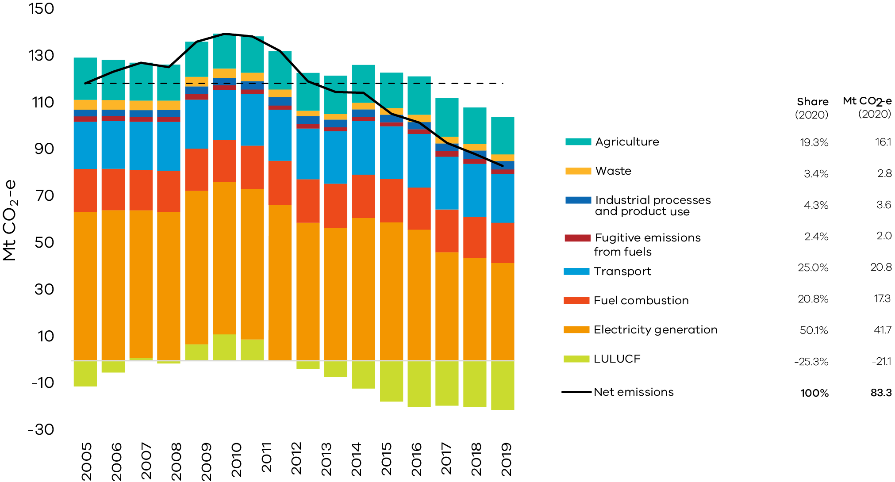
Source: Australian Greenhouse Emissions Information System, DCCEEW 2022. Numbers may not sum due to rounding.

Key contributors to the fall in emissions between 2005 and 2020 were electricity generation, where emissions fell by 21.8 Mt CO₂-e (62 per cent of the change in total net emissions) and the LULUCF sector, which increased net sequestration by 10.0 Mt CO₂-e (28 per cent of the change in Victoria’s total net emissions).
Reductions in emissions also occurred in agriculture (2.0 Mt CO₂-e), waste (1.4 Mt CO₂-e), fuel combustion (1.1 Mt CO₂-e) and fugitive emissions from fuels (0.3 Mt Co₂-e). Emissions increased in transport (0.6 Mt CO₂-e) and industrial processes and product use (0.8 Mt Co₂-e)

      - Strong and achievable energy targets

Victorian Renewable Energy Targets
Victoria beat its first renewable energy target for 2020 and exceeded 30 per cent renewable electricity generation in 2021.
25 per cent  renewable energy by 2020 | 40 per cent  renewable energy by 2025 | 50 per cent  renewable energy by 2030
Victoria’s renewable electricity generation has almost tripled since 2014-15 as a result of substantial investment in new wind and solar farms and continued uptake of rooftop solar systems by Victorian homes
and businesses. These investments were supported by Government policies such as the 2017 Victorian Renewable Energy Targets (VRET) auction and the Solar Homes program.
The Government has also released energy targets for offshore wind in Victoria – 2 gigawatts by 2032, 4 gigawatts by 2035 and 9 gigawatts by 2040.
The Government has also released energy targets for offshore wind in Victoria – 2 gigawatts by 2032, 4 gigawatts by 2035 and 9 gigawatts by 2040.

Figure 14: Renewable electricity generation in Victoria, 2014-15 to 2021-22

Source: NEM Review, Metered generation (as generated), extracted on 1 July 2022 except for bioenergy (based on DCCEEW, Australian Energy Statistics).

Victoria’s greenhouse emission from electricity generation

Greenhouse gas emissions from electricity generation in Victoria have fallen from around 60 Mt CO₂-e a year in 2014-15 to around 39 Mt of CO₂-e in 2021-22. This reduction has been mainly driven by the closure of the Hazelwood power station in March 2017 but also reflects increased outages from coal generation in recent years, growing renewable generation both in Victoria and across the National Energy Market, and continued improvements in energy efficiency.

Figure 15: Greenhouse gas emissions from electricity generation in Victoria, 2014-15 to 2021-22

Source: NEM Review, Greenhouse emissions, extracted 1 July 2022

Victorian Energy Upgrades program

The VEU program is a government program providing households and businesses with discounted energy efficient products and services. Program activities and discounts can be accessed through accredited providers who operate across the state generating Victorian Energy Efficiency Certificates, which are sold to energy retailers.
The Government sets annual emissions reduction targets that require energy retailers to buy certificates. The target increases each year and in 2022 the target is 6.7 million tonnes in 2022 increasing to a target of 7.3 million tonnes in 2025.
Table 2: VEU targets for 2022-25
Year | Number of VEU certificates | Emissions savings (tonnes)
2021 | 6.5 million | 6.5 million
2022 | 6.7 million | 6.7 million
2023 | 6.9 million | 6.9 million
2024 | 7.1 million | 7.1 million
2025 | 7.3 million | 7.3 million

      - Targets for government operations

The Government has developed targets and reporting guidelines that support government actions to reduce emissions from its own operations.

Government emissions reduction targets and metrics
The Whole of Victorian Government Emissions Reduction Pledge 2021-2025 includes key commitments to reduce emissions from government operations, as part of Victoria’s Climate Change Strategy and as required under the CC Act. The Government measures progress toward the key commitments in the pledge and is on track to deliver these commitments by 2025, as outlined below.

Table 3: Status for the Whole of Victorian Government emissions reduction pledge
Target | Status
100 per cent renewable electricity for government operations by 2025 | The second VRET Auction opened in May 2021 targeting at least 600 megawatts (MW) of new renewable energy capacity in Victoria.
Improved government building and infrastructure sustainability | Commitments are being delivered through updates to accommodation guidelines and standards relevant to specific facility types
400 ZEVs in government fleet by 30 June 2023 | The ZEV program is on track to encourage uptake of the 400 ZEVs by 30 June 2023 with infrastructure upgrades and transition vehicles well underway.
All new public buses zero emissions from 2025 | Zero emissions bus trials are underway, involving 52 buses to date (including two hydrogen fuel cell buses).

Improved reporting on government emissions

The Government’s commitment to reducing government emissions is supported by ongoing improvements to reporting of environmental data and emissions by departments and public entities.
Financial Reporting Direction 24 sets out directions and guidance for government entities to report environmental data in their annual report of operations as part of broader requirements under the FM Act. This direction has been strengthened with all government entities required to report on all office and non-office activities across a range of environmental indicators in their annual reports from 2022-23 onwards.
The new environmental information will provide greater transparency of the environmental impacts of public services, illustrate how they are being responsibly managed, and support delivery of five-yearly whole of government emissions reduction pledges required by the CC Act.
The updated Financial Direction 24: Reporting of environmental data by government entities is available on the DTF website.

    - Next steps for Victoria

The Victorian Government is embracing a net zero future and maximising opportunities that a clean economy offers in a just and sustainable way. Effective management of climate-related risk will ensure that the government can continue to respond effectively to the challenge of climate change and also support Victorians, invest in the state’s future, and attract capital and investment. The Government will continue to strengthen its understanding and management of climate-related risks and opportunities, with short to medium-term priorities including further work to:
- Solidify the evidence base for climate action using economic, research and scientific expertise to develop policy responses to harness Victoria’s climate-related opportunities.
- Use futures thinking via greater application of climate scenario (possible or desired futures) analysis, in line with best practice frameworks to bolster our response.
- Strengthen our understanding and assessment of the impact of climate change on the Victorian economy and on the financial performance and position of the State. This will include assessment of the impact of a selection of risks over different time scales and under different climate scenarios.
- Bolster enterprise risk management frameworks, at departmental and agency levels, to ensure that climate-related risks are effectively identified, assessed, and managed throughout the department.
- Influence the international platform by continuing to engage as a Net Zero Leader and inspire more states and regions to accelerate ambitious climate action.

Abbreviations and Acronyms
AMAF Asset Management Accountability Framework
ACCUs Australian Carbon Credit Units
BVRC Building Victoria’s Climate Resilience
CO2-e carbon dioxide equivalent
CC Act Climate Change Act 2017
CSIRO Commonwealth Scientific and Industrial Research Organisation
DELWP Department of Environment, Land, Water & Planning
DTF Department of Treasury and Finance
EM Act Emergency Management Act 2013
EMV Emergency Management Victoria
FM Act Financial Management Act 1994
GED General Environmental Duty
IGEM Inspector-General for Emergency Management
ICMA International Capital Markets Association
ISSB International Sustainability Standards Board
LULUCF Land use, land-use change, and forestry
LVA Latrobe Valley Authority
MW megawatts
Mt million tonnes
PBSP Powerline Bushfire Safety Program
REZ Renewable Energy Zone
VRET Victorian Renewable Energy Targets
VRET2 Second Victorian Renewable Energy Target Auction
SPF Social Procurement Framework
SCRC State Crisis and Resilience Council
SEMP State Emergency Management Plan
Risk IDC State Significant Risk Inter-Departmental Committee
TCFD Taskforce on Climate-Related Financial Disclosures
TCV Treasury Corporation of Victoria
VEU Victorian Energy Upgrades
VFMC Victorian Funds Management Corporation
VGRMF Victorian Government Risk Management Framework
VMIA Victorian Managed Insurance Authority
VSB Victorian Secretaries Board
ZEV zero emissions vehicles

Figure 1, ‘Core elements of TCFD recommendations’ sourced from Financial Stability Board, Recommendations of the Task Force on Climate-related Financial Disclosures, 2017
State Government of Victoria Department of Environment, Land, Water and Planning, Working towards a net-zero, climate-resilient Victoria. 2022.
State Government of Victoria Department of Environment, Land, Water and Planning, Working towards a net-zero, climate-resilient Victoria. 2022.
State Government of Victoria Department of Environment, Land, Water and Planning, The economic impact of heatwaves on Victoria, 2019
Australian Institute of Health and Welfare, Data update: Short-term health impacts of the 2019–20 Australian bushfires, 2021
Climate Change Strategy and published at 2019-20 Eastern Victorian bushfires | Victorian Government (www.vic.gov.au) State Government of Victoria Department of Environment, Land, Water and Planning, Victoria’s bushfire emergency: biodiversity response and recovery, 2020
State Government of Victoria Department of Environment, Land, Water and Planning, Victoria’s Climate Change Strategy Economic Analysis, 2021
Victorian Funds Management Corporation Responsible Investment Update, July – December 2021
Victorian Funds Management Corporation, Annual Report 2020-2021
Commonwealth of Australia, National Greenhouse Gas Inventory 2020 data for Victoria. See https://ageis.climatechange.gov.au/
Victorian Government Risk Management Framework, p. 3.
Australian Greenhouse Emissions Information System, DCCEEW 2022.
Australian Greenhouse Emissions Information System, DCCEEW 2022.
Analysis based Department of Climate Change, Energy, the Environment and Water "State and Territory Greenhouse Gas Inventories 2020” (2022); Australian Bureau of Statistics "Australian National Accounts: State Accounts, 2020-21” (2021) and “National, state and territory population: September 2021” (2022)
Australian Greenhouse Emissions Information System, DCCEEW 2022.
Australian Greenhouse Emissions Information System, DCCEEW 2022.
NEM Review, Greenhouse emissions, extracted 1 July 2022
NEM Review, Greenhouse emissions, extracted 1 July 2022

